Forest School Learning Progression Map

Intent:

What do we intend children to learn?
To achieve the best together is our aim at Belton C of E Primary School. We do this through our strong underpinning of the Christian values of hope, peace, forgiveness, love, friendship and trust coupled with the British values of liberty, freedom, community, tolerance, respect and law. We want to ensure that the pupils can be the very best they can be and become responsible, confident individuals who are well equipped for the future.

It has been widely documented that the Covid19 pandemic has had a huge impact on the mental wellbeing of children. Anxiety, loneliness, depression, boredom, isolation and uncertainty are all said to have taken their toll on our children today. Going forward, evidence suggests that routine and structure, a sense of control, having things to do, contact with friends and extra support to socialise, physical activity, learning new skills and outdoor play will help our children recover.

Implementation

How do we teach it?
A way in which we achieve this aim is to use one of our great school assets; the wonderful availability of the Leicestershire countryside within our school grounds. Every pupil is given the opportunity to learn and develop using the forest school approach with our fully qualified level 3 Forest School Leader (with QTS).

Therefore, our forest school provision aims to provide just that to every pupil in our school. For an hour each week, we will concentrate on eight important areas of outdoor learning; Core Values, Environmental Education, Outdoor Skills, Species Identification, Knots and Lashings, Reflect and Review, Tool Tasks and Firepit Finesse. These eight areas of learning are further split into skills within each section as explained below.

- Core Values

This area of outdoor learning encompasses five core values:

- Wellbeing and Emotional Intelligence
- Self-Management of Risk
- Environmentally Friendly and Sustainable Attitudes
- Creativity and Imagination
- Resilience and Problem-Solving Skills

Wellbeing and Emotional Intelligence
At Belton C of E Primary school, we strive to improve both emotional intelligence and wellbeing through our fun and practical outdoor activities. Emotional intelligence is the ability to understand and manage your own emotions, and those of the people around you. People with a high emotional intelligence know what they are feeling, what their emotions mean and how these emotions can affect other people. Emotional intelligence goes hand in hand with wellbeing. Wellbeing can be achieved through connecting with other people, being physically active, learning new skills, giving to others and paying attention to the present moment (mindfulness).

Self-Management of Risk
Part of our forest school approach involves teaching our pupils to be able to manage risk. In order to become responsible, confident individuals who are equipped for the future, we believe that our pupils should have the opportunity to take part in risky activities and should be involved in managing their own risks to age and ability appropriate levels. Everyday life is full of risks and challenges and our pupils need opportunities to develop the skills associated with managing risk and making informed judgements about risk from an early age. Risky play helps to develop important life skills such as building resilience and persistence.

Environmentally Friendly and Sustainability Attitudes
Our aim is to connect our pupils with their local environment in ways that can be maintained with minimal long-term environmental impact. We believe outdoor learning should cause no harm to plants or wildlife, should not contribute to an increase of pollution and waste, and not change the natural biodiversity of the outdoor area.

Creativity and Imagination
Through the fun activities provided in our forest school provision, we help to facilitate individuality and originality and enable our pupils to develop innovative skills. We strive to give our pupils the confidence to imagine, explore and invent. We ask full and open-ended questions, offer tasks and challenges to inspire our pupils to find their own solutions and ideas.

Resilience and Problem-solving Skills
Our fun learning activities and challenges offered through our forest school approach help to build confidence to enable our pupils to develop a positive growth mindset. We help our pupils to learn to ‘bounce back’ after failures and persevere when faced with challenges. Not everything in life is easy but can be manageable if you have the resilience to cope. We believe that our pupils need to learn that making errors is a valuable part of learning.

- Environmental Education
This area of outdoor learning is split into two key skills:

- Biodiversity
- Environment

Learning activities will include planting and caring for seeds until harvest, analysing the environment to identify possible food chains, learning about the importance of litter picking and recycling and understanding why we must choose sustainable products for outdoor crafts.

- Outdoor Skills
This area of outdoor learning is split into three skills:
- Map skills and navigation
- Shelter building
- Physical and practical outdoor skills

Our pupils will learn the pre-requisite skills to become confident navigators and map readers. They will learn to build shelters using tarpaulin and ‘lean-to’ shelters using natural resources. They will learn to dress appropriately for the outdoor environment and show increasing confidence in completing challenging physical activities.

- Species Identification
In this area of outdoor learning our pupils will learn to identify and name trees and plants. They will learn new vocabulary including deciduous and evergreen. The older pupils will observe leaf structure and identify the function of different plant and tree parts. Living things will be explored and classified.

- Knots and Lashings
In this area of outdoor learning, our pupils will learn to tie various knots and lashings. They must show great resilience but when they have mastered the new skill, they put it to good use creating jewelry, puppets, dream catchers etc.

- Reflect and Review
Reflecting on and reviewing their learning is an important skill to acquire. Reflection helps our pupils to develop a secure and confident knowledge base, and sense of self, that empowers them to take on new challenges, learn from mistakes, and try new things. By making reflection a habit, our pupils learn to appreciate their strengths, and make choices that align with their interests and values.

- Tool Tasks
The skills and knowledge gained in this area of outdoor learning are introduced through ‘tool talk’. Before handling any tools, our pupils must be able to talk about and identify the important parts and functions of each tool as well as explaining their safe use. The younger pupils begin by gaining experience using peelers and the older pupils enjoy hands on experience with bow saws, knives, loppers and secateurs.

- Fire-pit Finesse
This popular area of outdoor learning sees our pupils learn to use a fire steel to light their own mini fires to cook on. They will learn the positive and negative effects of fire and the importance of managing risk.

Forest school learning progression
The skills and knowledge learnt throughout the lessons are progressive as seen below.

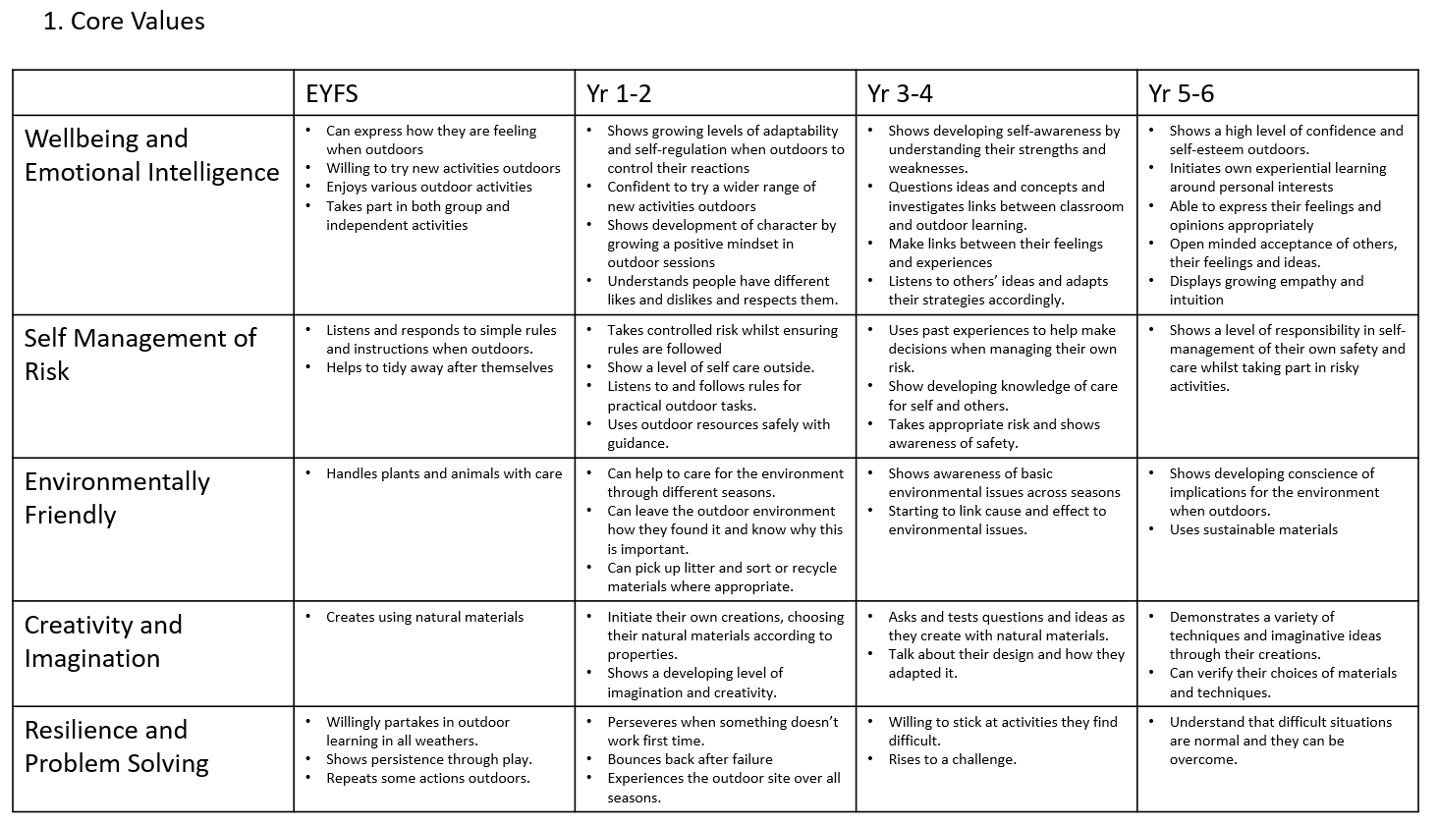

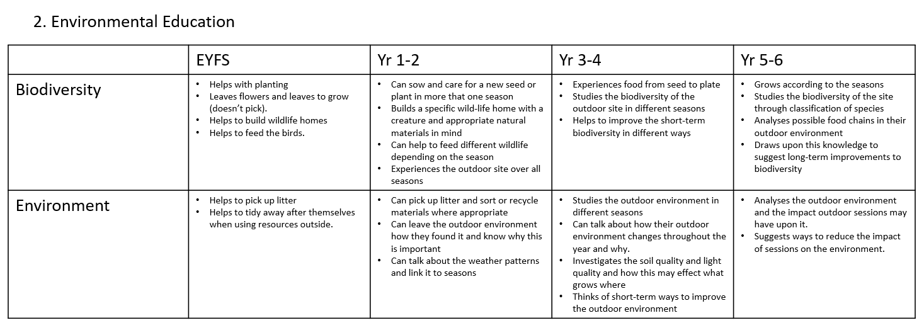

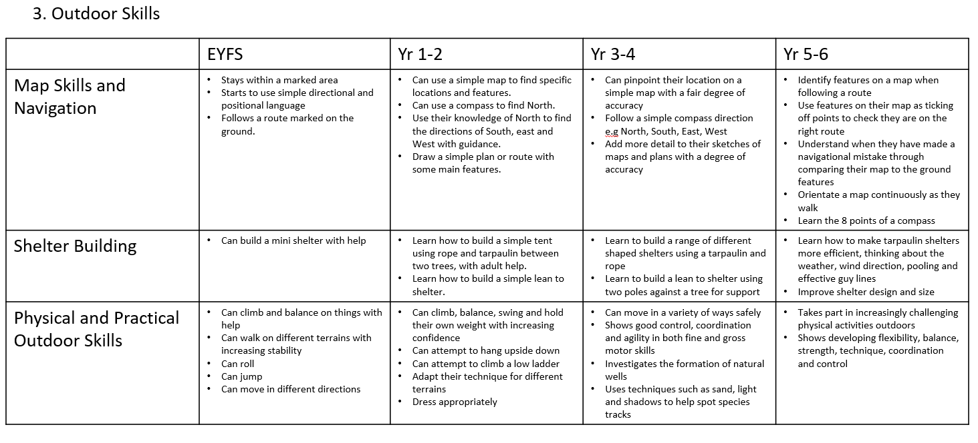

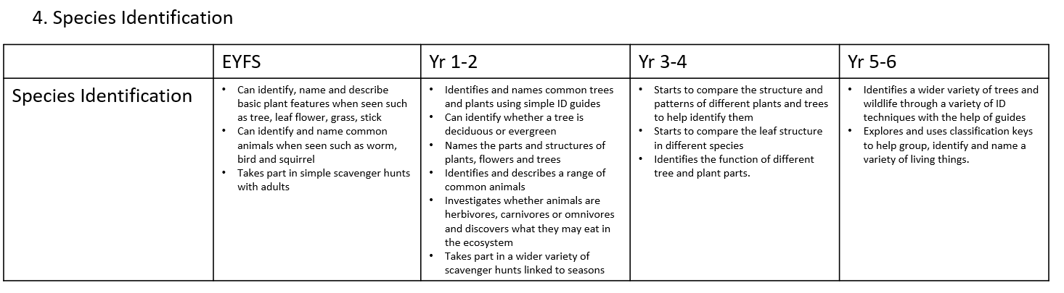

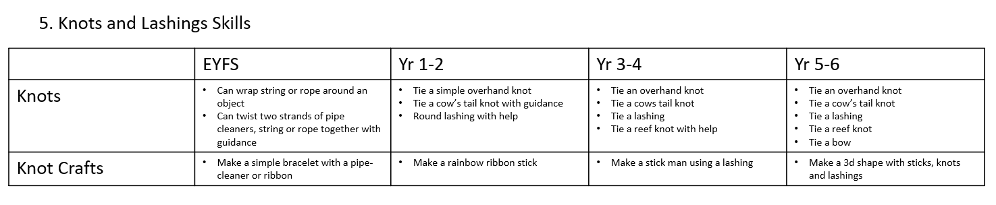

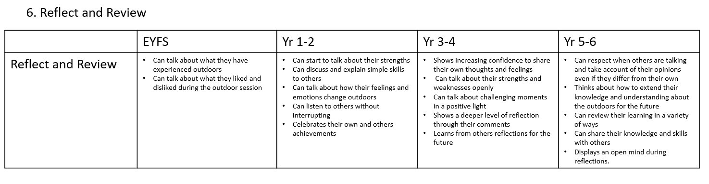

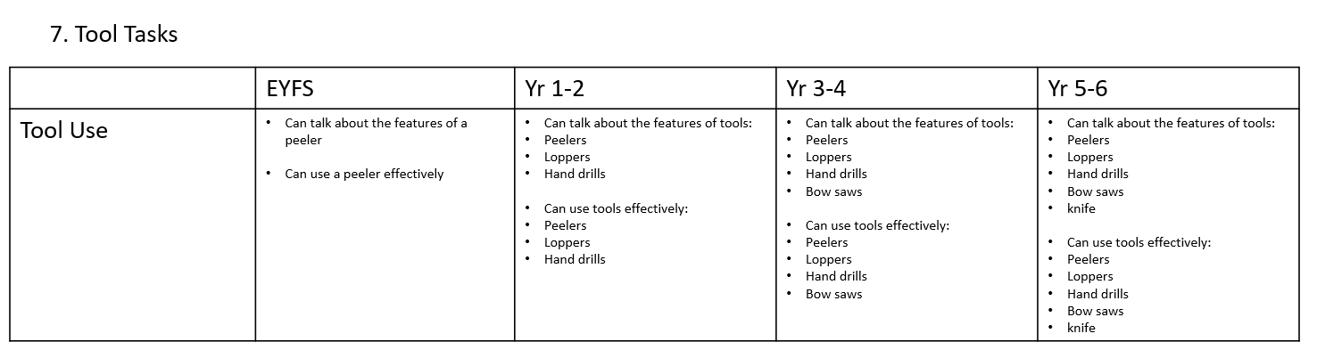

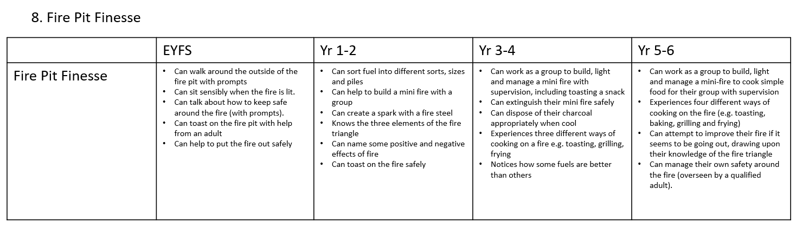

What does forest school learning look like at our school?

Every child in our school has an hour’s forest school learning each week. This is taught by a level 3 qualified forest school leader (with QTS) in our fantastic outdoor space and forest area within our school premises. At times, the children are also taken off premises to experience alternative areas to extend their learning.

In our small school, we have three mixed age classes and the Early Years Foundation Stage (EYFS) class. The mixed age classes have a two-year rolling plan and the EYFS a single year plan.

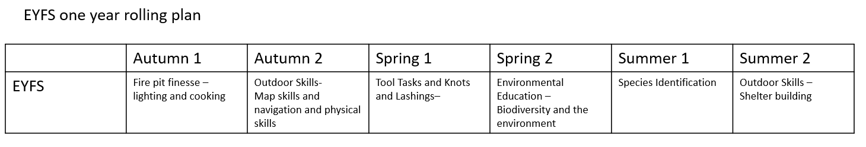

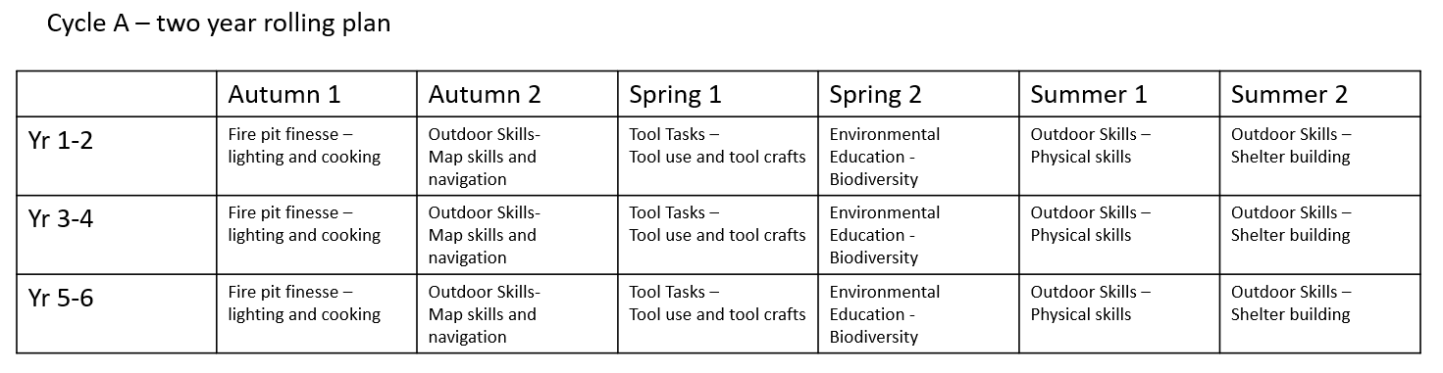

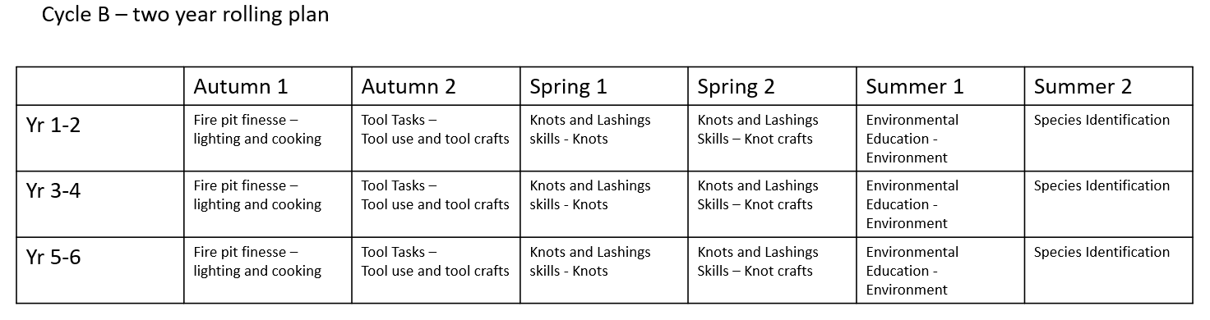

What does a forest school lesson look like in our school?

Core values
Each lesson has one of the core values as a focus alongside the skills-based learning of each outdoor learning unit. The lessons within each unit are progressive, building upon skills learnt in previous lessons.

Cross Curricular links
There are many links that can be made between our forest school learning, the EYFS and the National Curriculum. These are identified on each lesson plan and communicated to the class teacher. The nature of our cross curricular planning enables our pupils to relate their knowledge to different contexts, allowing for a greater depth to their understanding.

Below is an example lesson plan. This one is for the Yr 5-6 Species Identification lesson where our pupils learn to identify, describe and explain the different types of Oak Galls we have in our outdoor environment.
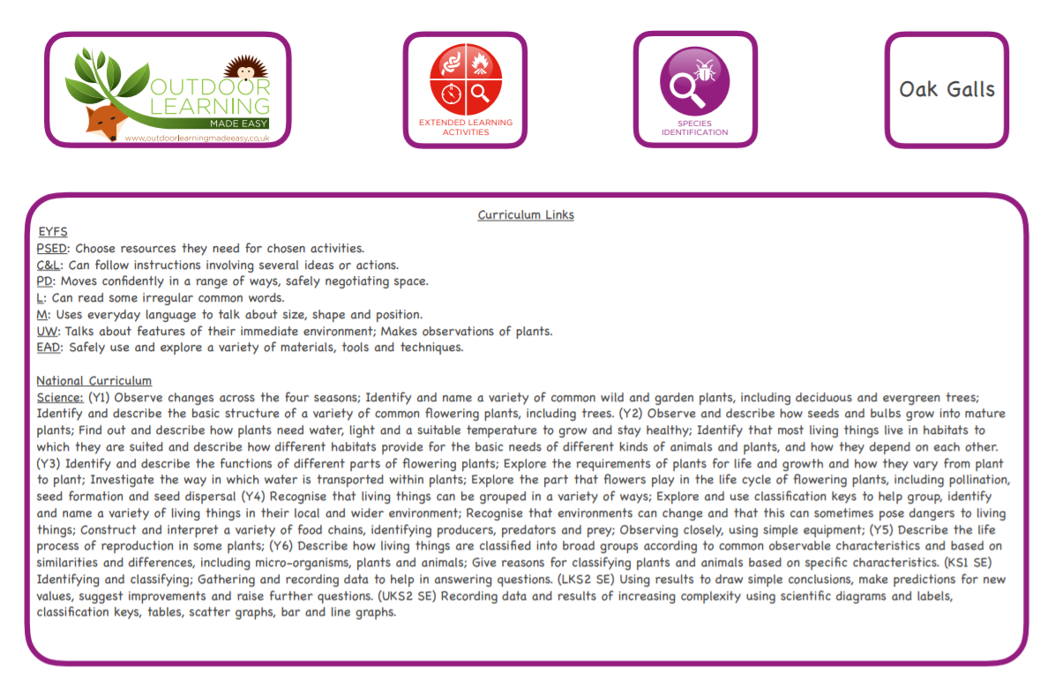
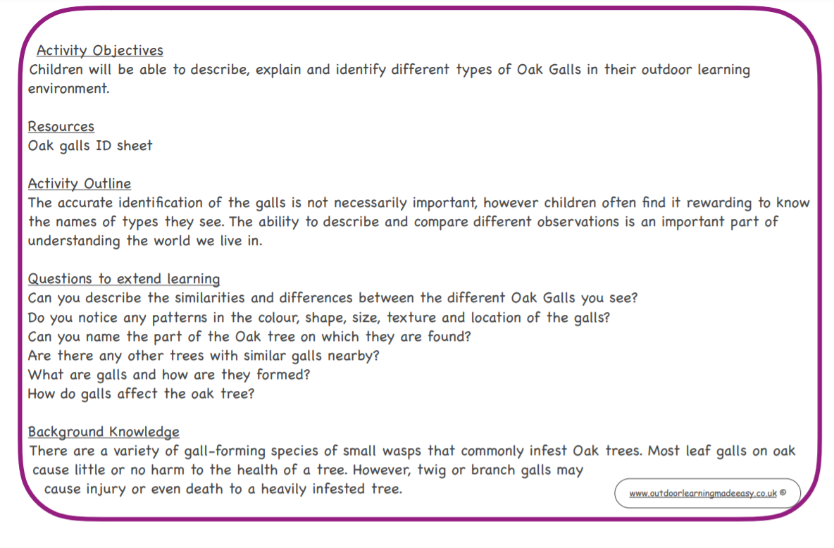
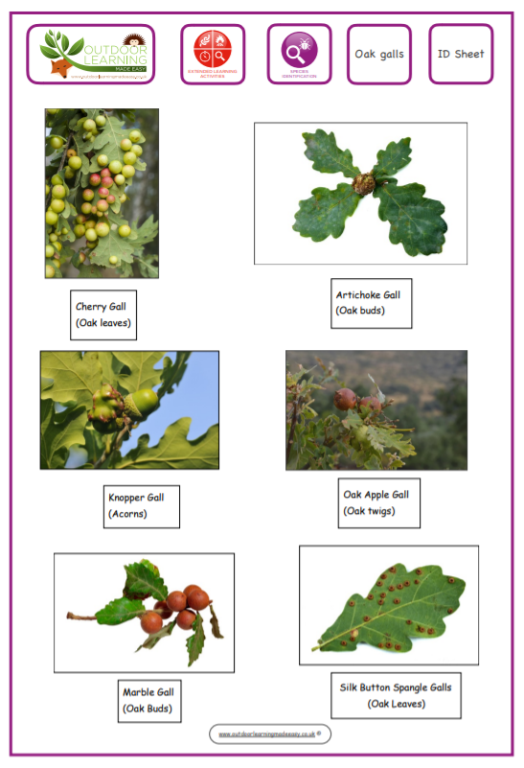

.

Impact

How do we know how well children are doing?

Reflect and Review
At the end of every lesson the children are given the opportunity to reflect on and review their learning. This helps them to develop a secure and confident knowledge base, and a sense of self that empowers them to take on new challenges, learn from mistakes and try new things.

Assessment of knowledge and Skills
Our pupils’ gain a good understanding of the knowledge and skills they are expected to acquire in their forest school lessons each session, term and year. This gives them the opportunity to take responsibility for their own learning through their own self-assessment. Alongside the observations of the forest school leader each pupils’ knowledge and skills are tracked. The Yr 3-4 tracking grid is provided below as an example.

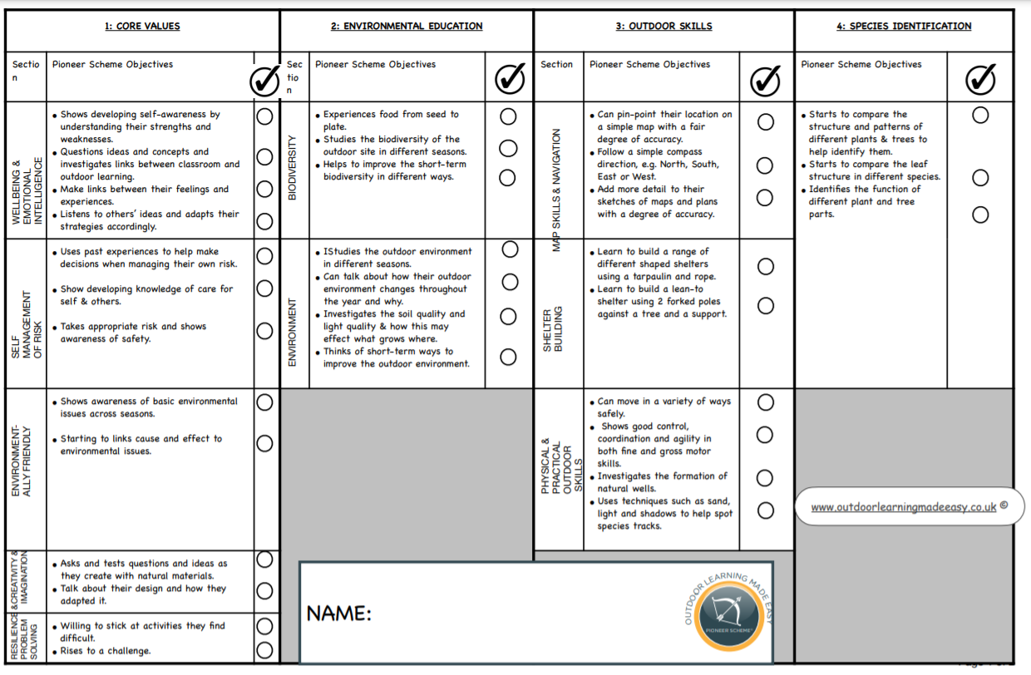

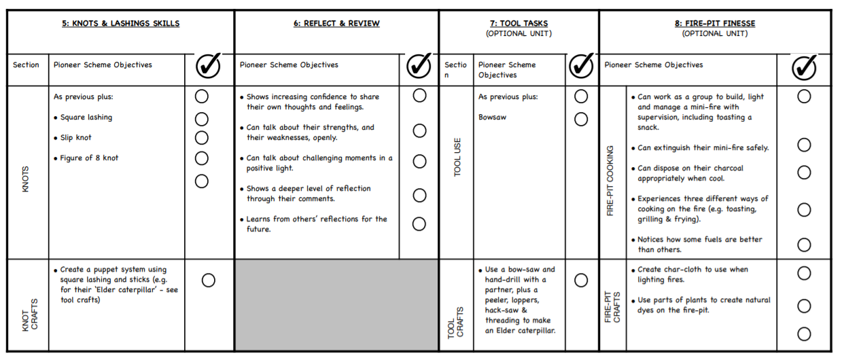

Forest school lessons provide a great sense of fun and enjoyment for our pupils which has a positive impact on their mental wellbeing. It provides our pupils with new experiences to look forward to, extra support to socialise, a growth mindset and physical activity, whilst learning about the environment in which they live and valuable new skills which will support them throughout life. All of this is delivered in a beautiful outdoor play environment in the beautiful Leicestershire countryside.

