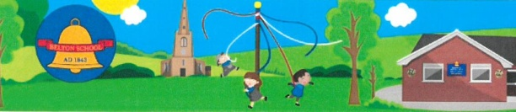
Belton C of E Primary School
Achieving the Best Together
Headteacher: Mrs E de Looze B.Ed M.A
Sadlers Wells, Belton, Leicestershire. LE12 9TS Email: office@belton.leics.sch.uk Telephone: 01530 222304 Website: www.belton.leics.sch.uk

3rd October 2014

Dear parents and carers,

I want to share some very exciting news with you. We have been fortunate to have been awarded a lottery grant of £10,000 towards developing our outdoor provision. This has been achieved by some very hard work on the part of FOBS on behalf of the school and all its pupils to achieve this impressive goal. The governors and I would particularly like to thank not least the chair-person of
FOBS last year, Lynn Moore, who lead the group and Debbie Bosworth (an ex parent now) who was treasurer and Michelle Hopkins who was secretary.

We have been in touch with the commission who have confirmed that we are able to adjust the specifications of the original application and are now refining our ideas and confirming our vision for the outdoor area. As you know, volunteer parents, carers, grandparents and children have begun to develop the bottom base over the past year and we are looking for ways to enhance the area with a view to incorporating the ethos of our school, giving our children inclusive opportunities to develop physically, to use their senses and their imaginations.

We will be talking with the school council and welcome suggestions from yourselves – so please do contribute.

We will keep you informed as to how things are progressing.
Mrs de Looze

Fundraising News
Macmillan Coffee Afternoon raised an amazing £342.74. Thank you from Class C to everyone who supported us.

Jeans for Genes. We enjoyed wearing our jeans in school and have sent a cheque for £100 to this very worthy cause.

Change of date for KS2 Christmas Carol Concert. This will now be held in church on Monday 15th December at 6.30pm.

