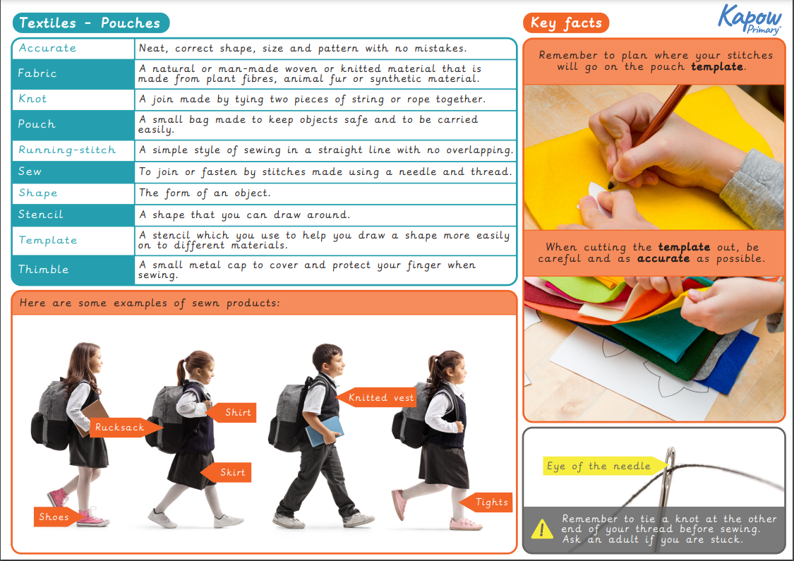

Foxes: Design and Technology: Textiles