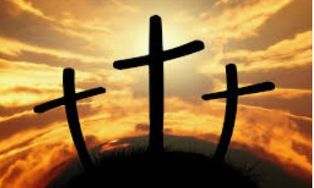

Year 3

RE

Knowledge Organiser (Spring 2 ) Salvation

What good things happened as a result of Jesus dying?

**Why do Christians**

**Did Jesus have to die? Do**

**Christians believe there is any other way to be saved?**

**call the day Jesus died**

**Good Friday?**

**Why is the death of Christ so important to Christians? How many dif- ferent emotions do you feel when you**

**remember the events of Holy Week?**

|  |  |  |  |
| --- | --- | --- | --- |
| **Key Vocabulary** | | | |
| Sacrifice | An offering, at loss to yourself, to  someone else | Passover | A Jewish celebration re-  membering when the Israelites were spared from the plagues |
| crucifixion | An ancient form of execution where someone is bound or  nailed to a cross | Communion | A celebratory meal of  bread and wine remembering Jesus’ death wine= blood  Bread= body |
| Salvation | Being saved or delivered from harm | Service | Putting other people’s  needs before your own |
| Golgotha | The place where  Jesus was crucified | Eucharist | The church of England’s  word for communion |



**As we think of the events of Holy week and the events**

**leading up to the death of Je- sus, we consider the motives and reasons which underpin all these events.**

**Did you know?**

**When Jesus died, the curtain in the temple tore in two. Do you think these events were related? Why?**