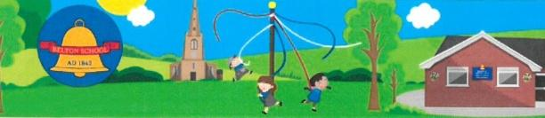
Belton C of E Primary School
Achieving the Best Together
Headteacher: Miss J Scott BSc (Hons) NPQH
Sadlers Wells, Belton, Leicestershire. LE12 9TS Email: office@beltonprimary.org
Telephone: 01530 222304 Website: www.belton.leics.sch.uk

30th April 2021

Dear Applicant,

I would like to take this opportunity to thank you for your interest in the position of SEN LSA
at Belton Church of England Primary School for a fixed term, start date asap until July 30th 2021.
This role will be supporting a child with specific needs in Year 6 and will be 4 afternoons per week (10 hours)

Belton Church of England Primary School is a small village school in North West Leicestershire with 105 pupils ages 4 to 11. We have strong links with the church, village and local community. The school is located in spacious attractive grounds which offer opportunities for creative outdoor play and interaction with nature.

Our school has been graded ‘Good’ by Ofsted. We are a happy school and our motto is ‘Achieving the best together’ and this with our rooted Christian values underpins the ethos of our school. We aim to promote and model these values in what we do; these are hope, peace, friendship, love, forgiveness and trust. We work in partnership with each other, staff, pupils, parents and families, governors and the community to achieve the best. We strive to give our pupils a firm foundation in primary education and equip them with skills they will be able to use throughout their lives.

Please find attached an application form, job description and job specification. Please return the completed application form by 10th May 2021 at midday. Interviews will be held on 12th May 2021.

Visits to the school are most welcome. Due to Covid 19 this will need to be after school. Please contact the school office (01530 222304) to arrange a convenient time.

I look forward to hearing from you,

Kind regards

Miss J Scott
Headteacher

