# Belton C of E Pupil Premium Strategy Statement 2021-2022-2023-24 (3 years)



## This statement details our school’s use of pupil premium (and recovery premium for the 2021 to 2022 academic year) funding to help improve the attainment of our disadvantaged pupils.

## It outlines our pupil premium strategy, how we intend to spend the funding in this academic year and the effect that last year’s spending of pupil premium had within our school.

## School overview

|  |  |
| --- | --- |
| Detail | Data |
| School name | Belton C of E Primary |
| Number of pupils in school | 105 |
| Proportion (%) of pupil premium eligible pupils | 10.5% |
| Academic year/years that our current pupil premium strategy plan covers **(3 year plans are recommended)** | 2021/2022  2022/2023  2023/2024 |
| Date this statement was published | November 2021 |
| Date on which it will be reviewed | September 2023 |
| Statement authorised by | J Scott |
| Pupil premium lead | C Yendall |
| Governor / Trustee lead | J Hall |

**Funding overview**

|  |  |
| --- | --- |
| **Detail** | **Amount** |
| Pupil premium funding allocation this academic year | £19,105 |
| Recovery premium funding allocation this academic year | £2810 |
| Pupil premium funding carried forward from previous years | None |
| **Total budget for this academic year**  If your school is an academy in a trust that pools this funding, state the amount available to your school this academic year | £21,915 |
|  |  |

# Part A: Pupil premium strategy plan

## Statement of intent

|  |
| --- |
| At Belton Primary School we target the use of Pupil Premium Grant funding to ensure that our disadvantaged pupils receive the highest quality of education to enable them to become active, socially responsible citizens of the future. We recognise that disadvantaged children can face a wide range of barriers which may impact on their learning.  Our ultimate objectives are to:   * Remove barriers to learning created by poverty, family circumstance and background * Narrow the attainment gaps between disadvantaged pupils and their non-disadvantaged counterparts both within school and nationally * Ensure ALL pupils are able to read fluently and with good understanding to enable them to access the breadth of the curriculum * Develop confidence in their ability to communicate effectively in a wide range of contexts * Enable pupils to look after their social and emotional wellbeing and to develop resilience. * Access a wide range of opportunities to develop their knowledge and understanding of the world   Achieving our objectives: In order to achieve our objectives and overcome identified barriers to learning we will:   * Provide all teachers with high quality CPD to ensure that pupils access effective quality first teaching * Provide targeted intervention and support to quickly address identified gaps in learning including the use of small group work, 1:1 tuition * Target funding to ensure that all pupils have access to trips, residentials, first hand learning experiences. * Provide opportunities for all pupils to participate in enrichment activities including sport and music * Provide appropriate nurture support (ELSA) to enable pupils to access learning within and beyond the classroom.   This is not an exhaustive list and strategies will change and develop based on the needs of individuals.  Key Principles: We will ensure that effective teaching, learning and assessment meets the needs of all pupils through the rigorous analysis of data. Class teachers will identify through the class pupil premium plan specific intervention and support for individual pupils which will be reviewed at least termly. Alongside academic support, we will ensure that those pupils who have social, emotional and mental health needs will access high quality provision from appropriately trained adults (eg. ELSA) |

## Challenges

This details the key challenges to achievement that we have identified among our disadvantaged pupils.

|  |  |
| --- | --- |
| eligible | Detail of challenge |
| 1 | **Social/ Emotional/ Mental Health needs**  SEMH issues ( eg Attachment, anger management and low self-esteem) for many of our pupils eligible for PP are having a detrimental effect on their learning and academic progress as they aren’t always ‘ready to learn’. |
| 2 | **Narrowing the attainment gap across Reading, Writing, Maths and Science**  Entry baseline in basic English and Maths; as well as poor oral skills. These are poorer in some PP students than others. This has slowed academic progress in subsequent years, especially reading.  Some of our PP children are also SEND (56%). Their SEND complexities impact academic progress. |
| 3 | **How to structure and apply Oracy skills across the curriculum.**  Some PP pupils find it challenging to know how to structure and apply their basic oracy skillls across the curriculum which ultimately impacts on them achieving the expected writing standard at the end of KS2. |
| 4 | **Behaviour/ Attitudes to Learning**  Behaviour issues for a small number of pupils (eligible for PP) are having a detrimental effect as they are unable to take responsibility for and control their behaviour, therefore impacting on their learning and ultimately their academic progress. |
| 5 | **Wider opportunities to participate in learning beyond the school day.**  A smaller number of PP eligible pupils have less opportunities to participate in learning beyond the school day. |

## Intended outcomes

This explains the outcomes we are aiming for **by the end of our current strategy plan**, and how we will measure whether they have been achieved.

|  |  |
| --- | --- |
| Intended outcome | Success criteria |
| Progress in Reading, Writing and Mathematics.  Disadvantaged pupils maintain at least the standard of achievement they achieved the previous year.  To ensure fallen behind children receive targeted high-quality intervention. | Achieve national average progress scores in KS2 Reading/ Writing and Maths  Teacher Assessments (end of Summer 2022 and 2023) will show that most of the disadvantaged children have made expected progress from the previous summer. 10 – 20% of disadvantaged children will have made accelerated progress.  Analysis of Interventions will show that interventions have had positive impact on the disadvantage children’s learning and has helped with accelerating their progress. |
| Pupils and families with identified SEMH needs are well supported by school staff so that needs are removed or alleviated. | SENCO/ ELSA/ Headteacher identify and support families and children, working with them to alleviate barriers to learning.  Vulnerable disadvantaged children wo; have access to a trained ELSA who will provide support and alleviate barriers.  Pupil and parent questionnaires will show that parents/ children of disadvantaged families feel supported and additional barriers alleviated where possible.  The use of worry boxes and the Whisper app is a way for children/ parents to voice concerns. |
| Improved attitudes to learning and ‘ready to learn’ strategies  School will deliver an engaging, broad and varied curriculum | Reduction of behavioural incidents on CPOMS.  Positive comments on Pupil Voice  Pupil observation by class teacher  Children will be exposed to a wide range of social, cultural, enrichment and sporting experiences within the school day.  Teachers and support staff will plan a wide range of visits/ WOW experiences to inspire/ enhance learning and make it more memorable. |
| More opportunities to participate in ASC such as Judo, Multisports, Dance | Positive comments on Pupil Voice  All children to partake in at least one ASC  Children will be exposed to a wide range  of social, cultural, enrichment and sporting activities outside the school day that will enable SEMH. |

## Activity in this academic year

This details how we at Belton C of E Primary School intend to spend our pupil premium (and recovery premium funding) **this academic year** to address the challenges listed above.

### Teaching

Budgeted cost: £4,100

|  |  |  |
| --- | --- | --- |
| Activity | Evidence that supports this approach | Challenge number(s) addressed |
| Staff training on challenging behaviour and attitudes to learning | PP pupils who are unable to take responsibility/ control of their behaviour will have access to learning. | 4 |
| Staff Training on Mental Health and Well-being continues with action plan  Mental Health training for children  Trauma training ongoing for next phase of staff | We want to ensure that PP who have SEMH are supported successfully in order for them to be able to access their learning. | 1, 4 |
| Improved Oracy – SIP and CDP priority | All teachers will be trained in practices that provide opportunities for children to use and apply their Oracy skills and knowledge across the curriculum. | 3 |
| Working with Subject Leaders to improve/ enhance the teaching and learning within every subject. | <https://sandbox.educationendowmentfoundation.org.uk>  /education-evidence/teaching-learning-toolkit | 2, 4 |
| Targeted Support | Quality first teaching with rapid intervention tailored to educational needs will be put in where necessary. | 2 |

**Targeted academic support**

Budgeted cost: £ 14,094

|  |  |  |
| --- | --- | --- |
| Activity | Evidence that supports this approach | Challenge number(s) addressed |
| Improved Maths and English core skills with a specialist Intervention Teacher/ CT  Interventions to be monitored and evaluated by CT/ HT on a termly basis. | Some of the students need targeted support to catch up.  EEF Toolkit suggests that targeted support matched to pupils with particular needs can be effective.  PP children who have SEMH needs are supported successfully in order for them to be able to access their learning. | 2,3 |
| Split Maths class in Yr ½ with CT for QFT | Ensuring that all learners have the chance of QFT in a supportive environment.  Small groups have been known to benefit children with SEMH needs. | 1, 2, 3, 4 |
| Access to Oakfield resources and staff | Develop confidence in the classroom and with peers.  Build self-esteem.  Appropriate behaviours and strategies being learnt. | 1 |
| 1:1 LSA’s | To develop and implement strategies for confidence in classroom with peers.  Build self-esteem.  Appropriate behaviours and strategies being learnt. | 1, 2, 3, 4 |
| Funding to cover forest School sessions – provide training and resources for forest schools teacher. | Forest school is proven to work for SEMH kids, it encourages independent learning and pupils gain confidence and resilience.  <https://www.forestresearch.gov.uk/>  search/?s=forest+schools+report | 1, 4 |

**Wider strategies**

Budgeted cost: £ 2703

|  |  |  |
| --- | --- | --- |
| Activity | Evidence that supports this approach | Challenge number(s) addressed |
| Trained ELSA time for all PP/ PP+ children if deemed necessary by HT and staff.  CPD for ELSA to ensure they are kept up to date with current developments.  New ELSA trained | Children continue to have emotional needs, and worries and fears well into secure placements often testing the security and boundaries around them.  Children seeing the positives in what they do will ensure that they are more confident within the classroom environment.  https://www.elsanetwork.org/wp-content/uploads/2017/11/Impact-of-ELSA-on-Children-in-Care-Spring-2018.pdf | 1, 4 |
| Wide variety of lunchtime and ASC for children to access.  New playground equipment bought | If children’s attitudes to learning are poor, if they have no inspiration/ aspiration to learn then it is a challenge to improve attainment.  If children have no interest in the clubs on offer, then they won’t attend.  Attitude is as important as ability as we want to inspire the children to want to learn and want to succeed. | 1, 4, 5 |
| Financial support on trips and visits and uniform. | Enable all pupils to access residential visits for outdoor and adventurous learning and team building.  Ensure no pupil is disadvantaged in terms of uniform, sports kit or equipment. | 1, 4, 5 |
| Social Skills groups and Circle of Friends intervention to support SEMH needs | Social skills groups are small groups (typically two to eight kids) led by an adult who teaches the kids how to interact appropriately with others their age. They can help kids learn conversational, friendship, and problem-solving skills. It also benefits negative behaviours.  **Benefits**   * Children negotiating with others to achieve tasks. * More helpful behaviour * Positive relationships with children in their peer group. | 1, 4 |
| Calm boxes, nurture areas and resources to support children to regulate themselves. | Nurture areas are consciously  planned and arranged: ‘’to create an educational experience that is rooted in feelings of emotional security’’ | 1, 4 |
| Sensory circuits | With COVID 19 having a huge impact on the youngsters today we have found this as a good way to give children back a sense of routine so they are mentally and physically prepared for the day ahead. | 1, 4 |
| Team Teaching | Staff will undergo training to support children with behavioural issues. This will help diffuse any angry outbursts and support children with coping with the day ahead, | 4 |
| Breakfast Club | To ensure that children start the day with a nutritional breakfast and allow a smooth transition into school. | 1, 4 |
| Cool Milk | This will help with cognitive development and support their growth. | 1, 4 |

**Total budgeted cost: £20,897**

# Part B: Review of outcomes in the previous academic year

## Pupil premium strategy outcomes

This details the impact that our pupil premium activity had on pupils in the 2021 to 2022 academic year.

|  |  |  |
| --- | --- | --- |
| Activity | Evidence that supports this approach | Challenge number(s) addressed |
| Staff training on challenging behaviour and attitudes to learning | PP pupils who are unable to take responsibility/ control of their behaviour will have access to learning. | 4 |
| Staff Training on Mental Health and Well-being.  Senior Leader for Mental Health training (grant)  Trauma training | We want to ensure that PP who have SEMH are supported successfully in order for them to be able to access their learning. | 1, 4 |
| Improved Oracy – SIP and CDP priority | All teachers will be trained in practices that provide opportunities for children to use and apply their Oracy skills and knowledge across the curriculum. | 3 |
| Working with Subject Leaders to improve/ enhance the teaching and learning within every subject. | <https://sandbox.educationendowmentfoundation.org.uk>  /education-evidence/teaching-learning-toolkit | 2, 4 |
| Targeted Support | Quality first teaching with rapid intervention tailored to educational needs will be put in where necessary. | 2 |

|  |  |  |  |  |
| --- | --- | --- | --- | --- |
| Activity | Evidence that supports this approach | Challenge number(s) addressed | Impact | Lessons learnt  (and whether to continue with this approach) |
| Staff training on challenging behaviour and attitudes to learning | PP pupils who are unable to take responsibility/ control of their behaviour will have access to learning. | 4 | New behaviour policy and restorative conversations training  PP pupils understand the new process and improving behaviour is seen | Behaviour policy working well and is embedding |
| Staff Training on Mental Health and Well-being.  Senior Leader for Mental Health training (grant)  Trauma training | We want to ensure that PP who have SEMH are supported successfully in order for them to be able to access their learning. | 1, 4 | SML in place with training implemented  Action plan in place and disseminated to staff  Trauma training for key adults implements | Continue to work on action plan to embed |
| Improved Oracy – SIP and CDP priority | All teachers will be trained in practices that provide opportunities for children to use and apply their Oracy skills and knowledge across the curriculum. | 3 | Some training through Subject leaders has taken place but needs more work Year 2 and 3 | To continue |
| Working with Subject Leaders to improve/ enhance the teaching and learning within every subject. | <https://sandbox.educationendowmentfoundation.org.uk>  /education-evidence/teaching-learning-toolkit | 2, 4 | Belton’s curriculum is stronger and staff have improved and enhanced their teaching and subject offer. This has been evidenced by external visits and audits. Children are enjoying their new learning and monitoring shows more consistency across the school  Working with local collaborate through moderation, subject leader meets and CPD has strengthened subject leaders further | To continue strengthening |
| Targeted Support | Quality first teaching with rapid intervention tailored to educational needs will be put in where necessary. | 2 | Progression has been made and had been tailored to specific needs | Higher impact on learning when interventions are specific and targeted  Focus adapted mid year to included further work in KS1  Half termly review and ongoing monitoring by PP lead ensure the provision was timely and effective  These approached need to be continued |

|  |  |  |  |  |
| --- | --- | --- | --- | --- |
| Activity | Evidence that supports this approach | Challenge number(s) addressed | Impact | Lessons learnt  (and whether to continue with this approach) |
| Improved Maths and English core skills with a specialist Intervention Teacher/ CT  Interventions to be monitored and evaluated by CT/ HT on a termly basis. | Some of the students need targeted support to catch up.  EEF Toolkit suggests that targeted support matched to pupils with particular needs can be effective.  PP children who have SEMH needs are supported successfully in order for them to be able to access their learning. | 2,3 | Children even if still working below had made accelerated progress  PP children with SEMH needs have a secure and individualised timetable to meet their specific needs | Higher impact on learning when interventions are specific and targeted  Focus adapted mid year to included further work in KS1  Half termly review and ongoing monitoring by PP lead ensure the provision was timely and effective  These approached need to be continued |
| Split Maths class in Yr ½ with CT for QFT | Ensuring that all learners have the chance of QFT in a supportive environment.  Small groups have been known to benefit children with SEMH needs. | 1, 2, 3, 4 | Children are taught in much smaller and focused groups. The gaps in Year 1 and 2 due to covid have been caught up more quickly  SEMH have accessed more learning | This approach needs to continue  Training for teachers in year group needs to also continue particularly in assessment |
| Access to Oakfield resources and staff | Develop confidence in the classroom and with peers.  Build self-esteem.  Appropriate behaviours and strategies being learnt. | 1 | Self esteem has developed and there has been a reduction in negative behaviour | This approach and relationship needs to continue as the process evolves |
| 1:1 LSA’s | To develop and implement strategies for confidence in classroom with peers.  Build self-esteem.  Appropriate behaviours and strategies being learnt. | 1, 2, 3, 4 | Children have the appropriate support and are supported well to achieve  LSAs are strong and can facilitate good learning conversations and model expected behaviour. There has been a reduction in work refusal by SEMH children | This approach needs to continue to give the right level of support to children across school in order for them to continue to develop self esteem and appropriate behaviours |
| Funding to cover forest School sessions – provide training and resources for forest schools teacher. | Forest school is proven to work for SEMH children, it encourages independent learning and pupils gain confidence and resilience.  <https://www.forestresearch.gov.uk/>  search/?s=forest+schools+report | 1, 4 | Children’s mental health is slowly improving since returning to school.  SEMH children are gaining independence during more unstructured times and resilience to take part in activities has grown | Approach needs to continue and be embedded into Belton school life, reflecting the children in the school and the needed cultural capital |

## Externally provided programmes

*Please include the names of any non-DfE programmes that you purchased in the previous academic year. This will help the Department for Education identify which ones are popular in England*

|  |  |
| --- | --- |
| Programme | Provider |
| TTRS | TT Rockstars |
| Readiwriter and Mathletics | 3P Learning |

## Service pupil premium funding (optional)

*For schools that receive this funding, you may wish to provide the following information:*

|  |  |
| --- | --- |
| Measure | Details |
| How did you spend your service pupil premium allocation last academic year? | N/A |
| What was the impact of that spending on service pupil premium eligible pupils? | N/A |

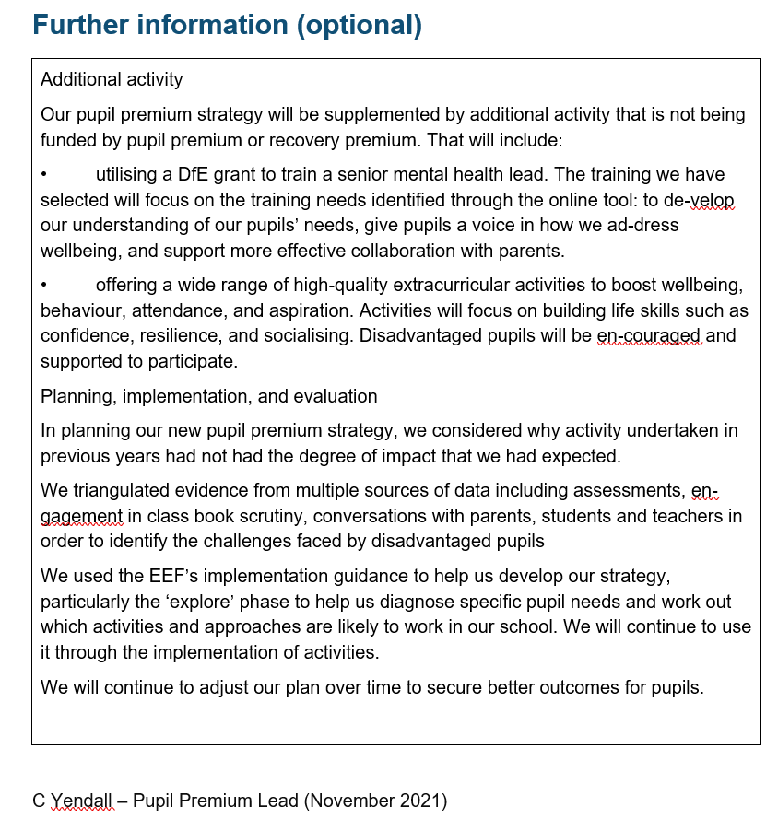

Reviewed September 2022 J Scott