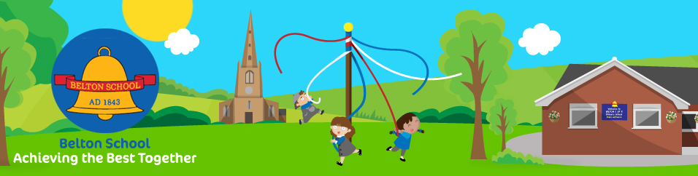
Welcome
to
Belton Church of England
Primary School

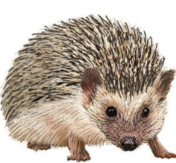

September 2024
Welcome to Belton C of E Primary School.
This booklet tells you about the sort of things you will be doing when you join our school and start in the Hedgehogs Class.
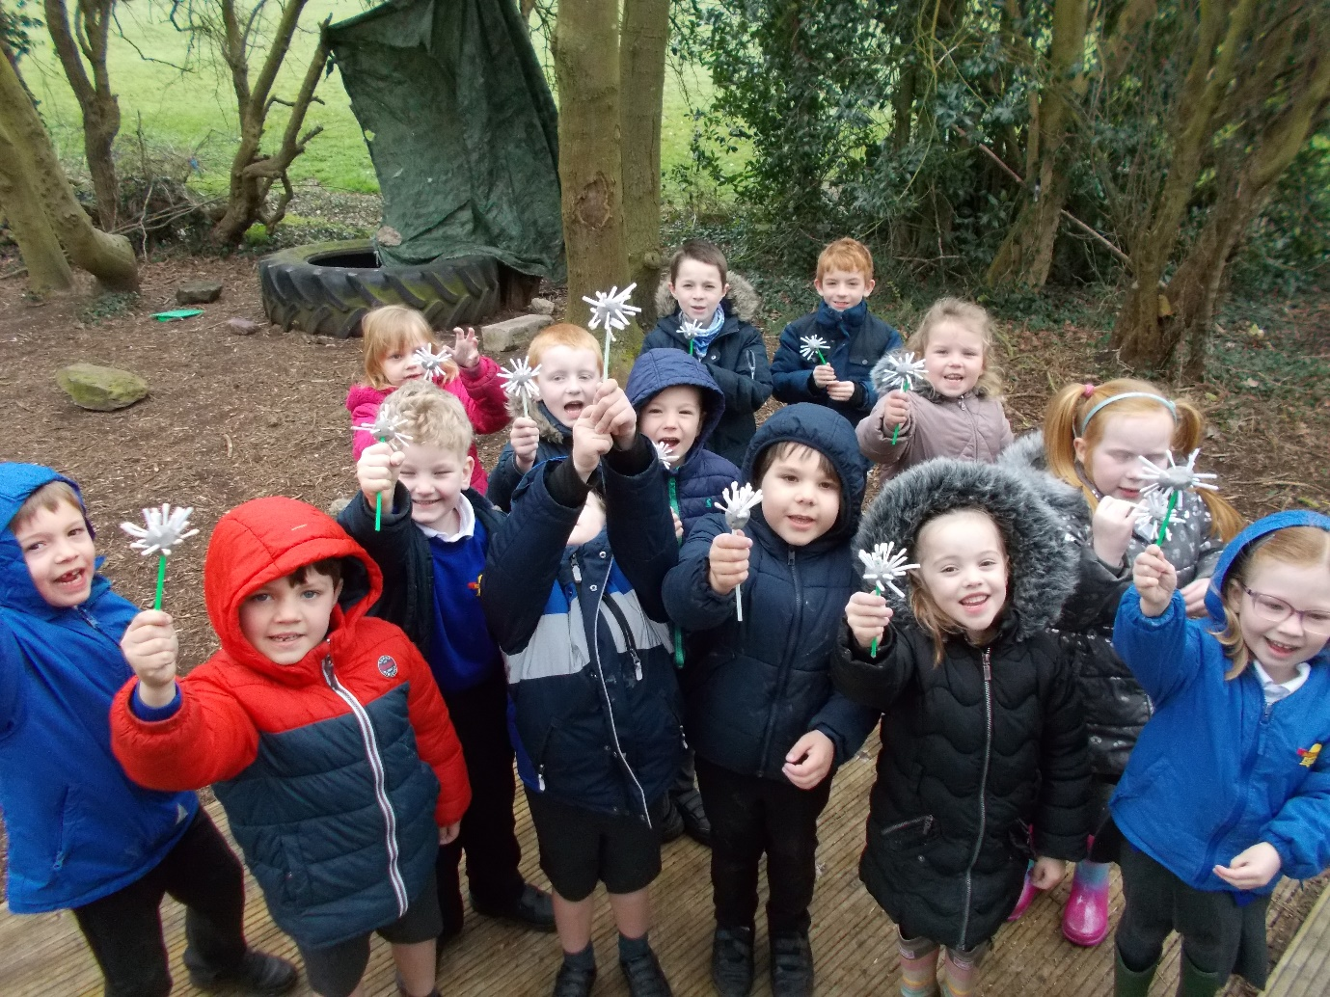

We hope you will have many happy times at our school.
Mrs Ghirardelli
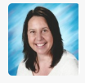
You will be taught by Mrs Ghirardelli, Mrs Peczek and Mrs Scarcliffe.



Mrs Peczek


Mrs Scarcliffe
We like counting and numbers.
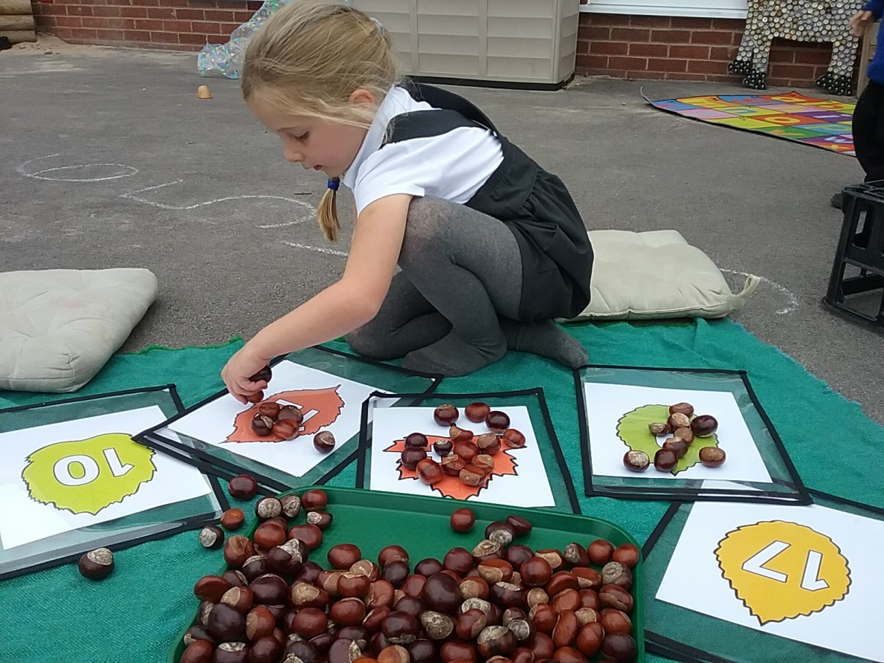
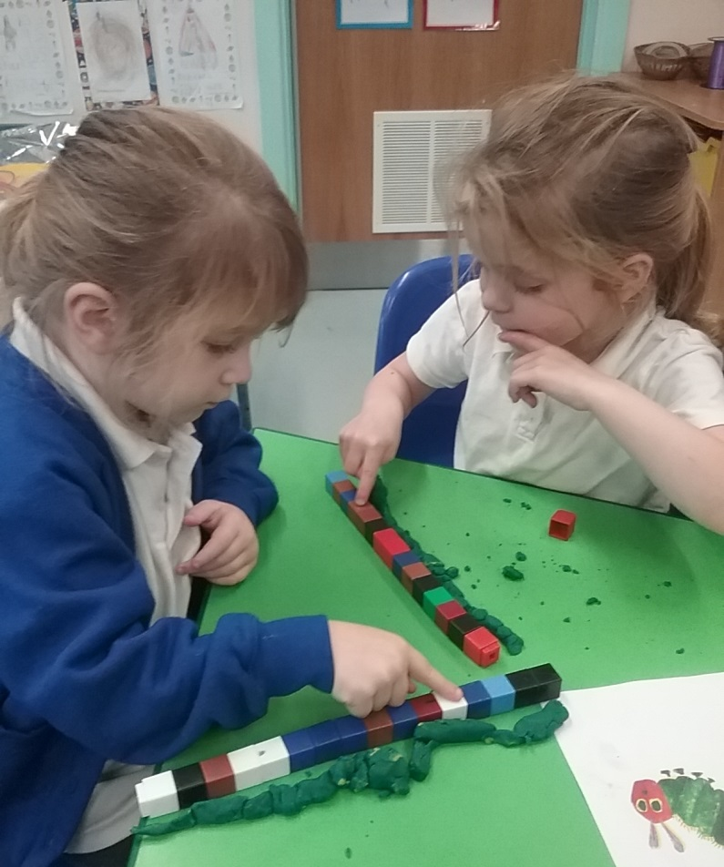
We do lots of drawing and writing.
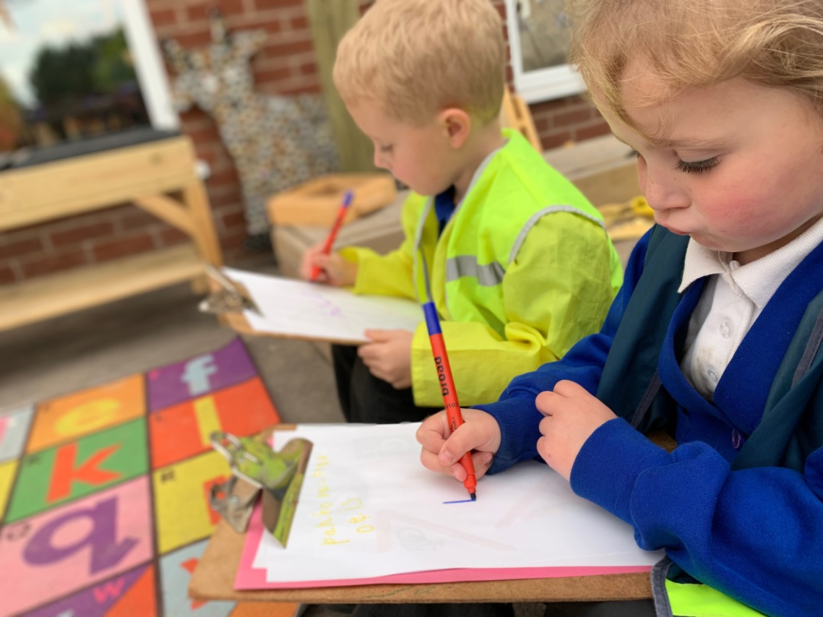
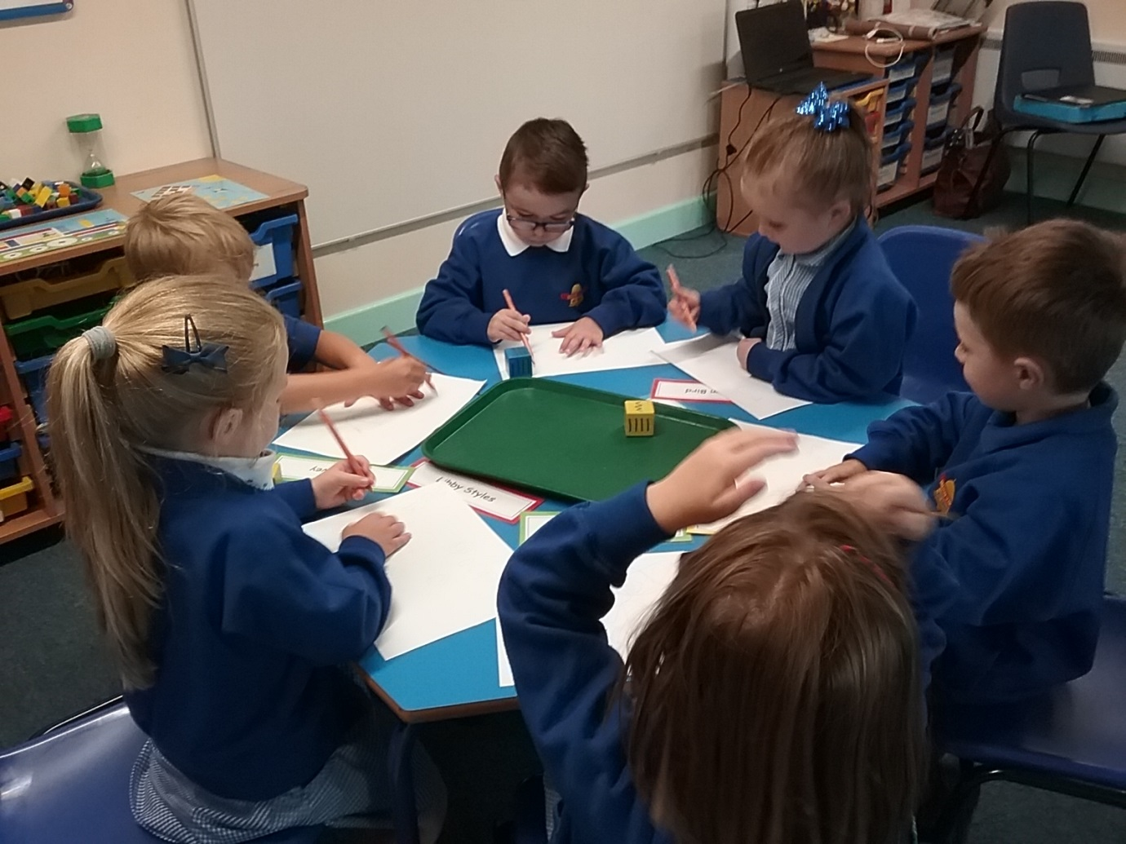
At break time we have milk and fruit and go out to play.
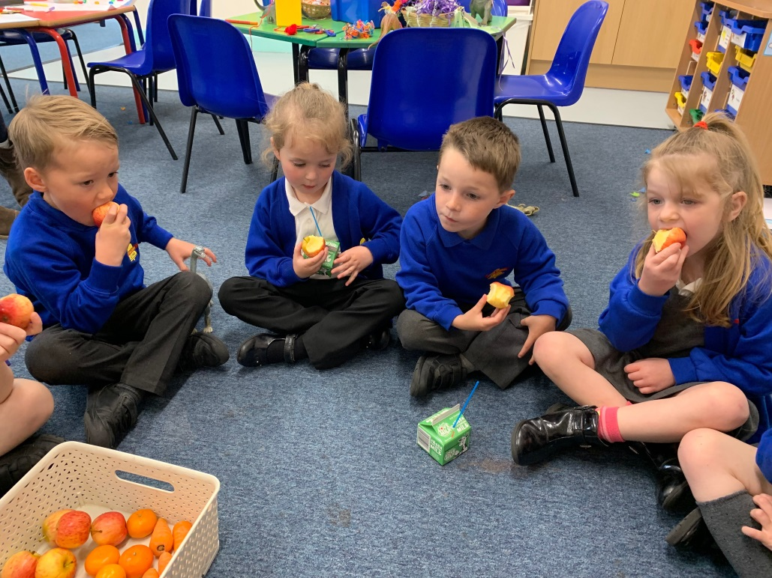
You eat your cooked dinner in the hall.
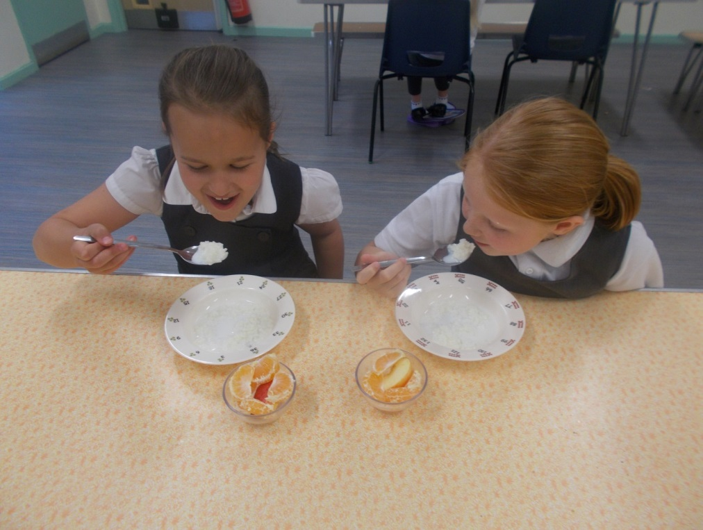
After dinner you go out to play.

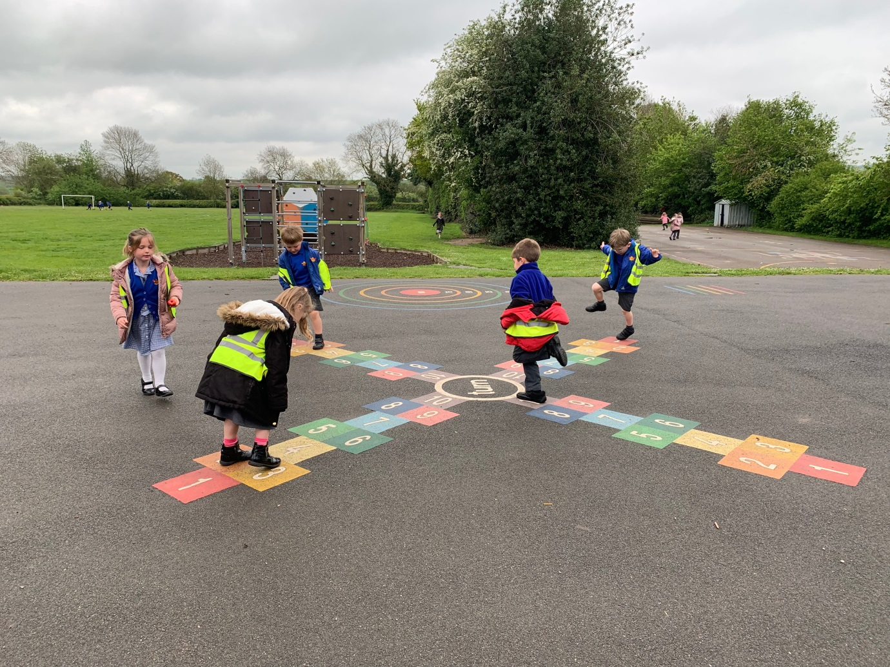

At school we like to make things.

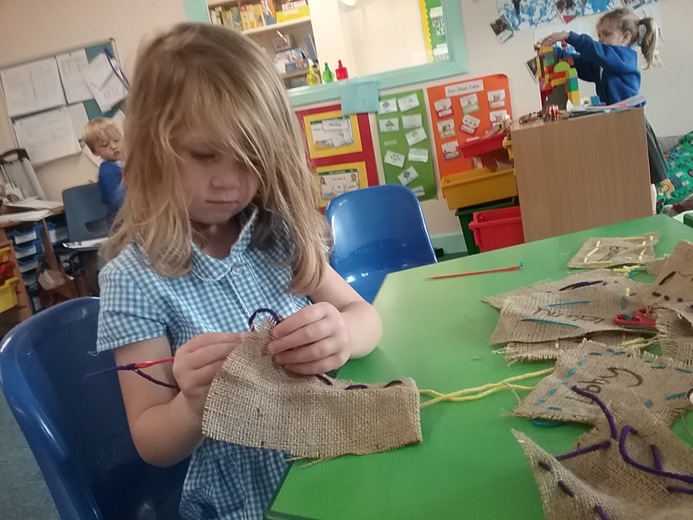

We like to pretend and we dress up.
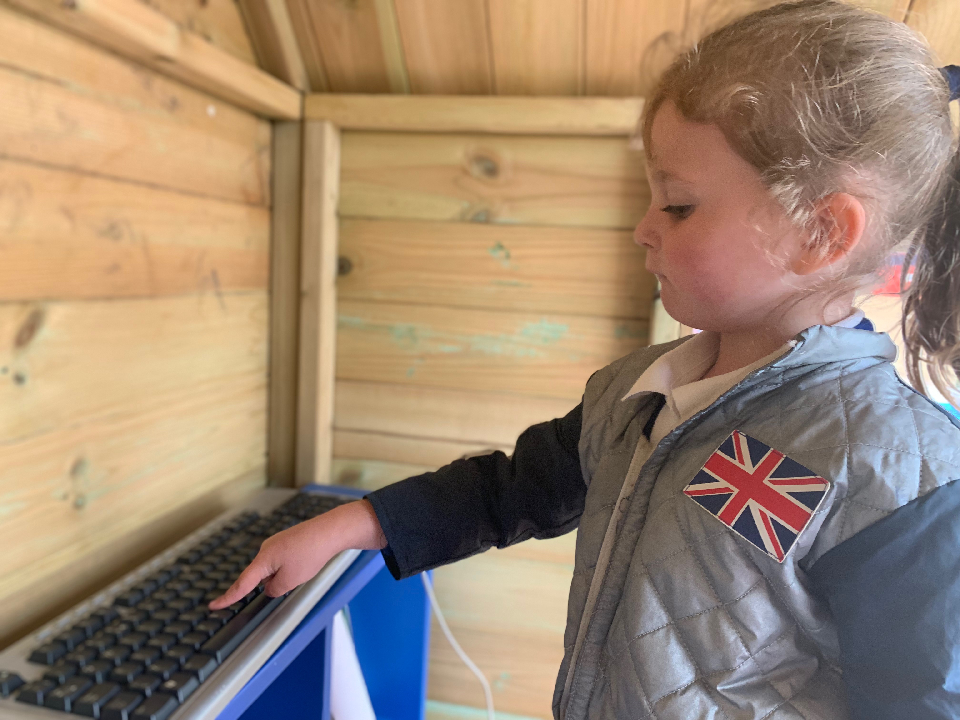

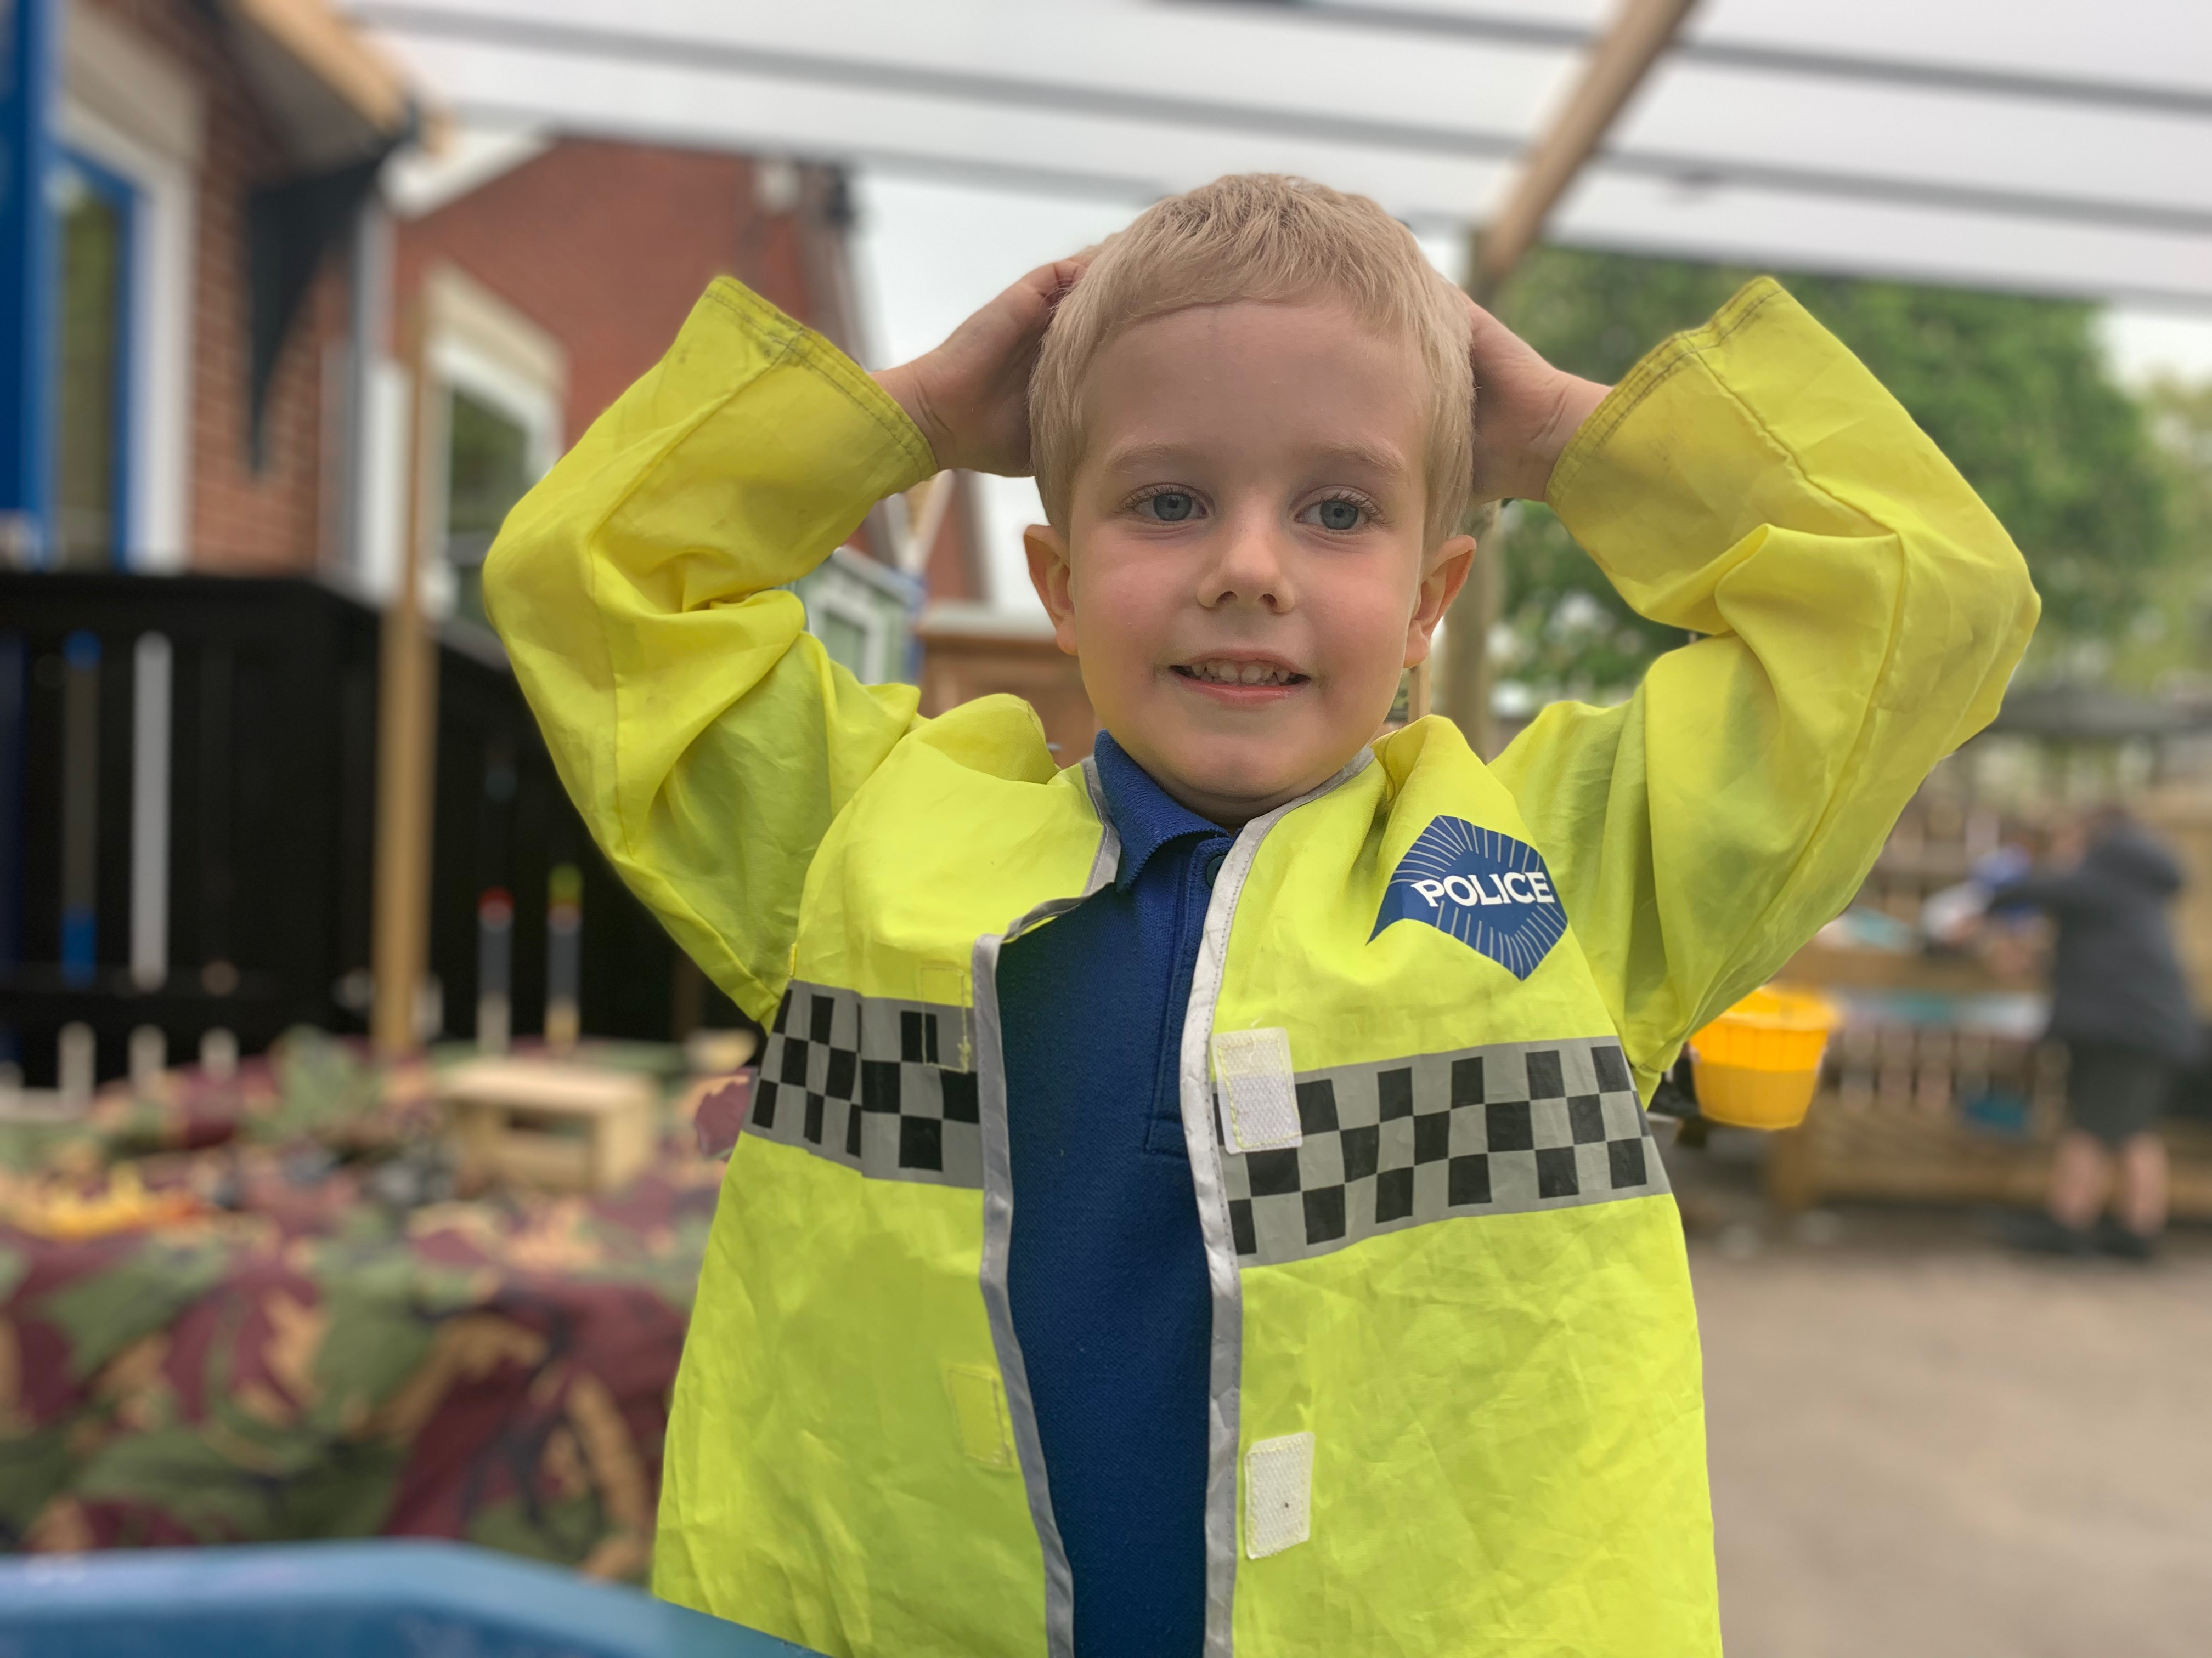

We enjoy playing in our huge sandpit.
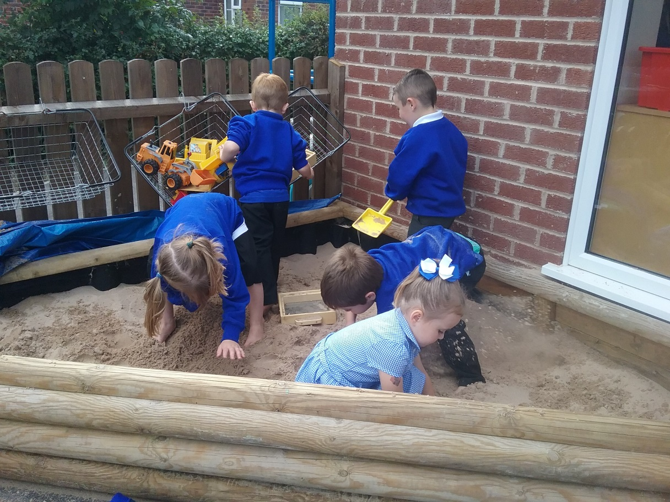
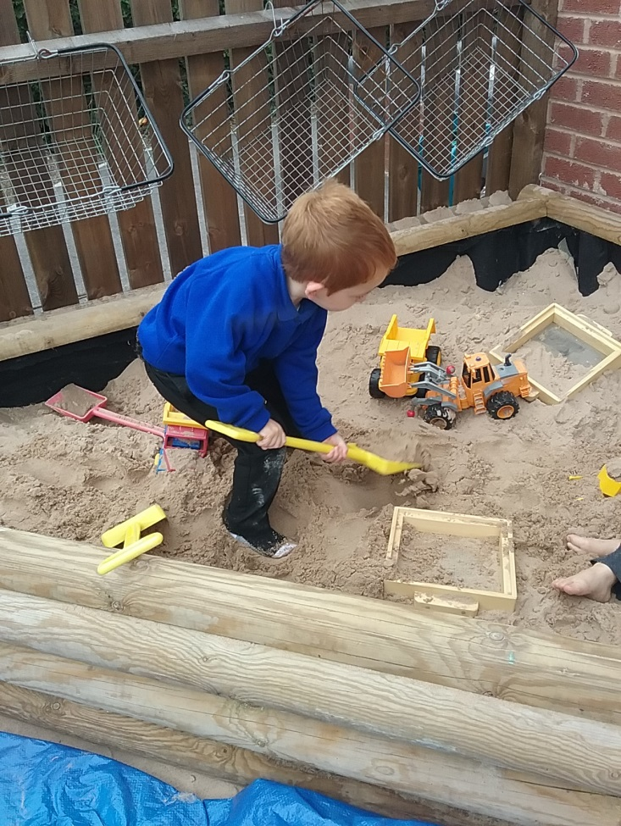
We love our outside area.

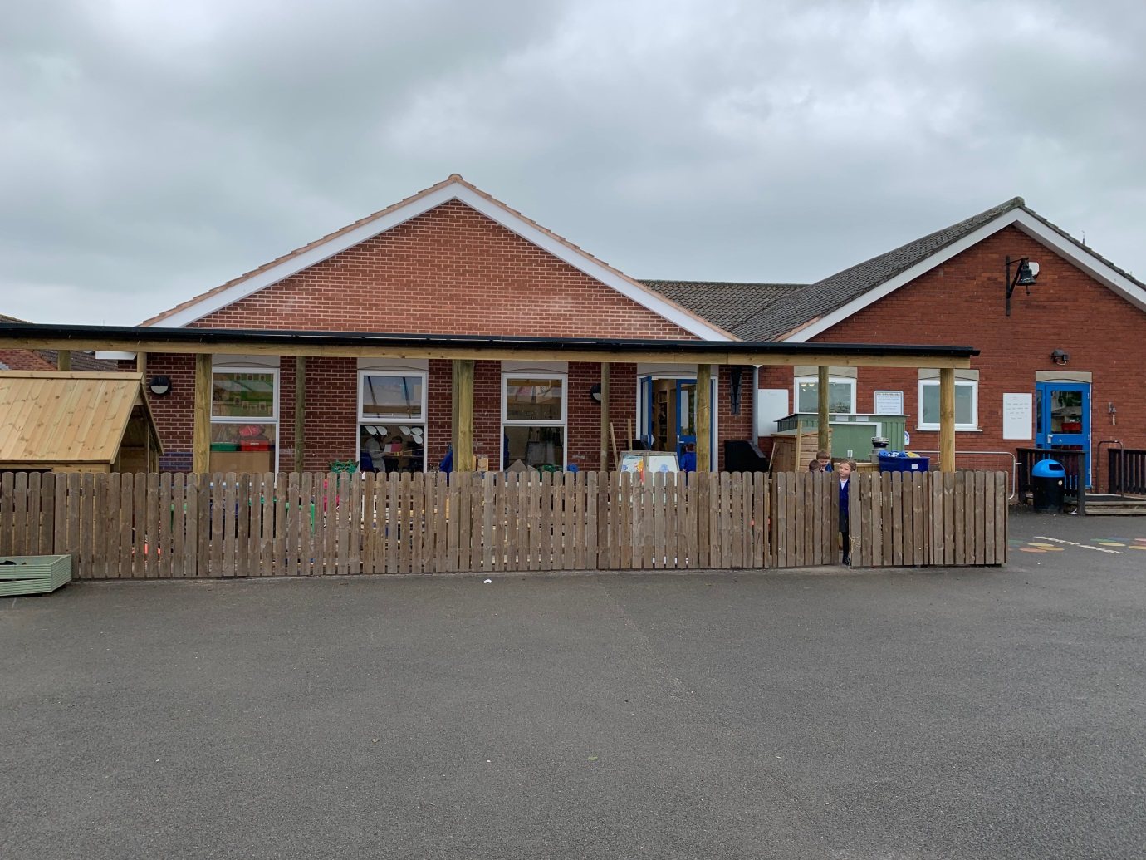

We like to paint.
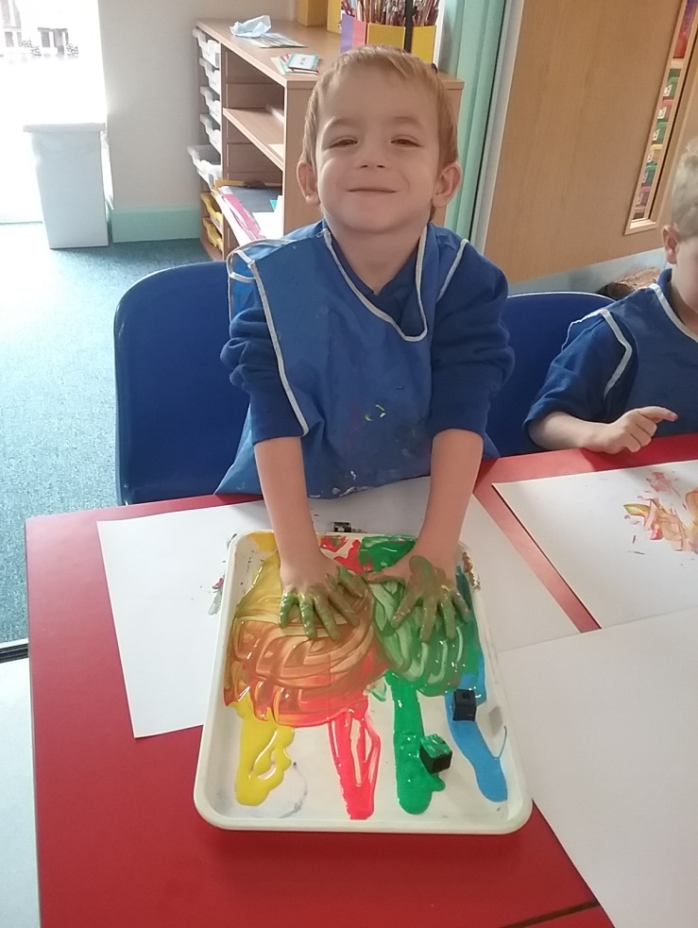
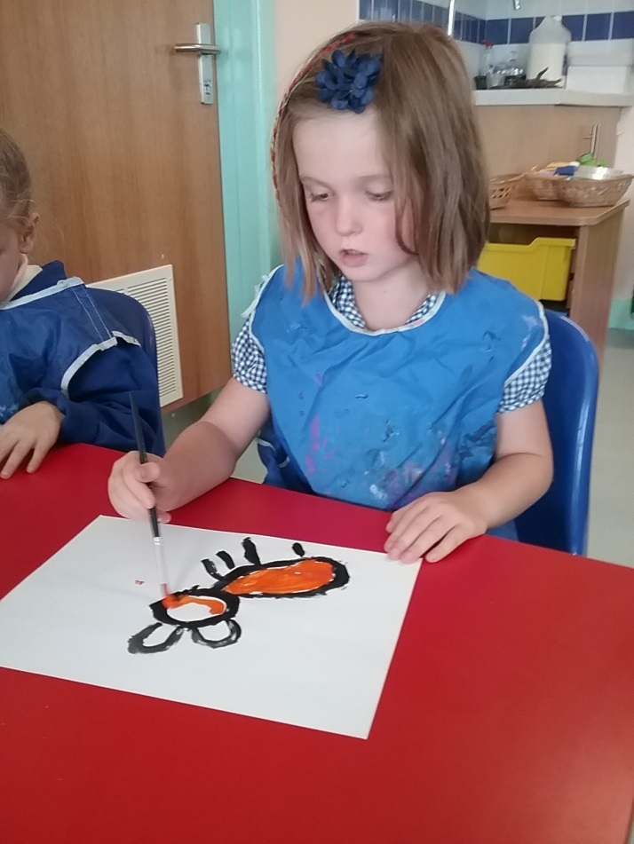
Sometimes we work with an adult.
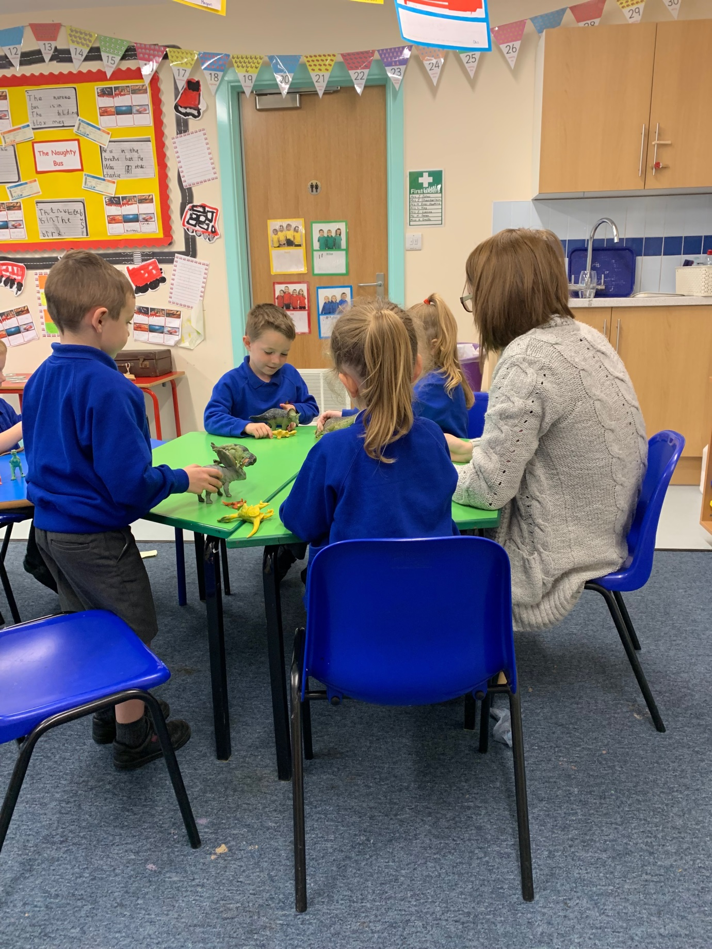
Sometimes we work with a friend.

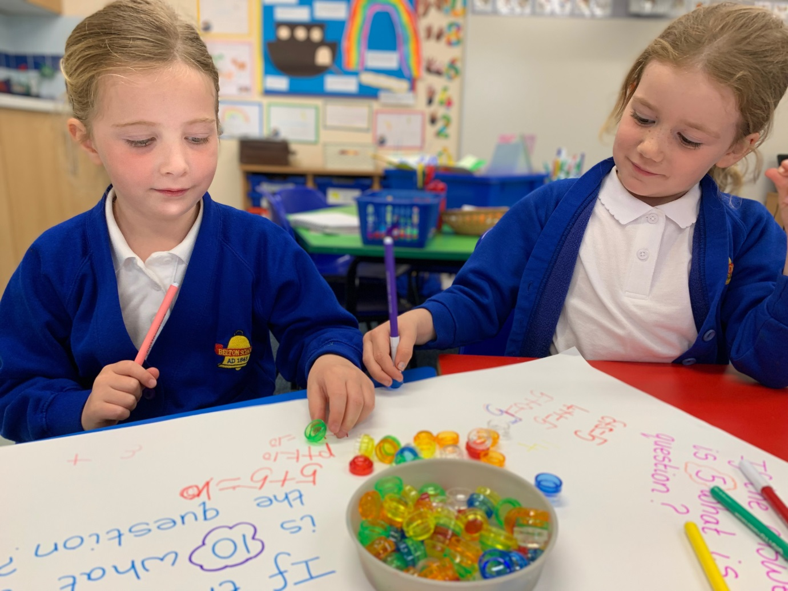

We love playing and being outdoors.
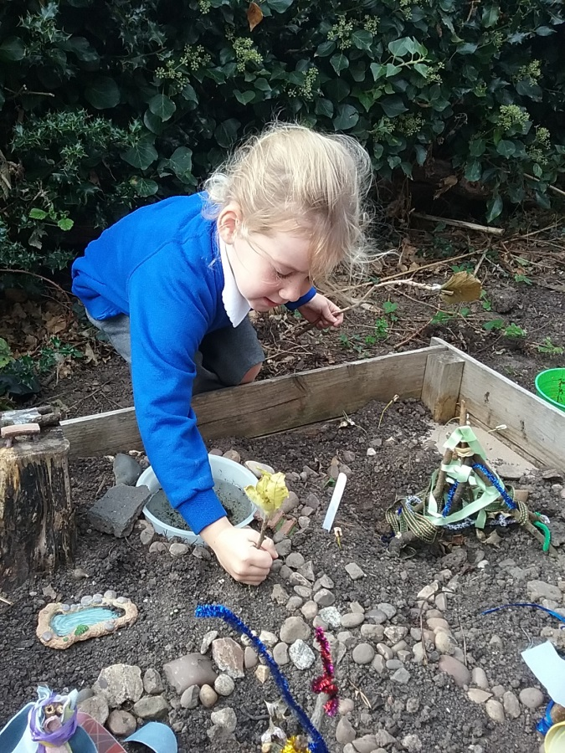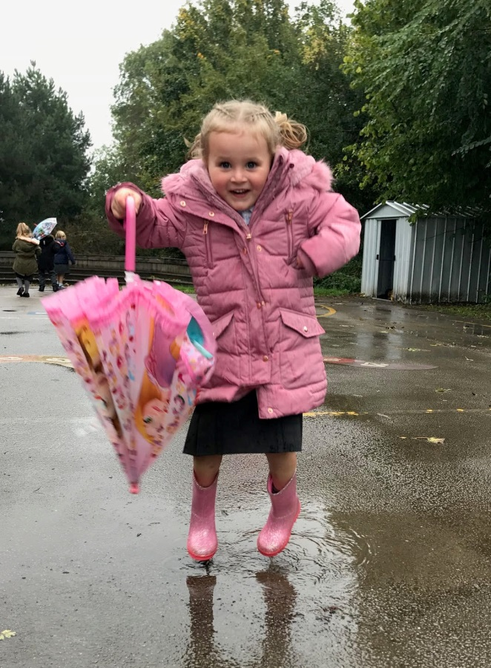
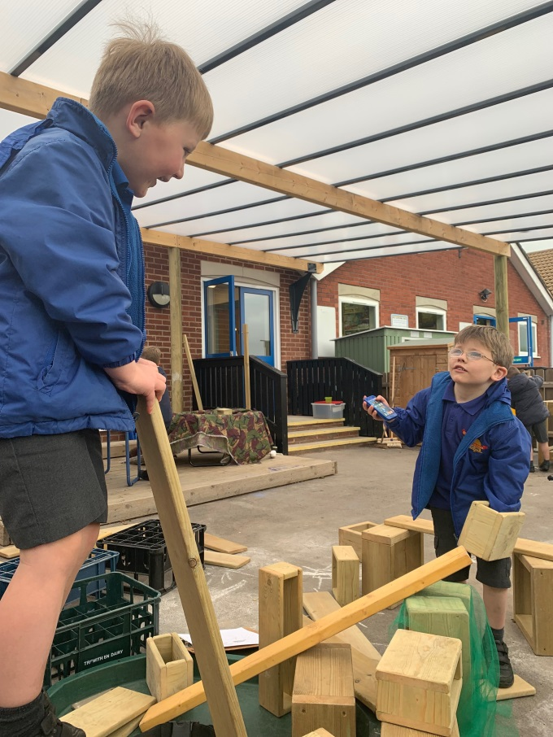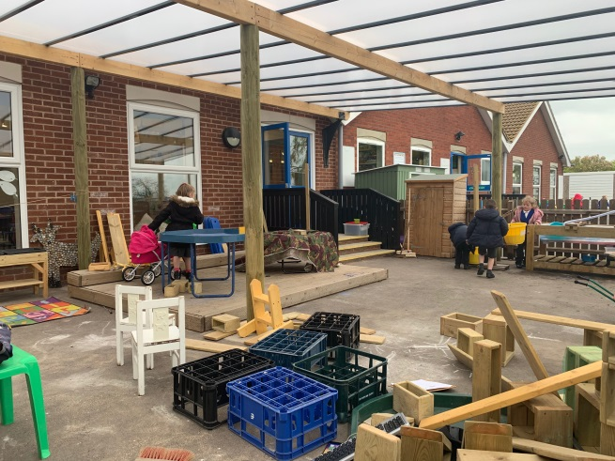
We like sharing books.

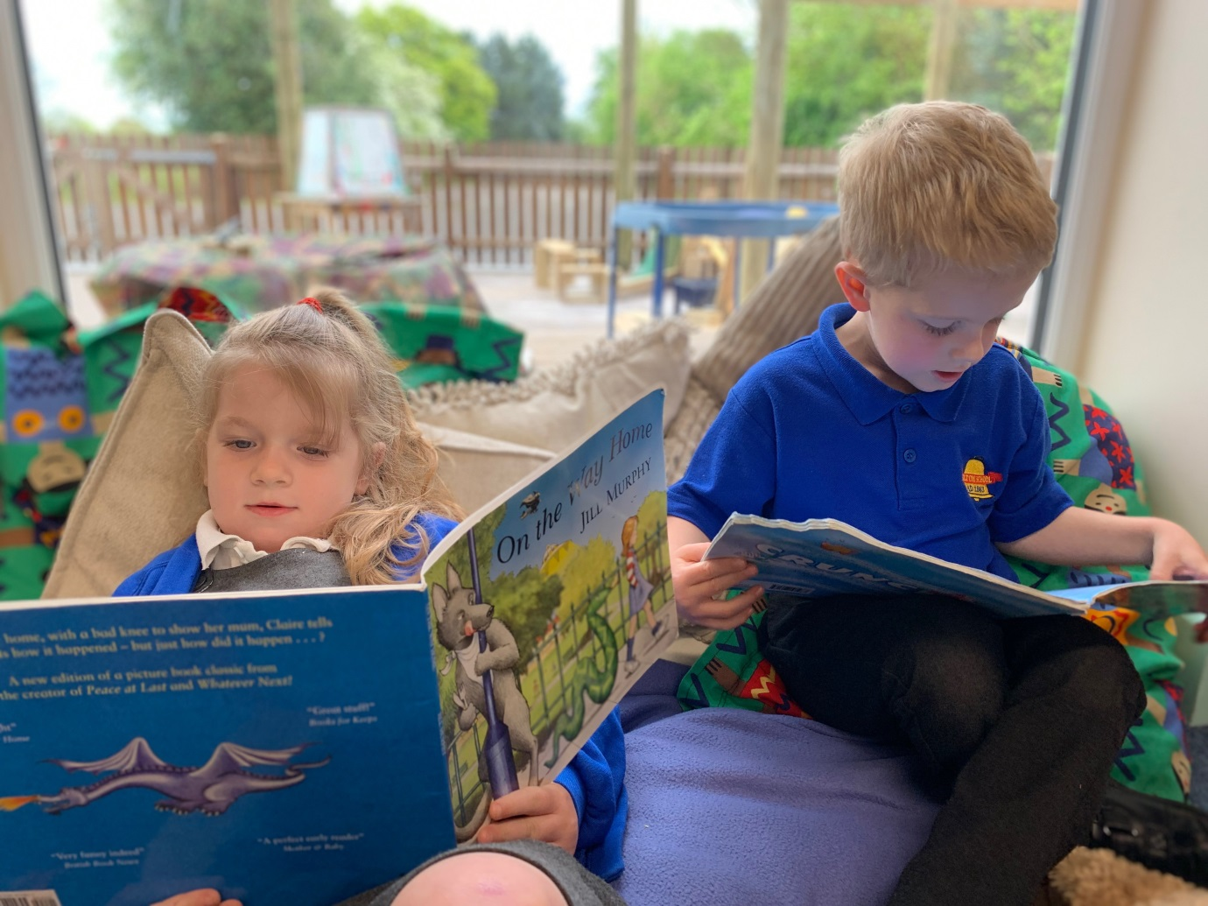

You need both an outdoor and an indoor PE kit:
- long blue or black joggers
- a hoodie in your house colour
- trainers

- a T shirt in your house colour
- blue or black shorts
- black plimsolls
- Spare socks are also very useful
Everything must be named and in a drawstring bag as it’s easy to get things mixed up.

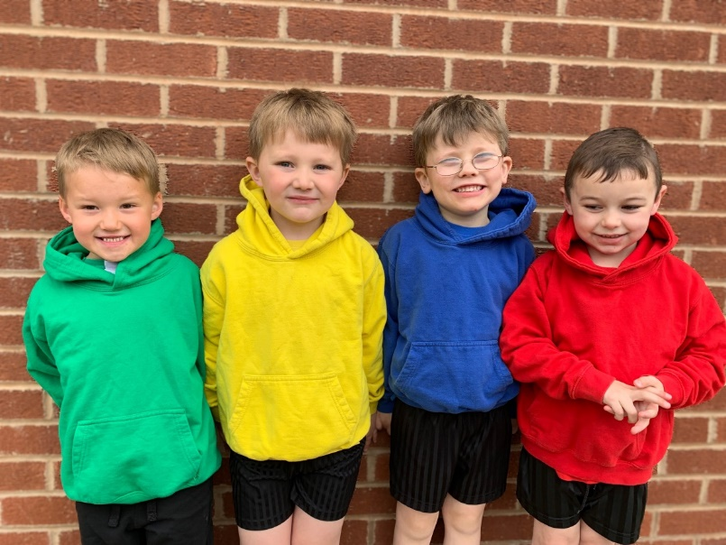
You also need wellies, waterproof trousers and a coat for forest school activities.

