Squirrels – Writing – Staying Safe with Electricity
Key Vocabulary | 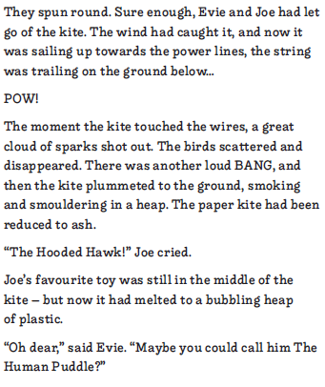  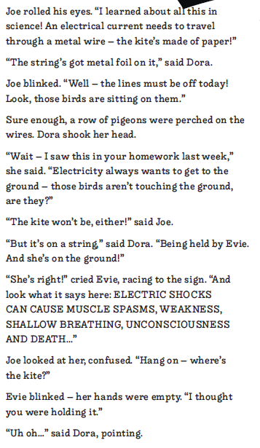  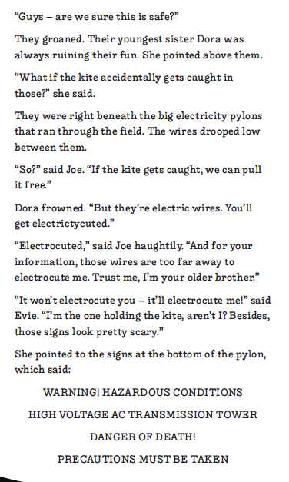  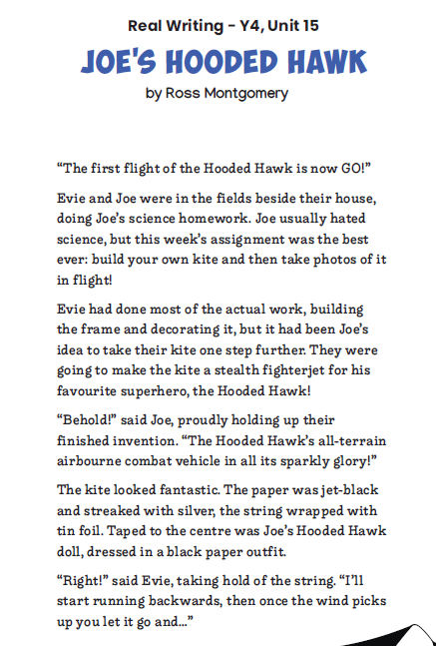 | In this unit, pupils will read an engaging narrative for  children. It is an example of a warning story, where the characters  learn about the dangers of electricity. Pupils will investigate how  the author has created characters, showing their feelings and traits  through dialogue as well as through descriptions. They will also  explore how synonyms and antonyms can be used to describe,  helping to develop their vocabulary choices. In the final writing task,  pupils will follow the structure of the model text to write their own  warning tales about the dangers of electricity.
haughtily
plummet
precaution
shallow
stealth
current
electric
electricuted
voltage
acctidentally

Squirrels - Multiplication and Division
Key Vocabulary | 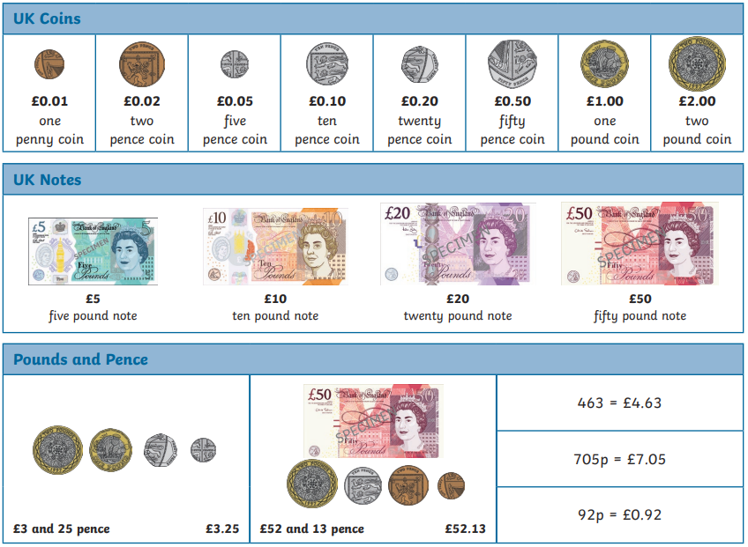
Amount
Change
Combinations
Estimate
Decimal
Pence
Pounds
Round
Value
Convert
Squirrels - Science
electricity | 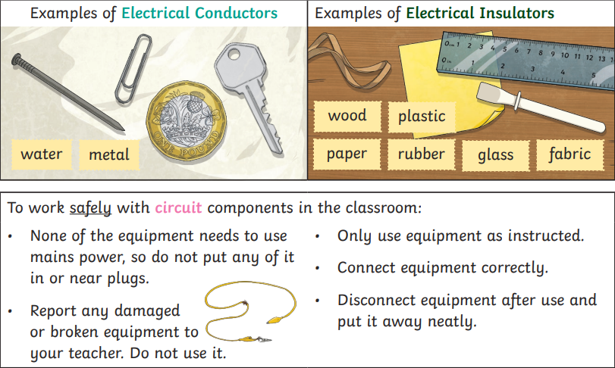  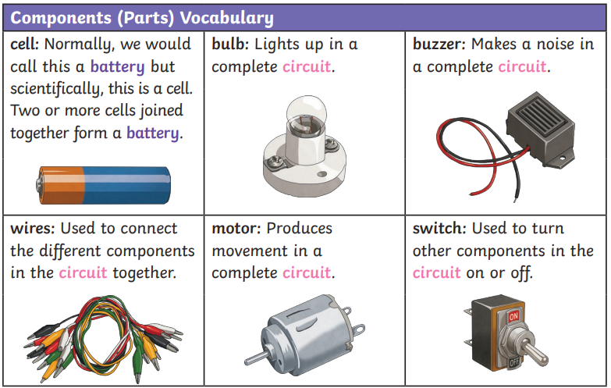  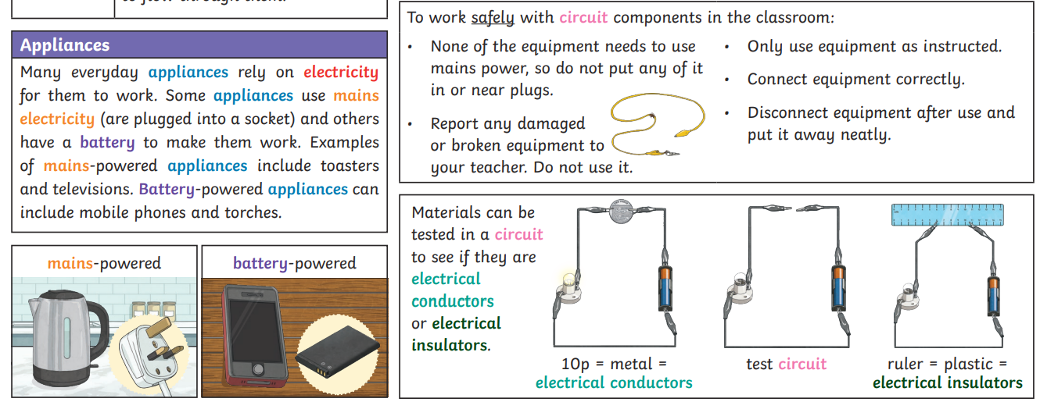
appliances
battery
mains
circuit
conductor
insulator
appliance
power
flow
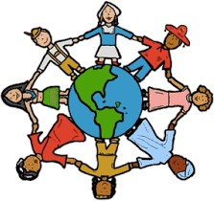

Key Vocabulary:
Deeds | Something that is done. These can be good or bad.
Creator | A person or thing that brings something into existence
Ten Commandments | The Ten Commandments are the fundamental laws of Jewish and Christian people which tell them how they should live.
Humanist | A person who trusts scientific method when it comes to understanding how the world works and rejects the idea of the supernatural. Find out more here https://humanism.org.uk
tikkun olam | A Jewish concept defined by acts of kindness performed to perfect or repair the world.
tzedaka | A Hebrew word meaning "justice" or "righteousness," but commonly used to signify charity
zakah | It is compulsory for Muslims to donate money to charity once a year.
In this unit, children will make connections with prior learning from earlier in the year: what have they already learned about how believers try to live? Why do believers want to follow the commands and teachings of their traditions?
What should I already know:
- Some people pray to their God to ask for forgiveness for their sins (they have disobeyed the creator)
- Christians believe God helps them through the Holy Spirit
- Muslims believe people do good and bad deeds and need God’s mercy
Key Question: How and why do people try to make the world a better place?

Golden Rule - In this unit we will compare religious and non religious ways of being good and making the world a better place.
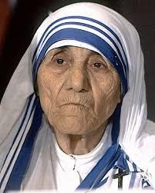
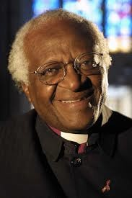
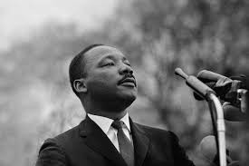
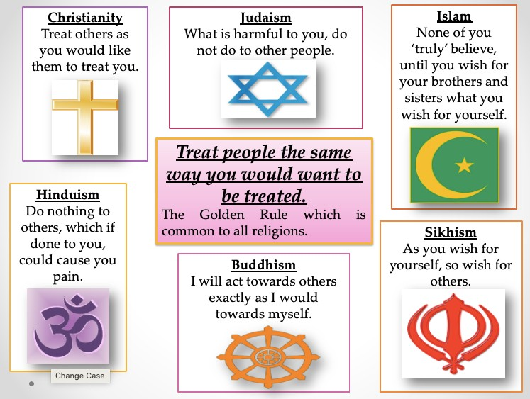

Inspirational Christian figures

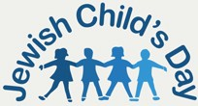
Their religious faith inspired and guided them in their lives, and their contribution to making the world a better

Jewish Child’s Day is a charity set up to help over 12,000 Jewish children from deprivation, disadvantage, abuse and neglect; to nurture them and offer them a better future.

Zakah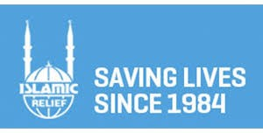
This is one of the 5 pillars of Islam. The charity Islamic Relief is a charity, which Muslims can donate to. They run projects to help make the world a better place.

As writers…
The children will write warning stories which will be around the topic of electricity. This links nicely to our topic in Science. We will focus on the grammatical elements such as the use of apostrophes for possession and contractions.
Then we will move onto another fiction piece based on the Story Echo and Narcissus.

As mathematicians…

We will be looking at money and how we can apply our knowledge of decimals, addition and subtraction.

Then we will move on to shape and position and direction where we look at the features of 2D and 3D shapes. Moreover we will look at coordinates.

As Geographers…
We will look at Florida and how it is a unique place in the world. We will understand why Florida is a hot spot for British tourism and why it is so different compared to other places in America.
As Musicians…
We will be continuing to look at music technology and thinking about how we can use our knowledge of music to create pieces that use various different musical instruments, apps and computer software.

As scientists…
We are looking at electricity where we will construct simple circuits and understand what the different parts of the circuit are.
We will also look at conductors and the different materials that can allow electricity to flow through them.
Overall, we all also think about necessary safety precautions surrounding electricity
In PHSE…

We will be looking at Safety and the body. Year 4 children will have some lessons in growing up and puberty. All children will start to prepare for their transition into the next year.
As people of faith in RE:
We will be looking at ‘How and why do people try to make the world a better place?’ We will look at various different religions and how making the world a better place is an important part of their practices such as giving to charity.

Summer 2
