Squirrels – Place Value
Key Vocabulary | Counting  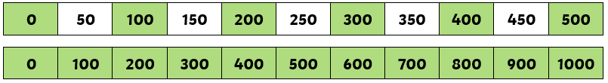
thousands
hundreds
tens | 3 Digit Numbers  256  two hundred fifty six  200 50 6 | 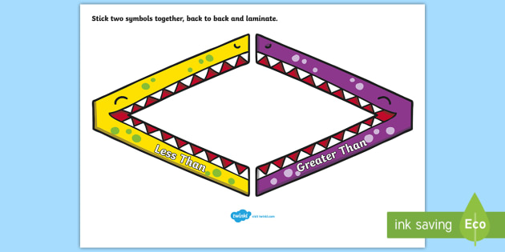  Being able to understand how numbers can be grater than or less than.  10 > 9  3903 < 4320  10 + 1 = 12 – 2
ones
zero
place value |  | Objectives  Year 3 Year 4  - Count in 100’s and 50’s - Represent numbers in 1000 - Thinking about place value of 100’s, 10’s and 1’s. - Number lines to 1000 - Find 1, 10,100 more or less than any given number. - Compare objects and numbers to 1000. - Count in 1000’s and 25’s - Partition numbers - Number lines to 10,000. - Roman Numerals to 100. - 1000 more and 1000 less. - Compare and order numbers. - Rounding to the nearest 10, 100 and 1000. - Negative numbers.
number
numeral
Roman Numeral | 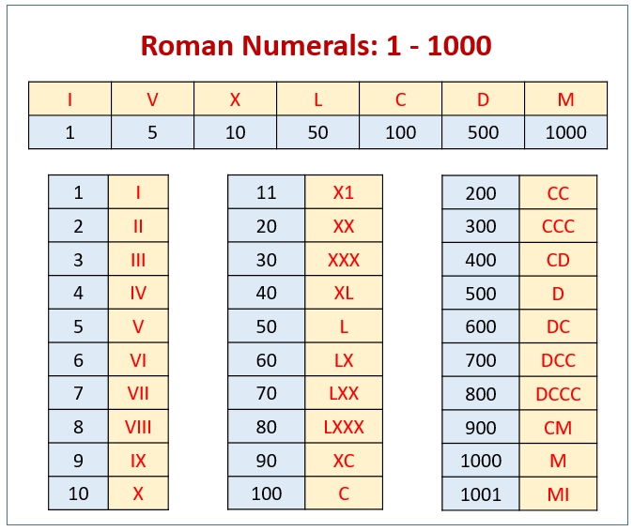  Year 4 – Only  Roman Numerals
digit
negative number

