**Belton C of E Primary**

**Information Report**



**‘Achieving the Best Together’**

**Information Report 2025**

Date: September 2025

Date adopted by Governors: September 2025

Date of review: September 2026

Belton CE Primary School

**‘Achieving the Best Together’**

|  |  |
| --- | --- |
| School Name: | Belton C of E Primary School |
| Address: | Sadlers Wells, Belton, Leicestershire, LE12 9TS |
| Contact telephone Number: | 01530 222304 |
| Head teacher: | Miss J Scott |
| Special Needs Coordinator (SENCO) | Catrin Yendall |
| Website address: | [www.belton.leics.sch.uk](http://www.belton.leics.sch.uk/) |
| Age Range of students | 4 to 11 years |
| Date of Last Inspection: | 3rd October 2023 |
| Outcome of last inspection: | Good |
| Total number of pupils with special educational needs at setting: | 11 |
| Total number of pupils receiving Intervention funding/EHCP: | 0 |

***The kinds of special educational needs for which provision is made at Belton CE Primary School in line with regulation 3 of the Special Educational Needs and Disability (Information) Regulations (2014)***

*Belton CE Primary School prides itself on offering a supportive and caring environment which caters for children with various special educational needs. The School strives to be a fully inclusive school, fostering a sense of community and belonging through:*

1. Personalised learning
2. A Broad, balanced and creative curriculum for all pupils
3. Early identification of barriers to learning
4. High expectations of all pupils

The Government defines a child as having a special need if they have a learning difficulty or disability which calls for special educational provision to be made or has a significant greater difficulty in learning than the majority of others the same age.

We provide SEN support for students with significant needs in the following areas:

The areas of need we support include:

● **Cognition and Learning:** This includes conditions such as dyslexia and dyspraxia, where we implement strategies to enhance understanding and skill development.

● **Communication and Interaction**: We support children with Autism Spectrum Disorder (ASD), Asperger’s Syndrome, and various speech and language difficulties, facilitating effective communication and social interaction.

● **Sensory and/or Physical Needs:** Our provisions cater to students with visual impairments, hearing impairments, processing difficulties, and conditions like epilepsy, ensuring they can access learning in a comfortable and accommodating environment.

● **Social, Emotional, and Mental Health**: We address needs related to attention deficit hyperactivity disorder (ADHD), attention deficit disorder (ADD), and attachment disorders by promoting emotional well-being and social skills.

The four significant areas can be classified into core, additional and high needs. Some children require minimal interventions and support whilst others need additional support to raise their learning. The school will also provide provision for children on an Education Health and Care Plan (EHCP) which require high needs.

***Information about the school’s policies for the identification and assessment of pupils with special educational needs:***

At Belton, we are committed to identifying and supporting children with SEND in accordance to the SEND Code of Practice.

We identify pupils with special educational needs through teacher’s observations and assessments, previous school information. Staff fill out an initial concerns form to refer a child to the SENDCo.

***Evidence would come from:***

1. **Assessments and teacher observations:** Our staff closely monitor children’s behaviour and performance to identify any areas of concern.
2. **Parental/carers input:** We value discussions with parents and caregivers, considering their observations as vital components of our assessment process.
3. **Medical notes**
4. **Reports from other agencies**
5. **Child’s Views:** We encourage children to share their thoughts and feelings about their learning experiences which helps with their learning journey.
6. **Feedback from previous settings:** Information gathered from prior educational settings can provide important contexts regarding a child’s needs.

Children are regularly assessed through progress monitoring, assessment for learning (AFL), and a graduated approach to teaching. This allows us to identify those whose progress is:

**● Significantly Slower:** Children whose development is markedly behind that of their peers from the same starting point.

**● Demonstrating Gaps in Attainment:** Identifying discrepancies in academic performance compared to their peers.

It is important to note that slow progress or low attainment alone does not automatically classify a pupil as having SEND. Our assessments are thorough and consider a variety of factors to ensure each child receives the appropriate support needed to thrive.

Teachers who have concerns about a pupil will alert the SENCO and parents/carers will be involved in assessment and decision making. Parents/carers are regularly updated on their child’s progress and new targets set. Parents are given any support they need in this process.

**Belton CE Primary School’s policies for making provision for pupils with special educational needs whether or not pupils have Education Health Care Plans (ECH):**

***The provision for pupils with special educational needs is evaluated and monitored in the following way:***

1. At Belton C. of E. Primary School, we are committed to fostering each child's growth through our graduated approach to teaching, which incorporates the four-part cycle of Assess, Plan, Do, and Review. This systematic framework allows us to thoroughly analyse

each pupil's needs and provide tailored support that enhances their learning experience.

1. Regular assessments
2. Data analysis to monitor pupils not making expected progress and act on it.
3. Updating of the provision map to make sure pupils are receiving the correct support
4. Include views of parents/carers

***b. Our arrangements for assessing and reviewing the progress of pupils with special educational needs:***

1. Effective systems are in place to track and review individual pupil progress and to target intervention.
2. The effectiveness of intervention programmes is evaluated and reviewed on a regular basis, and Staff meeting time is spent on reviewing attainment and progress for all children in the school.

***c. Our approach to teaching pupils with special educational needs:***

A wide range of multi- sensory teaching styles are used so all children progress in lessons through first quality teaching, or in small group sessions. Staff have a good knowledge of pupils' learning needs and will scaffold and adapt tasks accordingly. Resources are used appropriately and reviewed regarding their effectiveness.

Our range of interventions is designed to address diverse learning requirements and includes:

Spelling/ Phonics interventions: Targeted support to improve spelling proficiency.

Maths interventions: Targeted support for foundational Maths skills and addressing gaps.

Literacy Gold:- Provides pupils with the skills and knowledge they need to read and spell, progressing systematically with carefully structures, small and cumulative steps.

Neli (4-5 years old) - identifying early language difficulties and is proven to improve children's language skills and behaviour

Social Skills Groups – Facilitating interactions among peers to enhance social understanding and co-operation.

Reading Intervention – Focussed strategies to boost reading skills and intervention.

***d. How the school adapts the curriculum and learning environment for pupils with special educational needs:***

***The following are used:***

1. Resources recommended by specialists or outside agencies
2. LSA time for extra support
3. Ability or Mixed Ability Grouping
4. One on one support/ small group support:- Providing individualised attention to address specific learning needs.
5. Visual timetables, and Makaton signs and symbols are used when appropriate
6. Scaffolding
7. Pre and post teaching
8. Targeted small group work: Creating focused learning experiences that foster collaboration and peer support.
9. Utilising Recommended Equipment: Implementing tools such as Chromebooks, coloured overlays, visual timetables, sensory break areas, fidget toys to support learning.
10. Pre-teach of vocabulary: Ensuring that key concepts are taught prior to the lesson to enable understanding.

All staff have undertaken training on adaptive teaching which enables them to modify tasks to match the varying needs of each pupil.

***e. How the school provides additional support for learning that is available to pupils with special educational needs:***

1. Personalised curriculums are devised using the small steps approach working in small groups.
2. Children work in small groups or on a one to one basis with the TA.
3. Where appropriate classes have an LSA to support to help meet the needs of pupils with SEND in the classroom.
4. Learning targets/next steps are shared with parents so that children can practice and refine skills at home. Some children are supported with homework tasks built around weaker areas.

***f. Activities available for pupils with special educational needs in addition to those available in accordance with the curriculum:***

1. The school runs clubs within the school day. This includes an after-school run by the school staff.
2. There are a wide variety of clubs that offer *sporting*, *physical and creative* and *thinking challenges*.
3. Residential visits, and day visits are used to support specific groups of children, and the school offers this to partner schools to bring children together with similar needs.

To facilitate participation, we create tailored individual risk assessments where necessary, identifying any additional provisions required to support our children with SEND.

Our philosophy is clear: no pupil will be excluded from these enriching activities due to their SEND or disability. We assess and implement appropriate measures to ensure that each child can fully participate and benefit from the school experience. By prioritising inclusivity, we create a supportive atmosphere where every child can thrive.

***g. Support that is available for improving the emotional and social development of pupils with special educational needs:***

1. We provide Social Communication groups and Forest school activities.

2. We ensure there is good behaviour management which allows staff to recognise when pupils might be encountering difficulties.

1. Each classroom has a space to retreat to or the pupil may spend some time away from the classroom to gather their thoughts.
2. PSHE lessons:- Our Personal, Social, Health and Economic Education follows KAPOW, equipping children with essential life skills.
3. Nurture groups – opportunity for children to engage in gardening, cooking, artwork while talking about their feelings.
4. School Council – Elected representatives from each class who voice their peers’ thoughts and feelings, fostering a sense of responsibility and community involvement.

***Information about the expertise and training of staff in relation to children and young people with special educational needs and about how specialist expertise will be secured***:

1. KS1 and 2 staff have attended training on Dyslexia, Autism Awareness, trauma, dyscalculia
2. Our support staff have been trained in ACES, dyslexia, MELSA, autism awareness as well as specific interventions.
3. The school SENCO attends partnership meetings and draws on the experiences of others within the cluster group where necessary.
4. Other outside agencies are involved when required. This may include Educational Psychologist, Speech and Language, CAHMS, Oakfield School, Behaviour and Attendance, Autism Outreach, and GPs as appropriate.

As a school we actively encourage all staff to engage in Continuing Professional Development (CPD) and training opportunities. This enables us to remain adept and knowledgeable in the latest practices of supporting children with SEND.

***Information about how equipment and facilities to support children and young people with special educational needs will be secured:***

***The following facilities are available at this school:***

1. Provision for special diets
2. A wide range of outdoor areas for lessons to take place outside
3. Wheelchair access
4. There is a disabled toilet
5. Disabled parking bay

***The arrangements for consulting young people with special educational needs about, and involving them in, their education:***

1. Pupils are invited with their parents to contribute towards Support Plan / EHC meetings.
2. Pupil Voice is undertaken regularly to aid in our SEND provision.
3. We have a house point that motivates the children and the children are encouraged to evaluate their own work.

***Any arrangements made by the governing body or the proprietor relating to the treatment of complaints from parents and carers of pupils with special educational needs concerning the provision made at the setting*:**

1. Our school has an “Open door” policy and parents /carers are able to talk to staff in the morning and at the end of the school day.
2. All staff, including the Headteacher are regularly available in the morning and after school for parents.
3. Governors become involved if complaints are made (see Complaints policy).

***The contact details of support services for the parents and carers of pupils with special educational needs, including those for arrangements made in accordance with clause 32:***

1. As a school we encourage and engage parents/carers in their child’s learning by holding information events and meeting with parents regularly.
2. We support parents/carers in liaising with any outside agencies that become involved with their child.
3. Contact the SENCO via the school office:- [office@beltonprimary.org](mailto:office@beltonprimary.org)

***Contact Information for Raising Concerns***

Parents and carers are encouraged to raise any concerns with their child's class teacher first. The teacher may provide guidance or assistance regarding the issue within the classroom. This discussion will be documented and communicated to the SENDCO for further support and follow-up. Your involvement is vital in ensuring the best outcomes for your child.

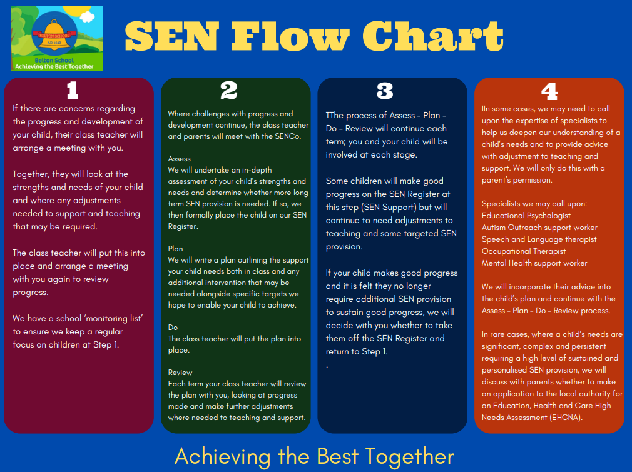

***The school’s arrangements for supporting pupils with special educational needs in transferring to a new education phase:***

1. Meetings are held regularly to discuss pupils with special educational needs as they move through EYFS to year 6 at our school.
2. Where necessary, photographs of the new class and staff are taken to help children. The majority of children move to Iveshead School or their new school at year 6.
3. The SENCOs from both schools meet to pass information on as well as the current class teacher.
4. Year 6 children have 2 days of induction at Iveshead school (or other local secondary schools) and any children who need extra time at their new school are able to go for further visits, accompanied by a member of staff from Belton if needed.

**The Local Authority Local Offer**

The Local Offer is a comprehensive resource provided by the Local Authority, featuring a website, Facebook page, and directory of support services designed for children with Special Educational Needs and Disabilities (SEND) and their families. This initiative aims to ensure that families can easily access information about available services, support options, and local resources to meet the unique needs of their children.

[https://www.leicestershire.gov.uk/education-and-children/special-educational-needs-and- disability](https://www.leicestershire.gov.uk/education-and-children/special-educational-needs-and-%20disability)

***Should you have any worries about any area of Special Needs and your child at starting school, please contact the SENDCO who will be more than willing to arrange a meeting to discuss any areas not covered.***