Early Years Mathematics
Intent
Our whole school approach to the teaching of mathematics aims to give all of our pupils the opportunity to develop their skills in the three aims of mathematics – Fluency, Reasoning and Problem Solving. We teach a mastery curriculum, ensuring pupils have access to a wide range of activities to practise each skill and all abilities must have the opportunities to reason and problem solve. We aim for all pupils to be able to describe, explain, convince, justify and prove their answers.

Implementation
At Belton Primary school, we follow the White Rose planning for Maths. This ensures that the positive start the pupils make in the Early Years continues with clear progression and consistency throughout the school.
Planning is split into three week units.
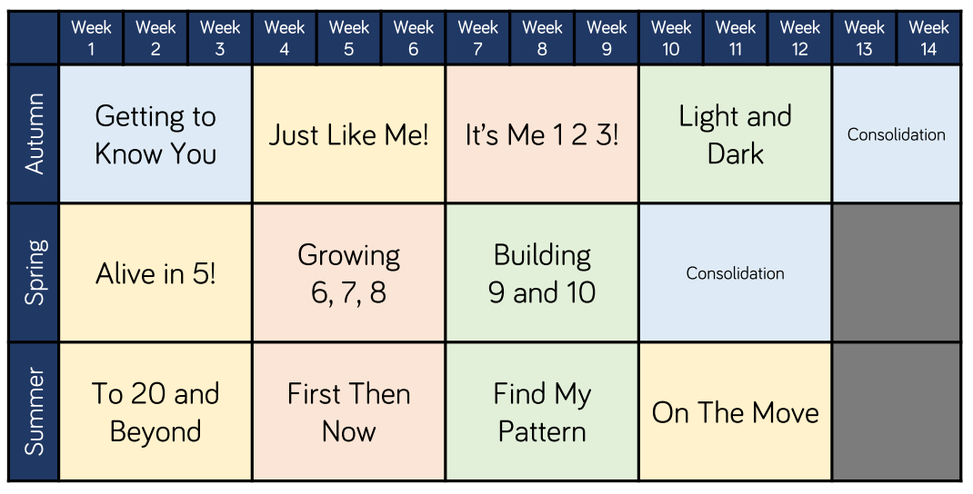

Autumn Term
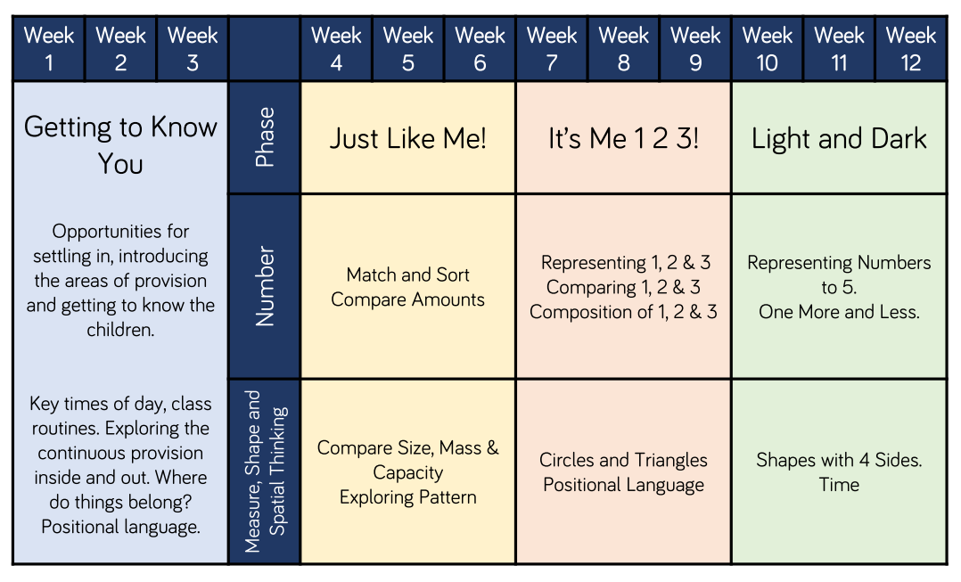

Spring Term
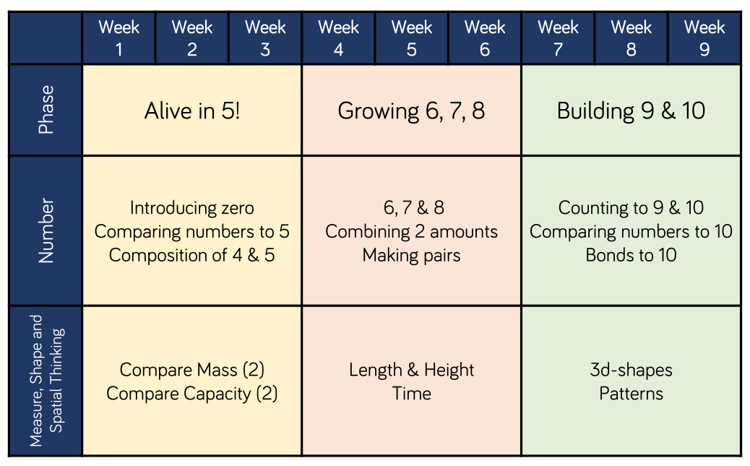

Summer Term
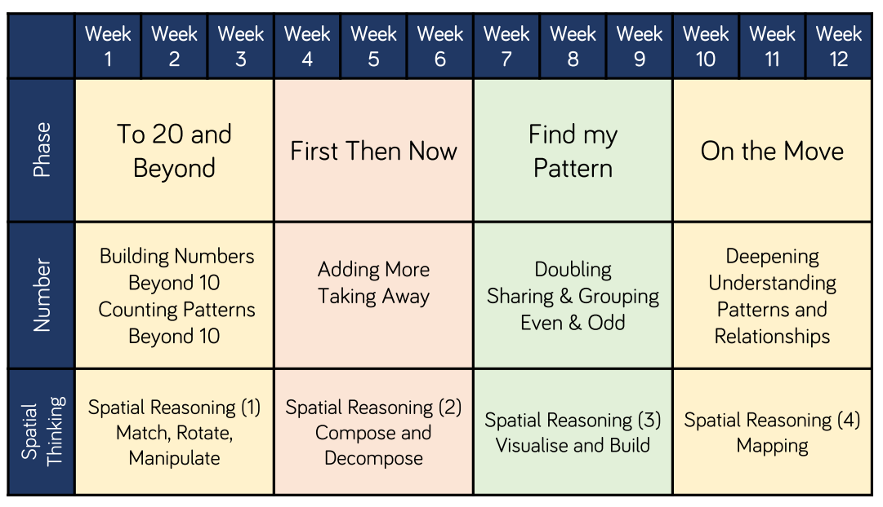

Our early years curriculum focuses on developing a really strong sense of numbers to 10. This will stand our pupils in good stead for the maths that follows as they move throughout the school. They learn a deep understanding of the link between numbers and quantity and represent numbers in many different ways.
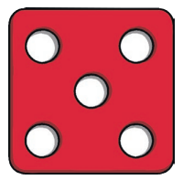
Our pupils investigate how quantities are composed of smaller parts (e.g. 6 can be made of two 3s or three 2s). They learn how numbers relate to one another and learn to compare and order them. They explore how quantities change when you add more items or take items away. Our pupils may be able to recite the number names to twenty and beyond but a sense of what those numbers mean develops gradually with repeated experiences with different contexts and that is what we create and teach within the Early Years Foundation Stage.
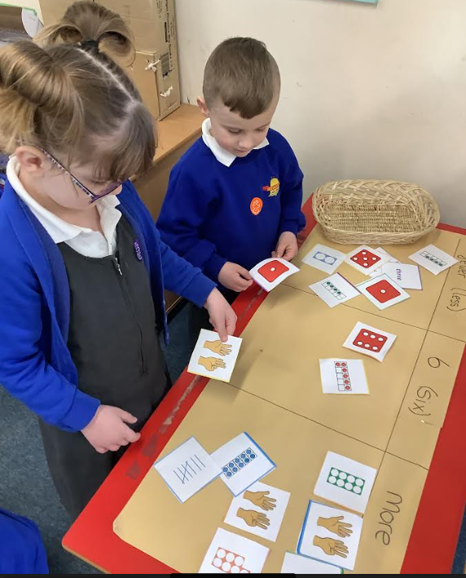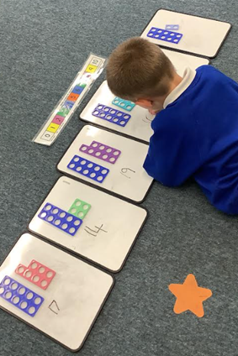
Mathematical Vocabulary
Mathematical vocabulary is an essential part of our teaching which is built upon as each pupil progresses throughout our school. We verbalise the thinking we would like our pupils to demonstrate e.g. “I can see five spots and two more so, I can start from 5… 5,6,7. There are 7 spots altogether”.
We use a ‘my turn, your turn’ approach with the teacher providing stem sentences for our pupils to communicate their ideas with mathematical precision and clarity. With lots of paired work and practise, these sentences then become part of the children’s every day vocabulary.
Our lessons are practical, hands on and engaging. They give our pupils the opportunity to use a variety of manipulatives such as Numicon, counting bears, tens frames, part whole models, their fingers, counters, dice and playing cards.
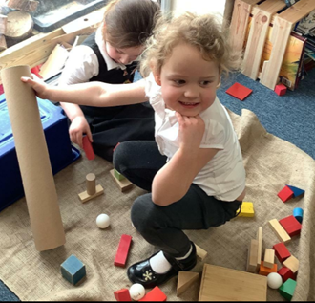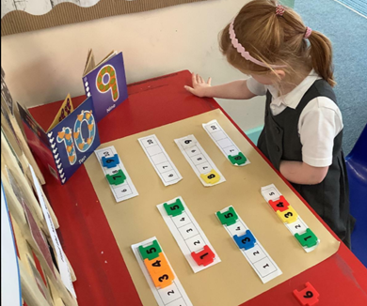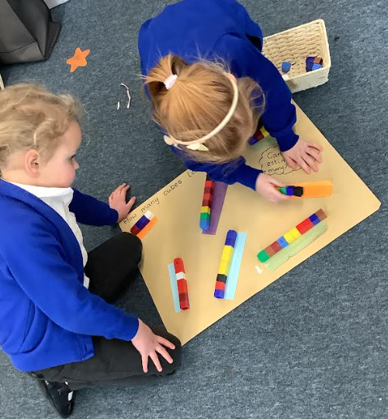

Supporting Story Books
Story books are used to help our pupils see maths in different contexts. 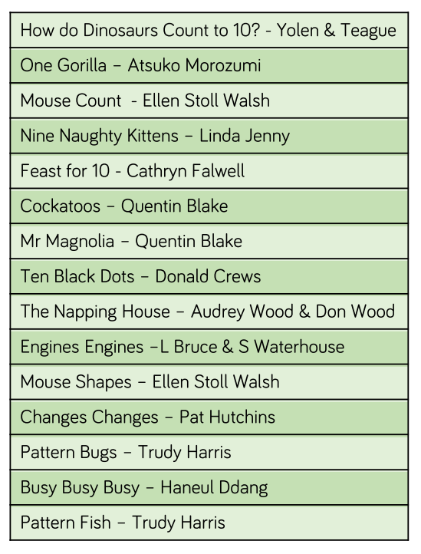

Enabling Classroom Environment
The classroom learning environment is constructed to enable lots of opportunities for practical maths experiences. Maths resources are freely available within the provision and our skilled adults model mathematical concepts through play and in real life contexts.
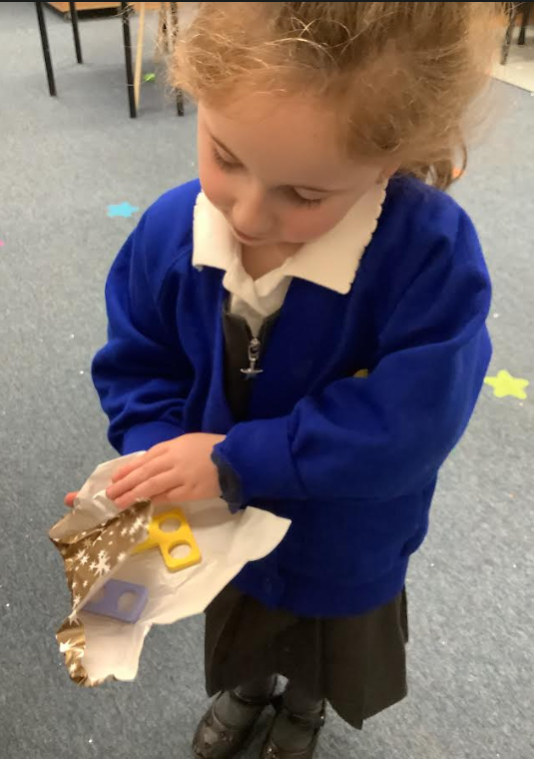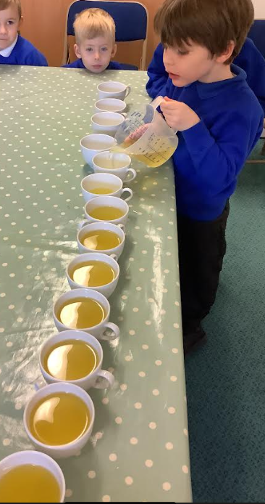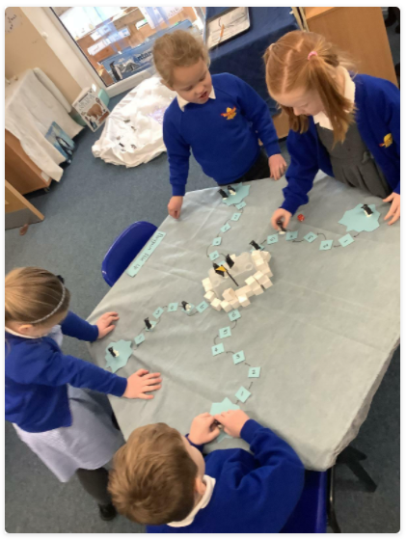

Fluency – Non-negotiables
We believe that all pupils need to learn specific skills each year. Fluency demands more of learners than memorisation of a single procedure or collection of facts. It encompasses a mixture of efficiency, accuracy and flexibility to move between different contexts, making connections and recognising relationships.
The non-negotiables are taught and reinforced at the beginning of each lesson to enable fluency. Deeper thinking challenges are set within the provision to enable pupils to apply the information they have learnt. Adult-led activities are completed on a daily basis as part of the class Gold Star Challenge and enable the class teacher to assess new learning.

EYFS Non-negotiables
Autumn 1 | Autumn 2 | Spring 1 | Spring 2 | Summer 1 | Summer 2
Say the number names in order to 5. | Say the number names in order to 10. | Begin to recognise the days of the week. | Partition numbers to 5 into two groups. | Count forwards and backwards in ones from any number up to 10. | Count forwards and backwards in ones from any number to 20.

The Counting Principles
In the EYFS we have regard for the five counting principles.

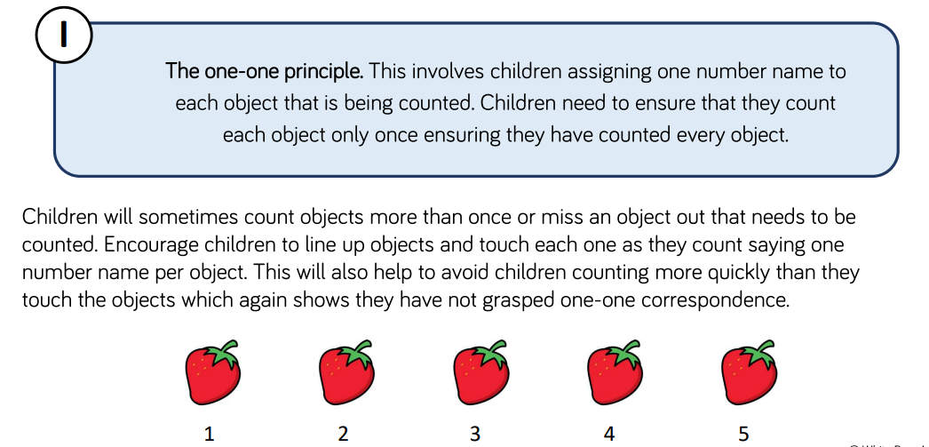

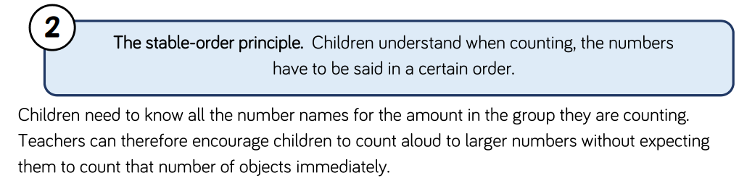
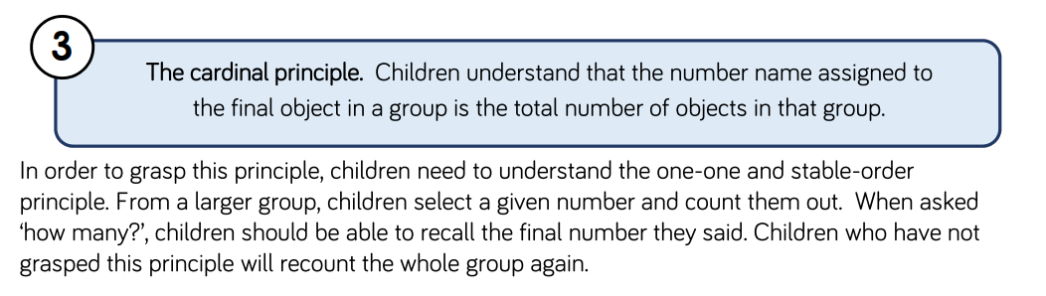
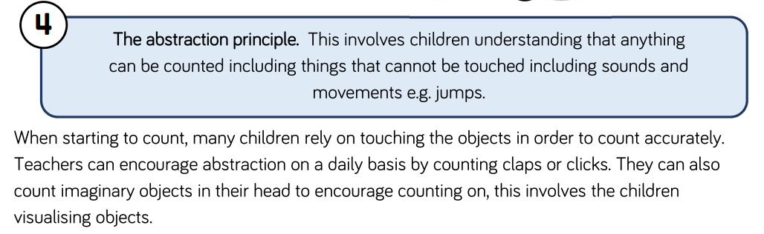
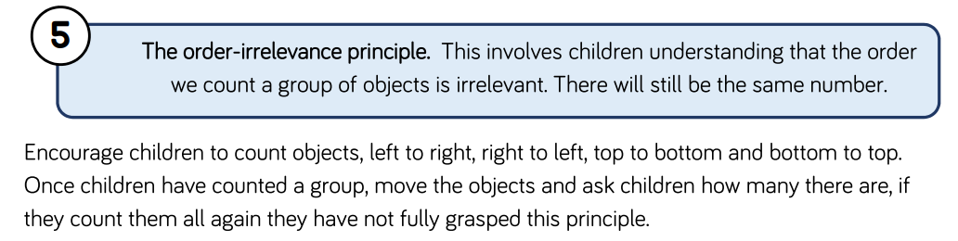

Impact
Our Early Years Mathematics curriculum provides a good solid foundation for our mathematicians as they progress throughout the school. They have a strong sense of numbers to ten, a deep understanding of the link between number and quantity and are able to represent numbers in many different ways. They are able to use their maths skills in every day contexts including being able to subitise and can count on; knowing that they don’t always have to start from the number one.
The children enjoy their maths lessons, show resilience when problem solving and leave the early years foundation stage ready to face the challenges of the maths curriculum throughout the remainder of their schooling life and beyond.

