Squirrels – Writing – Ada Lovelace
Key Vocabulary | Our Text  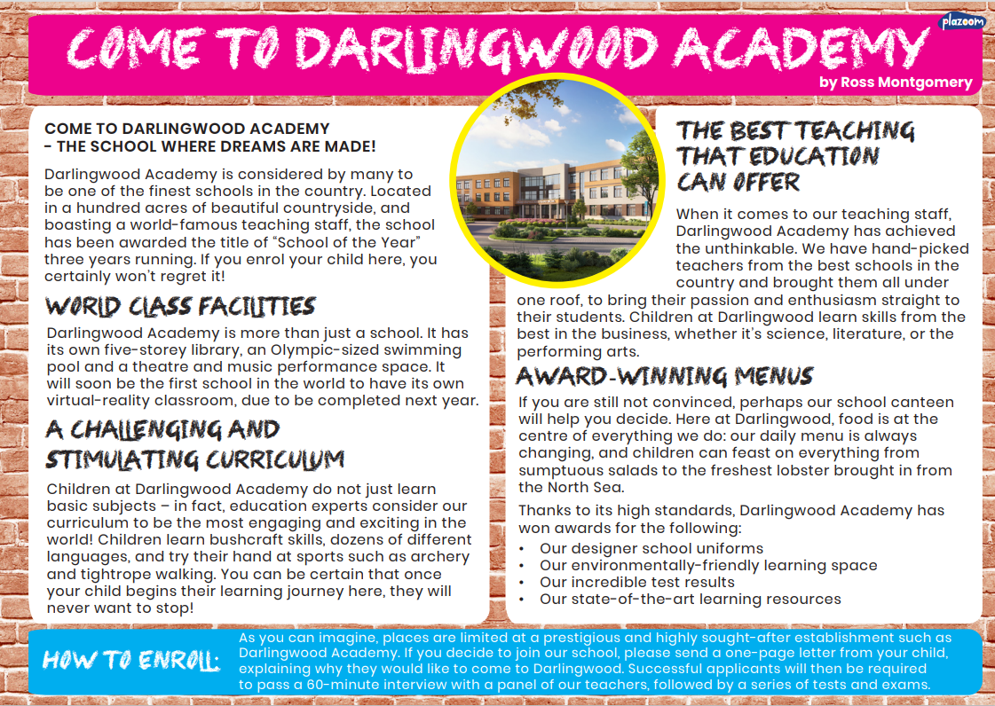 | In this two-week unit, pupils will read a persuasive report, setting  out reasons for parents to enrol their children at a prestigious (if  fictitious) school.  They will have an opportunity to learn technical  vocabulary related to education establishments. It will culminate  in them writing their own persuasive text – a promotional leaflet encouraging parents to enrol children at their own school. This  unit helps pupils to meet the curriculum objective of writing for a  wide range of purposes and audiences.  Our focus English objectives:  1) To build a rich vocabulary: synonyms  2) To compose and rehearse sentences orally.
awarded

designer
acres
engaging
achieved
sumptuous
enrol
prestigious
enthusiasm
engaging

