As scientists…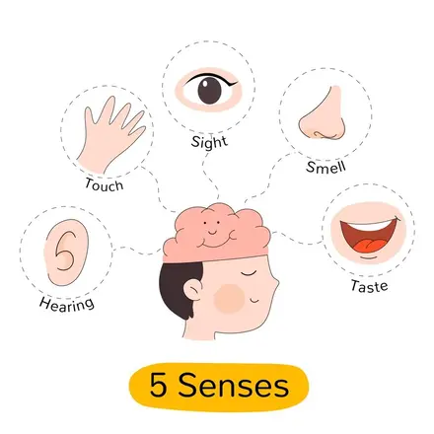

We will be learning about parts of our bodies and our 5 sense. We will be discovering how our senses work and using our senses to complete different activities.

As writers… 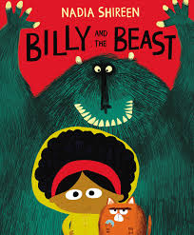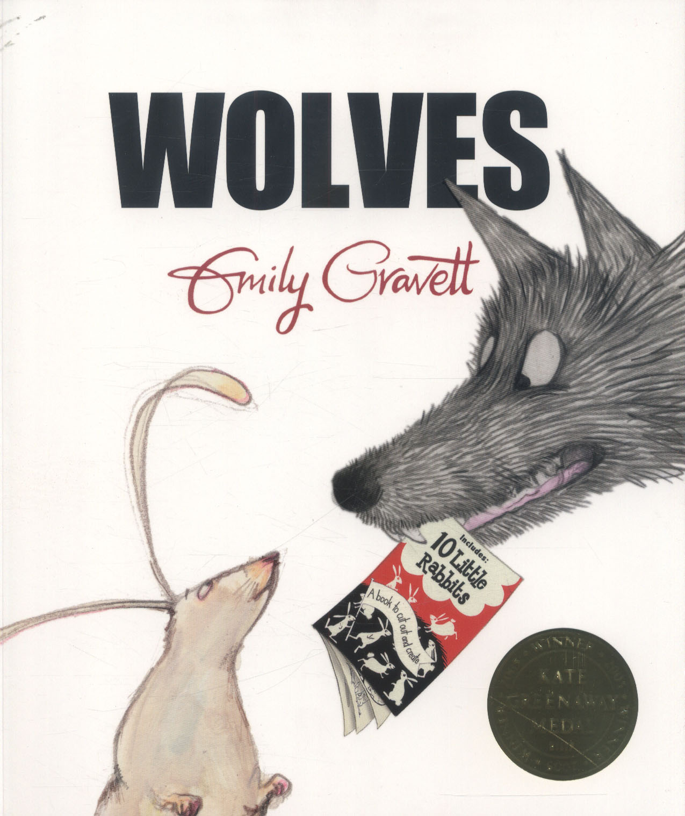

We are using the stories of Billy and the Beast and Wolves for our writing topics this term.

We will be exploring character descriptions and comparisons, wanted posters and recipes. We will then be writing our own beat the monster narratives and a non-chronological leaflet

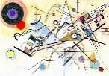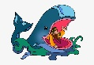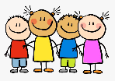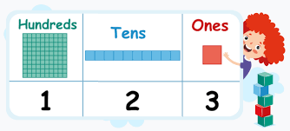

As artists…

We are going to be exploring drawing to make a picute. We will also be looking at using charcoal mark making and using texture to create our pictures.

As people of faith…

We are going to be thinking about ‘What is God like?’ using the parable of The Lost Son and the story of Jonah, looking at the hidden meanings within the text.

As computer technicians…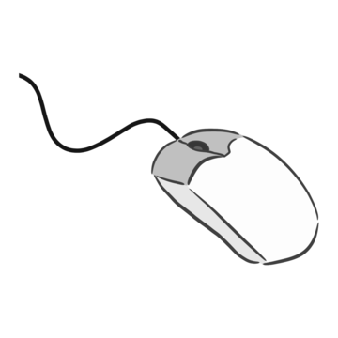

We will be improving our mouse skills and learning how to log on and off.

Fantastic Foxes

2025

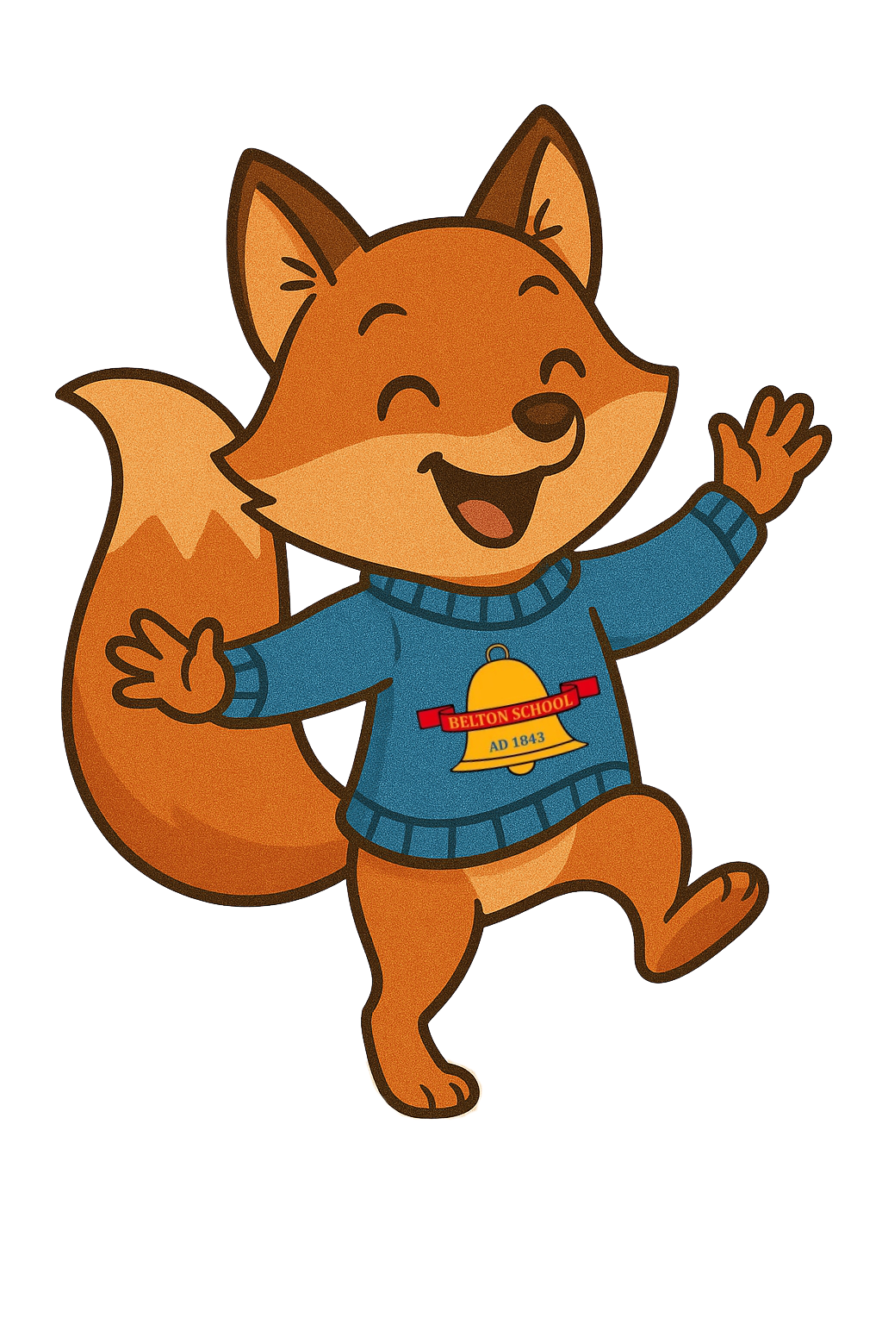

As unique individuals…

We will be thinking about what our family looks like and how all families are different.

We will also be focusing on developing friendships and how to solve problems when they arise.

As Historians…

We will be investigating the history of ourselves. We will look at special events that are important to us and what we remember about them. What was it like for children in the past, and how can we make history.

As mathematicians…

Place Value

Year 1’s will be focusing on place value within 10, sorting, counting and grouping objects and numbers. They will be counting 1:1 forwards, backwards, one more, one less and exploring greater than, less than and equal too.

Year 2’s will be working with numbers up to 100, counting in 2’s,3’s,5’s and 10’s.They will be using number lines, estimating and comparing numbers and portioning numbers up to 100. They will also be learning to write numbers in words.