
Belton C of E Primary School
Behaviour Policy
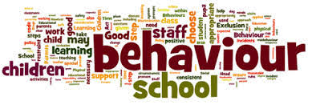
Our Vision
Achieving the best together. By preparing our pupils for fullness of life, reaching their potential, physically, mentally, and emotionally through an appreciation of their spiritual lives inspired by the values of Jesus Christ.
Mission statement:
To create and enable an exciting and supportive environment so that all our learners will flourish both emotionally and educationally. To ensure that they can be the best they can be and become responsible, confident citizens who actively contribute to society.
This mission is strongly underpinned by Christian values. In our school we have chosen six key Christian values which provide our focus. We believe that these values are at the heart of developing a healthy school community. These are hope, peace, forgiveness, love, friendship and trust.
The Christian values and the British values of liberty, freedom, community, tolerance, respect and law underpin our ethos.

Thinking of a child as behaving badly disposes you to think of punishment. Thinking of a child as struggling to handle something difficult encourages you to help them through their distress.
The most important aspect in children feeling valued, safe and secure is the sense of connection with the member of staff. For most children, this can be achieved by simple acknowledgement of the child and them having the knowledge that you have them in your mind, care about them as a person and care about what they are doing.
Strong relationships between staff and pupils are vital. Staff must be fair and consistent with children (taking into account individual needs) and children need to understand that the staff member is in control at all times enabling pupils to feel safe. Equally staff must be approachable and there to help (not only there to discipline) and children must understand this. If a member of staff is having difficulties with an individual or group of children they are expected to seek support in order to make a positive change.
This policy is developed to ensure guidance for staff in order to promote positive behaviour in school. The procedures and guidance in this document provides a consistent approach across the school and enables students, parents and staff to understand our approaches to the management of behaviour in school. It is also recognised that for some pupils, variance on these procedures will be made in order to meet any specific social, emotional, learning or other needs which require a personalised approach; guidance for this appears in the appendix I and approaches can be discussed with a member of SLT (Headteacher and Deputy Head Teacher).
General Expectations
It is important to have high expectations for our children while recognising some children have specific needs.
The following expectations cover all times of the school day and where children are representing the school out of hours or off site:
- Show respect and consideration to each other and to others, regardless of differences
- Behave sensibly around school e.g. move around in a controlled manner, use appropriate language, tone and volume when speaking
- Look after and respect your own and others property
- Work hard and follow instructions

Staff should ensure a good routine for their classroom and for when their children are around the school.
These expectations are reinforced through assemblies and interaction with children. It is everyone’s responsibility to challenge children where these expectations are not met but equally to comment positively when they are.
Good routines should be in place for:
• Start and end of day
• Transition times
• Lining up incl. assemblies
• Getting changed for PE
• Moving around the school
• Break and Lunchtimes

What do we do to teach and promote positive managements of behaviour?
- Whole School and Class Collective worship/ Assemblies: These cover areas such as ‘Caring for Others’ ,’Tolerance’, ‘Anti -bullying week’, ‘How to be a good friend’, ‘Who to go to if you need help’. They include parables for the bible, learning power assembles, assemblies on school values, British Values, current events and celebration.
- Pshe and circle time:
- ELSA
- Playground buddies and Sports Ambassadors
- Whole School days/weeks: Specific focus weeks are used to bring certain aspect a higher profile; these include: Tolerance Week, Mental health Week and Anti Bullying Week
- School Curriculum including RE & PSHE
- High focus on teachers developing positive relationships with children
- Clear and consistent routines in classrooms, around the school and in the wider community
- High expectations from staff about conduct in class and around the school
- Clear pathways when behaviour causes a concern and positive reinforcement for good behaviour (see appendix D: Approaches to positive recognition and classroom strategies)

What do I do if a child is showing inappropriate behaviour?

Any behaviour falls below the expectations of the school (e.g. disruption to learning, unkind or inconsiderate actions), requires some level of intervention. The following is a pathway of what to do: and will be followed by all staff (Teachers, LSA’s and lunchtime supervisors)

Belton Behaviour Pathway

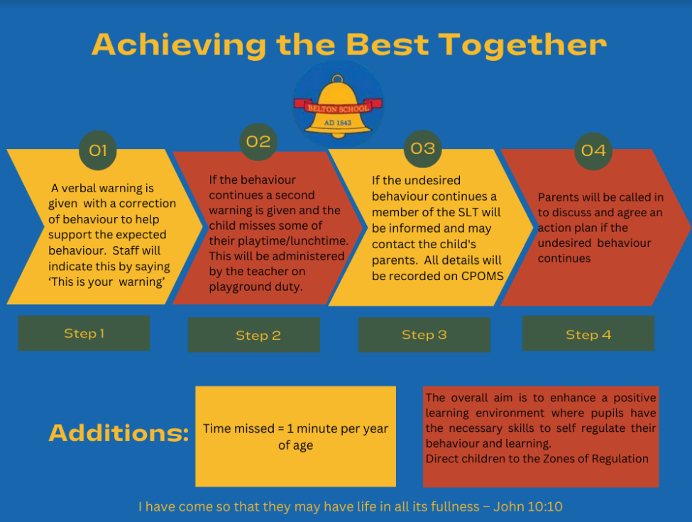

Child demonstrates inappropriate behaviou
CPOMS will be used to record detail of any behaviour issues.

When reporting incidents on CPOMS it is important to include

- Date time and location of incident
- What happened and who was involved
- Summary of Incident
- Any actions taken/ reparations used need to be added as an action

Remember – the strongest approach to support a child is through the relationship with the adult. At all points try to ensure you keep a strong connection with the child having difficulties. Use positive reinforcement, as appropriate to ensure the child knows you are still there and you recognise their effort and any chances they have made.
If a child is demonstrating unwanted behaviours at the end of the lesson (or during if appropriate) the teacher should talk with the child about the difficulties in the lesson and agree what improvement is needed for subsequent lessons.

General Responses to incidents

Children have to have the opportunity to reflect on their actions and the impact this may have had on others.
Below are examples for some situations that may occur in school and the types of response that are appropriate.

We will apply the aims of Restorative Justice

- The overall aim is to enhance a positive learning environment where pupils have the necessary skills to self regulate their behaviour and learning.
- To develop an understanding of our responsibilities to the communities that we are part of
- To develop emotional literacy, truth telling, accountability and responsibility
- Increasing empathy, happiness, social and communication skills
- Reducing bullying, conflict and the need for sanctions

The aim of Restorative Justice is to create positive outcomes from negative behaviour. It is:

- A process for resolving conflict
- A common language to resolve conflict
- Focuses on the needs of the victim
- Allows the wrongdoer(s) to understand the impact of their actions
- Encourages wrongdoer(s) to take responsibility for their actions
- Therefore creates accountability
- Likely to change behaviour and build character

The 4Rs

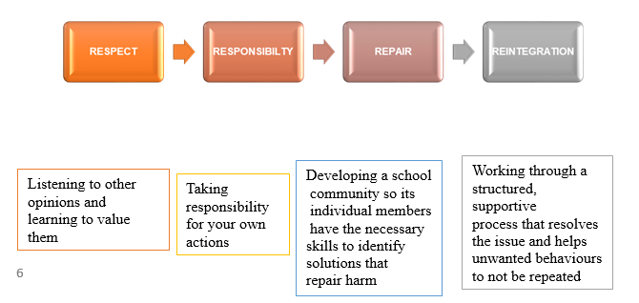

Restorative Questions
- What happened?
- What were you feeling/thinking at the time?
- What do you feel/think about it now?
- Who has been affected by what has happened? - In what way?
- What do you think needs to happen to make things right?

Types of approach
- Restorative language
- 1-1/ Restorative chat/conversation
- Restorative circles
- Informal conferences
- Restorative Justice Conferencing
- Restorative reflection sheet ( see appendix U)

Characteristics of restorative language: open questions, fair, respectful, non-judgemental and enquiring. They never assume you know what has happened

What is important?
- Body language and tone of voice are two extremely important constituents of restorative language.
- Body language needs to be non-aggressive and non-confrontational. This is vital to allow pupils their own personal space
- Tone of voice needs to be calm, respectful and non-judgemental

Emotion Coaching may be used so that the children:
- Become aware of emotion, especially if it is a lower intensity (such as disappointment or frustration)
- Connect and view emotion as an opportunity for intimacy and learning
- Accept – communicate your understanding and acceptance of the emotion – empathy – ‘I am wondering if…’
- Reflect – use words to describe feelings ‘name it to tame it’
- End stage – if necessary help them to solve problems. All wishes and feelings are acceptable but some behaviours are not

When the child is calm and in a relaxed state:
- Explore the feelings that give rise to the behaviour/problem/incident
- Scaffold alternative ideas and actions that could lead to more appropriate and productive outcomes
- Empower the child to believe they can overcome difficulties and manage feelings/behaviour

Incident | Type of response
Incident against another person | Show the person that has been affected by the child’s action that they are sorry. This can be in the form of verbal, written, picture, or an action.  We do not force children to say sorry
Incident relating to theft, damage to property etc | Where possible – a natural reparation should be used e.g. clean graffiti off the door, clean up the mess, pay for replacement of item.  Where this is not possible a close alternative should be used e.g. vandalism  that could not be fixed by the child – the child should then give time to complete a site task which enables the site person to fix the problem.  Where there is a cost for replacement of an item that has been damaged this  cost may be sought from the child following discussion with the family.
The particular activity has been causing issues e.g. football at  break time | Work with staff needed in order to ensure subsequent participation can be successful. E.g. having reduced time / supervision / or not taking part in the  activity
Child being disruptive in lessons | Child remains in for some or all of the break to catch up with the work that hasn’t been completed.  OR  The need for a discussion with teacher regarding behaviour and how to  improve this in the next session.

For children or response to incidents where children have difficultly to focus attention, control emotions and manage thinking, behaviour and feelings Zones of regulation will be used. See Appendix

The first step to self - regulation is identifying how your body and brain feels. There are four zones to help with this. These zones are called the Zones of Regulation. The posters below are up in classrooms.

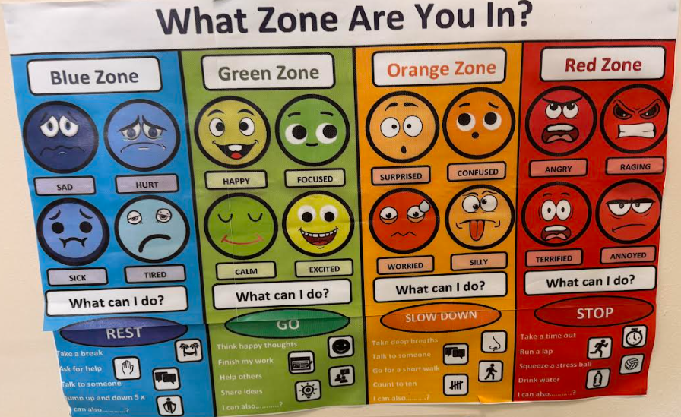

Blue Zone – Body running slow, such as when tired, sick, sad, or bored
Green Zone – Like a green light , “Good to Go!”
Yellow Zone – Proceed with Caution & Slow Down!
Red Zone – Extreme Emotions! out of control, trouble making good decisions, and must STOP

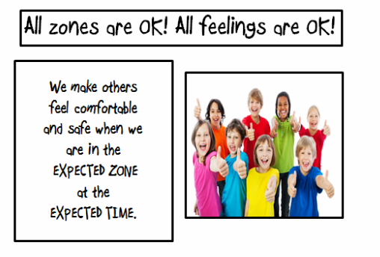

Concerns with a child’s behaviour

CPOMS will be reviewed at regular intervals by SLT and any children who appear to be causing concern (and whose parents have not already spoken with) will have their parents contacted. The child’s behaviour will then be tracked over the next few weeks. At the end pf this period the parents should be contacted to inform them of the progress made.
If no improvement is made a formal meeting will be held between the teachers, child, parent and a member of SLT. The child will have a behaviour plan which will be monitored on a weekly basis.
Regular contact should be made with parents to update them on any further issues or improvements. The child will meet with the class teacher (and SLT if needed) to discuss the issues and agree improvements if needed.

Daily Behaviour Tracking sheet for children demonstrating unwanted behaviours

In order to track behaviour and ensure the appropriate action is taken to reduce further disruption a daily tracking sheet (see appendix) is completed for the following:

- Session 1: Start of the day to break time
- Breaktime
- Session 2: After break to lunchtime
- Lunchtime
- Session 3: After lunch to the end of the day

Child’s teachers are responsible for recording the session and are responsible for ensuring other staff are made aware that the child is on a behaviour tracking sheet. A child should only need daily tracking for a short period of approximately 2 weeks when behaviour will be reviewed.
Tracking notes will be scanned and uploaded to CPOMS weekly. This is the responsibility of the class teacher. Any additional notes will also be recorded on CPOMS.

Major ongoing or serious issues

Where the behaviour is a cause for concern a behaviour related log is recorded on CPOMS which allows appropriate support and/or reparation to be planned for.
The behaviour related log should be completed by the person initially dealing with the incident. If the incident occurs during a lunch break – it will be passed on to the class teacher/ SLT.
Staff (Teacher & Tas) should then aim to deal with the incident and the reparations in the first instance. It will only be escalated to SLT if further actions or immediate response is required or it cannot be undertaken by the member of staff dealing with it.
When there is an incident where a child is exhibiting behaviour which becomes unmanageable or unsafe immediate support should be sought from another member of staff or SLT.
When an incident occurs a judgement is made by the class teacher/ SLT as to whether the parents of the perpetrator (s) and/ or victim (s) need to be informed, taking into the account the severity of the incident, any continuing difficulties the incident is likely to cause and the child 9ren)’s history of involvement in such incidents.
All incidents must be logged on CPOMS which allows an overview of issues and therefore establish any support that needs to be put in place for the child (ren).

The power to discipline beyond the school gate

As a school we will respond to concerns regarding children’s behaviour outside of school which could:

- Have repercussions for the orderly running of the school
- Poses a threat to another pupil or member of the public
- Could adversely affect the reputation of the school

Pupils, parents and staff are advised to inform the school if they have any concerns. Each concern will be dealt with based on the nature of the incident.

Specific circumstances – School trips/ visits/ swimming/ PE

Following the guidance of the Equality ACT 2010 we endeavour to provide all children with full access to the school curriculum: this includes educational visits and trips.
If a child has significant difficulties where an activity may pose additional risks for that child or the safety of others – we will work closely with staff and parents to develop a plan of support in order for the child to attend the trip and ensure the best possible outcome for all involved. This may involve: additional staffing, modes of transport, amended visit time/ structure of visit.

This policy will be reviewed annually.
August 2024 – to be reviewed August 2025
This policy is to be read in conjunction with:-
- Anti-bullying policy
- Exclusion Policy
- Equal Opportunity Policy

Appendix
Appendix A: Inclusion Team
Appendix B: Approaches to positive recognition and classroom strategies
Appendix C: Behaviour Log
Appendix D: Minor and Major Incident List
Appendix E: Exclusions
Appendix F: Supporting children with Social Emotional Mental Health/ SEND needs
Appendix G: Use of reasonable force
Appendix H: Governors’ statement
Appendix I: Zones of Regulation

Appendix A: Inclusion Team

Mrs Sara Gray/ Miss Joanna Scott (Executive Headteacher/ Headteacher(maternity))
Mrs Catrin Yendall (Deputy Headteacher/ SENCO)
Mr Mark Edwards (Chair of Governors)
Mrs Denise Boulton( Anti-Bullying Governor)
Mrs Denise Jackson (ELSA)
We have1 1 school based ELSA based 5 days a week who are able to help with a variety of mentoring or family support. Parents can make an appointment to discuss any concerns they have with their child or wider family issues.

 | Responsibilities
All staff | - All member of staff are responsible for supporting the needs of children across the school. Where a child is seen to be having difficulties they should be treated with respect and understanding.  - Shouting and shaming should never be used and is not tolerated at Belton.  - Staff will always endeavour to have private discussions with pupils in order to help support any issues that are arising.  - Staff use the Key principles outlined in this policy to support the needs of all our  pupils.
Specific Roles
Teachers | - Ensure parents are contacted when:  - a child is having ongoing issues  - there has been a ‘one off issue significant issue’  Where possible the teacher should do this in order to have the ongoing dialogue. On some occasions a member of SLT will liaise with parents for significant one off issues.  For ongoing issues, a discussion should be had with the parent(s) as to the best way to keep an dialogue going.
ELSAS/ SENCO | - Provide specific support for children experiencing any difficulties, whether this is an ongoing need or a short term difficult a child may be having.  - Provide support in class and at break and lunchtimes  - Provide 1:1 or group work to support emotional health needs and mindfulness  - Provide a behaviour plan (if needed)
SLT | - Lead the ethos of this policy  - Ensures the policy is implemented effectively  - Ensures effective training for staff  - Oversees the specific needs of pupils across the school  - Provides support to staff, pupils and parents as necessary  - Links with outside agencies to offer additional services  - Line manager for the ELSAS  - Ensures that all tracking and reporting of incidents and additional needs are up to  date
Head Teacher | - Lead the ethos of this policy  - Is the only person authorised to exclude a child
Parents | - Inform the school of any concerns (Class teacher, Senior Teacher, HEADTEACHER)  - Have an open dialogue with the school  - Support the school when needing to get further support
Governors | - Setting down these general guidelines on policy and of reviewing the effectiveness of this  - Duty to consider parents’ representations about an exclusion

Appendix B: Approaches to positive recognition and classroom strategies
Children need to feel valued, safe and secure with the member of staff. For most this can be achieved by a simple acknowledgement of the child and the child having the knowledge that you have them in your mind, care about them as a person and care about what they are doing.
We can categorise positive recognition as either personal or public. We create an ethos of every child as an individual and that all children are at different staffed with their learning, and development. Achievements is based on their own personal progress – not as a comparison to others.
For children with additional SEMH needs we look at the specific needs of these children to determine how we approach the use of both personal and public recognition.
The use of public positive recognition (praise, awards and rewards etc.) can, in addition to the desired positive impact on the target children, have negative impact on all children especially children with additional SEMH needs.
At Belton we have carefully thought about all the types of public positive recognition that are used in order to maximise the positive impact for all pupils and minimise any potential negative associations.
We ensure that systems are not based on control through bribery or over use of rewards. Consequences are steered towards those that are natural eg graffiti is cleaned up.
The following approaches are used at Belton.. Any additional approaches must be discussed with SLT.

 | Purpose | What it looks like | Key notes
Individual
Use of children’s work as an example | To celebrate the child  To help promote learning | Sharing of work on the board Reading out of child’s work. | Be mindful of using the same child all the time.
Classroom praise – public/private | To give feedback/ celebrate the child  To help promote  learning / conduct | Specific feedback (see feedback policy)  “James, super clear reading – your use of intonation for the characters really helped me to understand how they were feeling at different points  in the story.” | This can be public or private dependant on the circumstances and the individual needs of the children.  Be mindful of using the same child all the time.
Stickers and house points | To give instant  recognition for work/ behaviour | Staff give stickers to child and says why / leaves sticker in books.  House points to be put in slots in the hall and will be referred to in assembly  At end of each half term winning house has a treat such as a non-uniform day | Keep an eye out for children who are not getting any stickers/house points.  Children should not use this is a  comparison to each other or ask for  s tickers. This will need to be explained to the children.  Must not be used as a bribe (“If you do…. then you will get a sticker”)  or consequence (“You would have got a sticker if you had / hadn’t…..”)

WEDUC | Encourages home school l ink  Enables the sharing of successes | Staff send WEDUC to parents. | This is a quick and easy way to  communicate positive news to parents. Use as and when appropriate (balance of not too many/ not enough)  Useful method for when things haven’t been going to well for a child as a way  or re-connection for the home-school and child-parent relationship.
Phone call | Encourages home school link  Enables the sharing of successes | Phone call home. | This is a very powerful way to give that special news or information and enables effective relationship building between school and home.
Celebration  Assemblies-Belton’s Best (Fortnighlty) | To recognise the  ability, progress or  quality of every child  To celebrate work  To involve parents | Fortnightly on Friday to share good work, effort and positive attitudes and behaviour (1 child from each year group)  Parents are invited to the assembly  Names given to the office by Wednesday of the week of the Belton Best assembly.  The work is hung in frames which are displayed in the school reception area. Children are given a certificate where the learning powers are referred to.  Other certificates to be handed out include a Christian value certificate for both staff and child.  If a child has achieved something out of school we will mention this in this assembly  House points total referred to here | Every child must have the opportunity  to be in one of these assemblies (recognise individual who this may be difficult for or who may not want this type of recognition – for these look at  an approach that is appropriate – liaise with SLT and parents)  children will take certificate home  Must:  - recognise the here and now achievements  - Use the learning powers  Must not:  - indicate any previous negative issues  - specific results that could be used as a comparison to other children  - comparison to how children were before
Head Teacher/ DHT stickers | To provide positive recognition for hard work/ kindness | Child is sent/ brought to the office to show good work or for doing a good thing.  A child is given a sticker | Ensure a good mix of all pupils get the chance to bring good work/  achievements.  Must not:  - make an over public  ‘announcement’ in the class  - be used as a ‘bribe’ e.g. “if its great we can show it to …”
Governor awards – Year 6 only at the end of the year | To recognise a  particular outstanding contribution to school life or outstanding act of courage, bravery,  moral duty | Award given out (usually in the final assembly of the school year) | Nominations from staff are sought at any point during the year.  Quite a rare award.

Group/Class
Work on display | To recognise  children’s work and celebrate all  children’s work – regardless of ability | Children work on display.  Every child has some work on  display (unless they have asked for it not to be) | School ethos is to accept children work at different levels and that this is okay.  Must:  - Ask children if it is okay to display their work.  (This can be done as a general start of the year and/ or as and when work is to be displayed.)  Must not:  - indicate a level or mark
 | Purpose | What it looks like | Key notes
Praising groups | To promote positive expectations and  behaviour e.g. “Great yellow table – all  settled down to work well” |  | Must not be linked to any aspect of competition, points or prizes  Must not to be used to shame/name the individual tables that aren’t.  WHY?  Some children may struggle with organisational skills and need support with this rather than be criticised by peers for ‘losing’ points etc for them!
Class Reward | To promote and  celebrate whole class achievements  (Behaviour,  performance, values etc)  Catch the class in the moment:  “Great cooperation in PE today – well done  – add a marble to our  jar” | Staff or class teacher awarding 1  ‘marble’ to a class for collective good behaviour (lining up, walking around school, conduct on a trip,  entering/leaving assemblies or great work together for a lesson)  At the end of each half term a  member of SLT will pop in to have a look at the jar and give a little  ‘treat’. This will be discusses with the class teacher beforehand. | Must not be used to identify any group  or individual who have ‘stopped’ the class getting a ‘marble’  WHY?  Reduction in self-esteem and/or blame from other children / child shamed.  Must not Be used as a bride (“If we do…. then we will get a marble”)  or consequence (“You would have got a marble if you had…..”)  There is no specific ‘amount’ that is required for each class to collect.

Appendix C: Behaviour Log
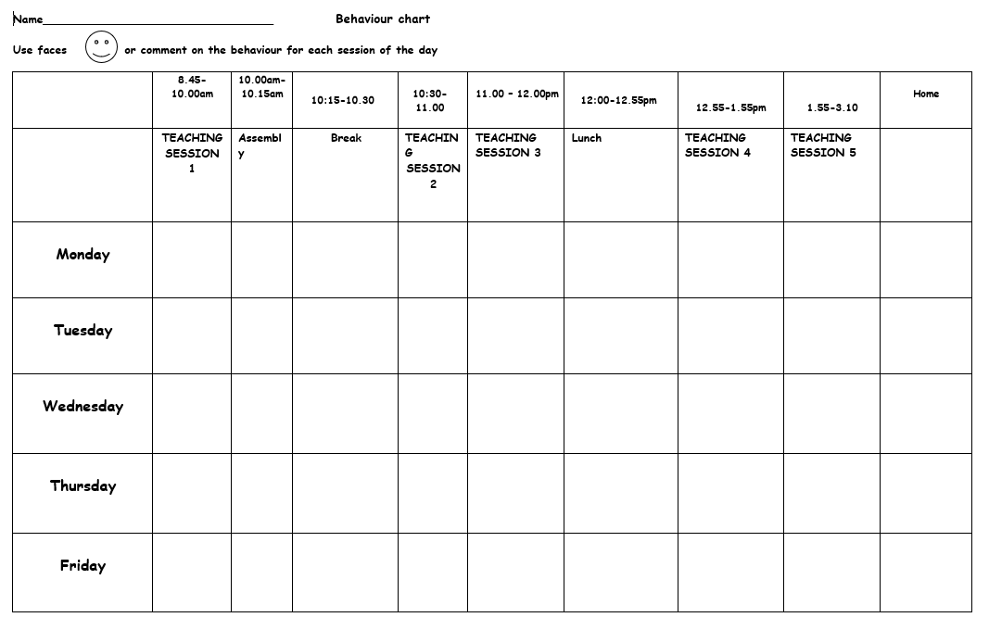

Appendix D: Minor and Major incident list
Minor incidents might include:

- Talking at inappropriate times
- Mistreating school or other property eg. mishandling books, dropping litter, wasting or not taking care of resources
- Not lining up properly
- Distracting other pupils e.g. pulling ‘funny’ faces, trying to attract their attention.
- General behaviour around the school building e.g. Running in the corridors, talking in assemblies
- Daydreaming
- Not having PE kit (refer to PE leader if persistent)
- Isolated shouting out e.g. an answer
- Not doing sufficient work / lack of co-operation with peers
- Eating in class
Major incidents might include:

- *Any prejudice based comments e.g. Racist/ Homophobic/ Transphobic/ Religious/ Ageist comments
- *Gender based comments e.g. “you can’t because you are a girl…”
- Verbal/written e.g. swearing (in any language), making comments intended, or likely, to cause upset or offence to someone else
- Theft
- Vandalism of anybody’s property, including graffiti on school books
- Physical e.g. punching, kicking, pushing, pinching, hitting another person with an object
- Play fighting / rough play
- Exclusion of peers from games, if intended to cause upset to them
- Defiance after a reasonable request has been specifically directed at the individual by an adult
- Bringing in inappropriate items e.g. weapons, drugs, inappropriate images
- Ongoing multiple issue in a day
*All incidents of a racist, homophobic or transphobic nature, or involving gender discrimination, are treated seriously and are dealt with according to the age, understanding and the nature of the incident. The principles within this policy are used to explore and deal with this situation.
CPOMS are completed for these incidents and SLT informed

Appendix E: Use of exclusions
These are only used as a last resort and where the safety or effective working of the child(ren) class/ school would be compromised. Wherever possible the use of class teacher, ELSA or SLT are utilised to deal with any significant issues.
Internal and external exclusions are sometimes used if returning a child back into the class setting may result in significant further disruption to their or others learning – or a significant incident has occurred which requires immediate investigation and time for children to become regulated.
We follow the DFE guidance of: “Exclusion from maintained schools, Academies and pupil referral units in England” 2012. Please refer to our exclusion policy.

Appendix F: Supporting children with Social Emotional Mental Health needs

It is the primary aim of our school that every member of the school community feels valued and respected, with each person treated fairly and well. We are a caring community, whose values are built on mutual trust and respect for all. The school’s behaviour policy is therefore designed to support the way in which all members of the school can live and work together in a supportive way. It aims to promote an environment where everyone feels happy, safe and secure and able to learn.

We recognise that children may experience a range of social and emotional or medical difficulties which manifest themselves in many ways. These may include children displaying challenging, disruptive or disturbing behaviour. These behaviours may reflect underlying mental health difficulties, social interaction difficulties, or sensory disorders. Other children may have attention deficit disorder, attention deficit hyperactive disorder, foetal alcohol disorder or attachment difficulties. These children will be supported using a variety of strategies and these will be developed with key adults within the child’s life (staff, professionals, parents) in order to best meet their needs.
We recognise that children with SEMH may exhibit behaviours which reflect a hyper or hypo state and that the behaviour(s) comes from a place of fear, stress, low self-esteem, dysregulation or as a result of a school based barrier to learning e.g. pitch of task, classroom environment. We have a duty to strive to help children to return to a place of regulation as only then will the child be in a place to reflect on their behaviour finding ways to repair the situation.
We also recognise that children in states of stress and dysregulation are unable to learn as effectively as those who are in a state of regulation.
In order to effectively support children it is vital that staff are well trained and understand the potential root causes of behaviour(s).
We also recognise the needs of children with Special Educational Needs and Disabilities and follow the policies and procedures associated with supporting these children, including but not exhaustively, the SEND code of practise, Equal Opportunities, Disability Act.

Concern level | Universal | Additional | Complex and Significant
Description | General low level concerns or single significant incident  (No known additional needs incl SEMH) | Ongoing concerns | SEND / SEMH underlying specific needs  OR  Ongoing concerns – little or no improvements
Approach | If you don’t already know - explore the history of the child including any previous incidents or key information  – by checking Core pupil information, Pupil chronology, talking to previous staff, SLT | If you don’t already know - explore the history of the child including any previous incidents or key information  – by checking Core pupil information, Pupil chronology, talking to previous staff, learning  mentors or Inclusion leader | Strategy meeting held with:  - Class teacher  - Any external agency in place  - SLT  - Parents  - Child
Approach | Talk to the child to establish any issues – including the use of ‘wondering’ questions | Class teacher arranges a meeting with parents, Can  include SLT  Discuss issues and agree a  plan of action/ support | Further support plan put in place with clear actions and timelines for review.
Approach | Set and agree expectations  Class teacher contact parents where appropriate | SEP completed if needed and implemented (Possible use of external support) | SEP written and child added onto SEND list
Approach | Regular monitoring and  discussions with child (and parent if appropriate)  including praise for success | Regular monitoring and  discussions with child (and parent if appropriate)  including praise for success
Approach | If not improved enough – move to ‘additional needs’ | If not improved enough – move to ‘significant needs’
For effective provision for SEMH needs, all staff are trained in the following areas:

  - ADHD
  - Autism – level 1
  - Adverse Childhood Experiences
  - Attachment
  - Trauma - how we track this and how we can plan for potential difficult times
  - Sensory
  - School ethos for working with children
  - Zones of Regulation

Key principles in supporting the universal needs of all pupils:

  - All behaviour (positive or negative) is a reflection of a person’s emotional state
  - Understand brain development and impact of stress and fear on behaviour
  - Children have different ‘stress windows of tolerance’
  - You can’t always see the ‘trigger’
  - Behaviours communicate a need
  - Scared children can do scary things
  - Don’t take things personally
  - Negative behaviour mostly comes from an unconscious place
  - In times of stress children’s thinking process is distorted and confused and short term memory is suppressed
  - Children who are dysregulated are unable to access the thinking part of their brain
  - Children without the strategies and skills need to manage their emotions need to be supported

How we support the universal needs of all pupils:

  - Use of natural consequences rather than ‘punishments’
  - High Structure (Strong routines and boundaries)
  - High nurture
  - The use of PACE (Playfulness, Acceptance, Curiosity, Empathy)
  - Use wondering in order to explore the potential cause of the behaviour
  - Giving children time, space and support when dysregulated BEFORE attempting to deal with the behaviour
  - Engaging children at an emotional level
  - Regulate our own emotions
  - Time in not time out?
  - Using staff presence to help regulate
  - Naming need
  - Empathetic Commentary
  - Access to ELSA
  - Understand that any traumas in a child’s life can impact on behaviour

How we support children with additional SEMH needs:
In addition to the above we have package of therapeutic support for specific difficulties.

Children having difficulties are identified through members of staff, parents or other children raising a concern, or as a result of school tracking showing that there is a change in behaviour(s).
Following the identification of a child with additional SEMH needs, we:

  - Meet with staff, child and parents to explore the issues and develop a plan or approach (A key approach is non-judgemental listening)
  - Observe the child in lessons incl review of approaches to teaching, classroom environment, access to
learning and relationships

Following this, support will be given in a range of ways

Approach | What looks like | Purpose
Regulation times | Access to:  - A quiet area/member of staff  - Soft play area  - ELSA space  - Physical / Sensory activities  - ‘Use of friends’ mental health  approach individualised books | Enable children to regulate before going into class before school/ after break/dinner etc.
Self-Elected withdrawal | Child can ask teacher to leave the room to go to a specific place  NB: Child may be angry – use limited talk or discussion. This is a strategy that has been discussed and planned for. | Enable children to develop skills to recognise their own dysregulation and remove  themselves from the situation.  Enables an adult to be close by and support  the child to regulate – where needed and when the child is ready.
Anger management groups | 1 to 1 or small group work working with ELSA or other support staff  trained in anger management. Looking at specific issues for children, identifying  triggers and areas that cause stress/anger  for the child. | Support child in developing approaches to managing these feelings.
Sensory  Assessment | Use of sensory checklist | To identify sensory needs and triggers in  order to develop provision for that child.
CLASS Support | - In class support  - Transition support from activities/ break etc  - Small 1 to1 or focus groups  - Daily / regular check ins  - targeted support in the playground  - Pastoral room | Provide overall support for children’s mental health and emotional needs in order to reduce anxiety
Social and Emotional Plans (SEPs) | Formal written support plan written by class teacher/ key adult / parents and  ELSA/SENDCOASS | Identifies the emotional needs for the child and the actions needing to be taken by  school in order to support their emotional  needs.
Individual Support Targets | Short term targets for pupils to address a specific issue. Written with the child and usually reviewed at the end of each  lesson/ break.  (For some children the use of a sticker/comment is used for each session – this must be agreed with the Inclusion  leader before being introduced) | This approach is not suitable for all children  – especially those with more complex needs or trauma and should only be used following discussion with SLT.
In class amended provision | Busy boxes, stress balls, fidget toys, social stories, drawing pads, self-withdrawal,  specific ‘safe’ places (e.g. tent) or other activities specific to the child  Child working on floor rather than at a  table | To help children remain regulated in order for them to access learning.
External Support  and or assessments | A range of support:  ADHD SOLUTIONS  School Nurse  CAMHS  Educational Psychologist Communication and Autism Team  Charnwood arts | To provide a range of assessments and  support for more complex needs – including individual assessment and family support.

Appendix G: Use of reasonable force and Screening pupils

As a result of our approaches to supporting the needs of children with additional needs it is very rare that the use of force is required. If a situation does occur, staff will use every possible solution to deescalate the situation and avoid having to resort to any physical contact in terms of managing a behaviour. Early help from a member of SLT is vital in supporting a difficult situation.
The law states that it is permissible to use reasonable force to prevent pupils committing an offence, injuring themselves or others, or damaging property, and to maintain good order and discipline in the classroom. This is a last resort and will only ever be used in the most extreme circumstances.
If such actions are necessary, the actions that we take aim to use the minimum amount of force necessary for the minimum amount of time necessary. Where physical intervention is needed, this is recorded on REACT form and must be reported immediately to SLT and uploaded to CPOMS. A record of these incidents is kept by SLT,

See Positive Handling policy for more information.

Appendix H: Governors’ statement:

As required by the guidance from the Department for Education on “Behaviour and discipline in schools -
Guidance for governing bodies”, the following is a statement of general principles in ‘determining measures to promote good behaviour and discipline amongst pupils’ DFE, p2
The Belton Governing Body believe that children behaviour well when they feel safe and secure and believe that behaviour is an expression of need. We strongly guide the school to develop approaches that reflect this belief and support the pupils to develop their emotional well -being. We also expect the school to provide effect support for pupils with difficulties.
In addition we ask school to provide clear guidance for their staff on:

- The power to use reasonable force or make other physical contact;
- The power to discipline beyond the school gate;
- Pastoral care for school staff accused of misconduct; and
- When a multi-agency assessment should be considered for pupils who display continuous disruptive behaviour.
Appendix I: Zones of Regulation
