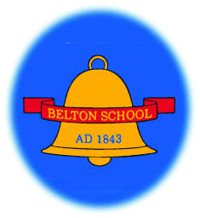

Checklist for a child starting school

Please return the following to the school office (by email, hand or post) before Friday 9th July 2021:

- Data Collection Sheet
- All About Me and Parents Voice information sheet
- Parental permission form
- Birth certificate
- Free School Meals (Pupil Premium) form
- School Meals Special Menu Request form - only if required

Every day please make sure your child is fully equipped for school:
A water bottle and all pencils and books are provided by the school.

- Uniform – named
- School book bag – named
- PE Kit – black or navy shorts, house coloured t shirt, navy or black jogging bottoms, hoodie in house colour, plimsolls and trainers – all named and in a named bag
- Suitable clothing for outdoor activities including wellies, waterproof trousers and coat
- A clean and full water bottle, filled with water – no juice

All uniform and PE kit can be purchased from https://www.sportsadvocate.co.uk/schoolwear/belton-ce-primary/ or via the link on the school website www.belton.leics.sch.uk

