As writers…

We are going to be reading a report all about Florence Nightingale. We will learn about how to use subheadings when writing reports and how to write in the correct tense. We will then be writing our own reports about Florence Nightingale.

As scientists…

We are going to become plant detectives, investigating what different plants need to grow and the different kinds of environments plants can live in.

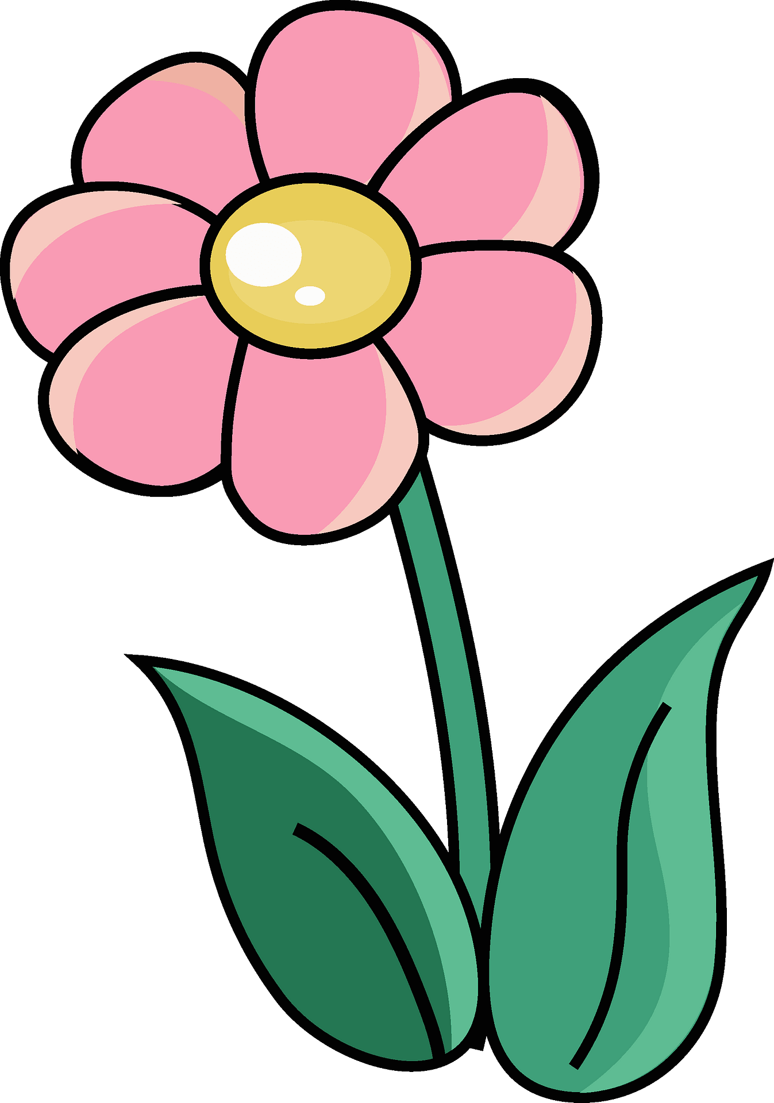

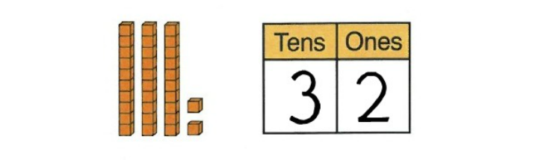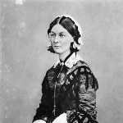

Fantastic Foxes

Spring 2

2023

As mathematicians…

Year 1

We will be developing our knowledge and understanding of place value up to 50. We will be counting by making groups of ten, partitioning numbers into tens and ones and looking at one more and one less.

After this we will be exploring length and height.

Year 2

We will be continuing our work on multiplication and division focusing on the 5 and 10 times tables. We will then be moving onto length and height, comparing and ordering different lengths and heights. We will also be using the four operations with length and height.

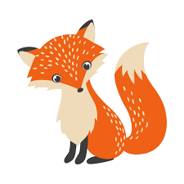

As unique individuals…

We will be thinking about how we are similar to

each other and how we are different. We will talk

about how we can care for ourselves, others and animals.

We are also going to be exploring rules and how we can make democratic decisions.

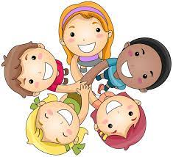

As people of faith…

We are going to be learning about how Christians believe the world was created and how they give thanks to God by caring for the world and everyone in it.



As musicians…

We are going to be developing our understanding of

pitch and using this to help us create a series of short compositions which we will perform to each other.



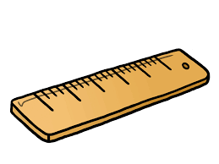



As historians…

We are going to be thinking about what a person

has to do in order to ‘make history’ as well as further exploring some of the greatest female history makers.

As designers…

We are going to be learning how to thread a needle and complete a simple running stitch. We will then be

designing and making a pouch, before evaluating our skills.

