Squirrels – RE – How do festivals and family life show what matters to Jews?
Key Vocabulary | 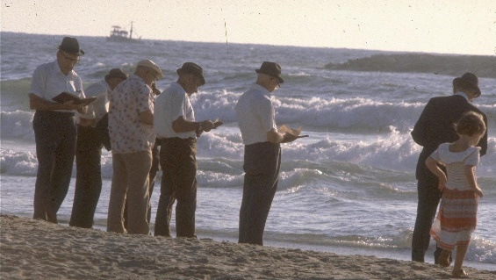  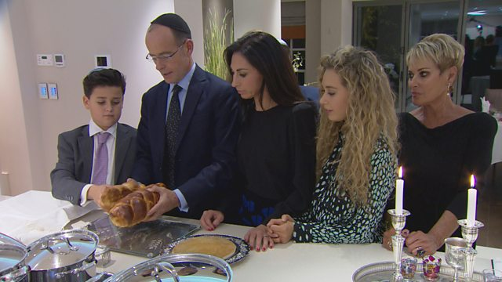  Rosh Hashanah, the celebration of the Jewish new year. The two-day holiday commemorates the beginning of the universe.  Shabbat is the Jewish Day of Rest. Shabbat happens each week from sunset on Friday to sunset on Saturday.  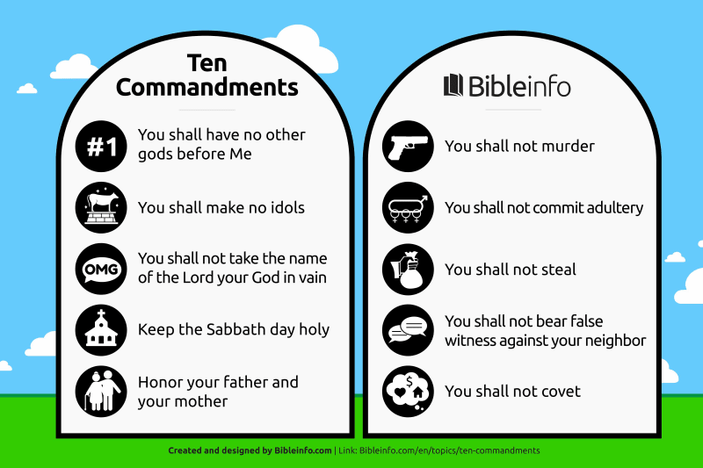  Tashlik, entails visiting a body of water following the afternoon service on Rosh Hashana and releasing your sins.  These are the 10 Commandments for Jewish people. | Outcomes  Make sense of belief:  - Identify some Jewish beliefs about God, sin and forgiveness and describe what they mean.  - Make clear links between the story of the Exodus and Jewish beliefs about God and his relationship with the Jewish people  - Offer informed suggestions about the meaning of the Exodus story for Jews today.  Understand the impact:  - Make simple links between Jewish beliefs about God and his people and how Jews live (e.g. through celebrating forgiveness, salvation and freedom at festivals)  - Describe how Jews show their beliefs through worship in festivals, both at home and in wider communities  Make connections:  - Raise questions and suggest answers about whether it is good for Jews and everyone else to remember the past and look forward to the future.  - Make links with the value of personal reflection, saying sorry, being forgiven, being grateful, seeking freedom and justice in the world today, including pupils’ own lives, and giving good reasons for their ideas.
Celebration
Shabbat
Yom Kippur
Rosh Hashana
Festival
Exodus
Forgiveness
Salvation
Belief
Synagogue
Judaism

