As writers…
We will explore the stories Naughty Bus and Cave Baby, enjoying the characters and adventures while developing our reading and writing skills. We will practise forming letters correctly and accurately, and learn to write clear, well-formed sentences.
As scientists…
We will explore our senses and learn to name and identify different parts of the body. Through practical activities, we will discover how our senses help us to understand and explore the world around us.

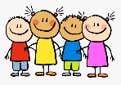
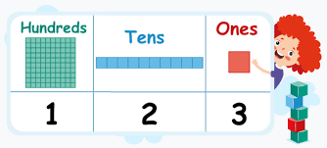
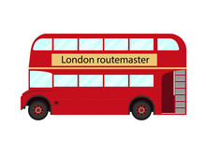
As readers…
Children learn new sounds, reading fluency, spelling patterns, and tricky words through daily phonics sessions. Learning supports confident reading and preparation for the Phonics Screening Check.

As people of faith… In RE, we will be exploring Christianity and considering the question, “Who do Christians believe made the world?” Children will explore the Christian creation story and develop their understanding of Christian beliefs about God as Creator.
As unique individuals…
In PSHE, we will be exploring how we can make ourselves and others feel safe. Children will think about positive relationships, kindness, respect and how we can support others to feel happy, included and safe.

As artists…
In Art, we will explore tone and texture through a combination of independent artwork and taught lessons. Children will experiment with different techniques and materials, developing their creativity and confidence as artists.

Fox Cubs
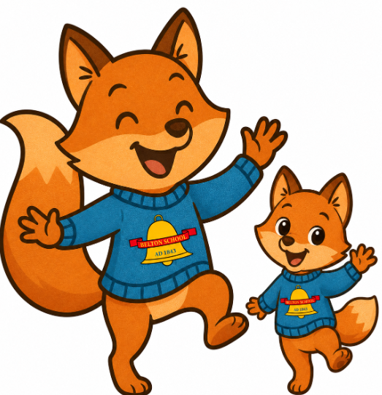
Autumn 1 2026

Summer 2
2026
As mathematicians…
Across EYFS, Year 1 and Year 2, we will develop our understanding of place value. We will begin with numbers to 10 in EYFS and build our knowledge through Year 1, progressing to numbers up to 100 in Year 2.

As historians…
In History, we will explore how holidays have changed over time. Children will compare their own holiday experiences with holidays in the past, considering how people travelled, where they stayed and how they spent their time.

