As writers… 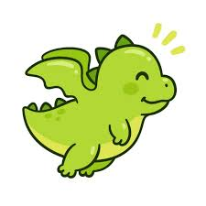
In our writing lessons, we’ll explore the world of dragons through The Dragon Machine by Helen Ward. We’ll create our own dragon encyclopaedia, focusing on using verbs and adverbs to enhance our descriptions. We’ll also learn to add suffixes to words and practice writing complete sentences that start with capital letters and end with full stops. This engaging approach will develop our writing skills and spark our imagination. Get ready to unleash your creativity in the magical realm of dragons!

As scientists…
We are going to become plant detectives, investigating what different plants need to grow and the different kinds of environments plants can live in.



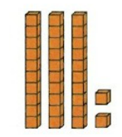
Fantastic Foxes

Spring 2
2026
As mathematicians…

Year 1
We will be developing our knowledge and understanding of place value up to 50. We will be counting by making groups of ten, partitioning numbers into tens and ones and looking at one more and one less.
After this we will be exploring length and height.

Year 2
We will be continuing our work on multiplication and division focusing on the 5 and 10 times tables. We will then be moving onto length and height, comparing and ordering different lengths and heights. We will also be using the four operations with length and height.

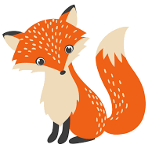
As unique individuals…
We will be thinking about how we are similar to
each other and how we are different. We will talk
about how we can care for ourselves, others and animals.
We are also going to be exploring rules and how we can make democratic decisions.

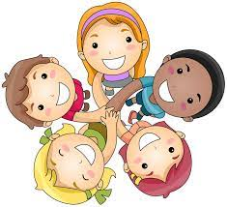

As people of faith…
We’ll explore how Christians celebrate Easter, focusing on traditions like church services and family gatherings, and discuss the significance of Jesus’ resurrection in their faith.



As musicians…
We are going to be developing our understanding of
pitch and using this to help us create a series of short compositions which we will perform to each other.

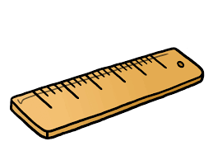

As historians…
As historians, we’ll explore toys from the past and see how they’ve changed over time. From wooden dolls to tin soldiers, these toys tell us a lot about what kids enjoyed and how society has evolved. It’s fascinating to see the creativity behind them!

As designers…
In our DT curriculum, students explore building structures using paper, testing their strength and stability. It’s all about creativity and understanding how design works in the real world!

