As writers…
Through the Literacy Tree units ‘I Want My Hat Back’ and ‘The bear and the Piano’, children will explore themes of courage, bravery and imagination while developing key literacy skills. In I Want My Hat Back, they will learn to express emotions through character role play and letter writing. In "The Bear and the Piano," students will learn about noun phrases, news reporting, and narrative story writing. Across both units, children will strengthen their reading comprehension, vocabulary, and writing skills, fostering a deeper love of stories.

As scientists…
In the Uses of Everyday Materials unit from Developing Experts, children will learn to identify different materials and what they are used for. We will also be exploring how materials can change shape, stretchiness of materials, how materials change shape when building a road.


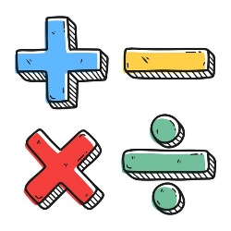

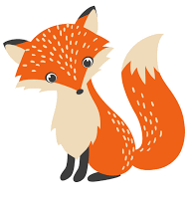
As computer technicians…
We will be learning about internet safety, online emotions, posting and sharing online and how much time should we spend on technology?

As people of faith…
Children will learn about Islam and their beliefs, how Muslims live, their customs and celebrations. The children will be learning about the Five Pillars of Islam, who is Prophet Muhammad and why he is important to Muslims and their faith.

As designers…
In the Key Stage 1 Craft and Design unit, they will explore is it art? They will learn techniques such as wool wrapping, warp and weft and fibre art.

As geographers…
What is the weather like in the UK? Children will learn where the UK is in the world and what the seasons are. They will learn about compass directions, is the weather the same everywhere, and how people prepare for different types of weather.
As unique individuals…
In the Kapow KS1 unit Safety and the Changing Body, children learn about surprises, appropriate contact and respecting personal boundaries.

This Photo by Unknown Author is licensed under CC BY
As mathematicians…
Children in Year 1 will be building on their Addition and subtraction skills through finding near doubles, related facts and missing number problems. In Year 2, they will be exploring multiplication and division. Children will build on their knowledge and skills through making equal groups, using arrays, counting in 2’s, 5’s and 10’s and problem solving.

Fantastic Foxes

Spring 1
2025

