Maths Apps and Websites to help

White Rose 1 minute maths (KS1)

Please look at this resource that can be used for building your child’s mathematical ﬂuency. The App version is free to download on cell phones and tablets. It does not need a signup or login and can be used when oﬄine.

For mobiles and tablets
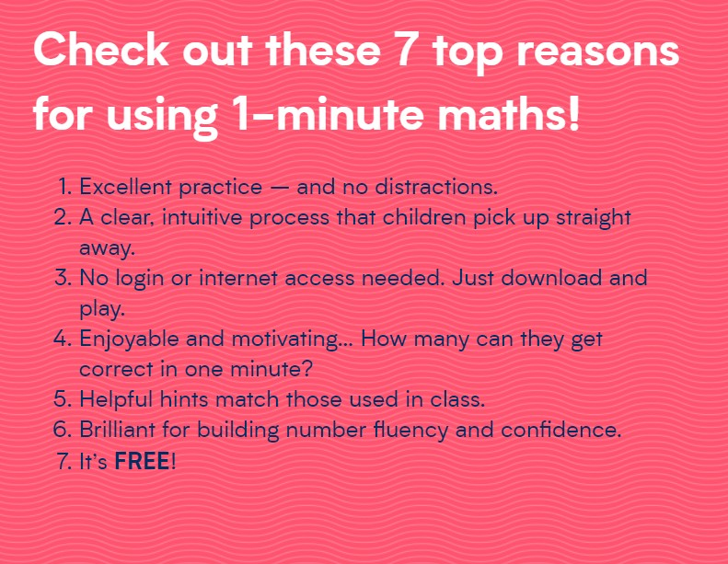
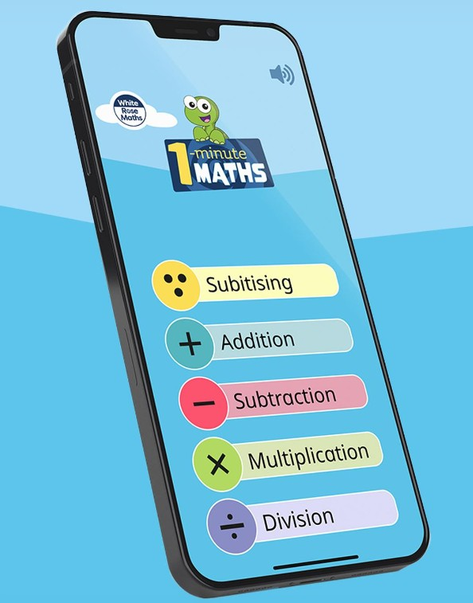


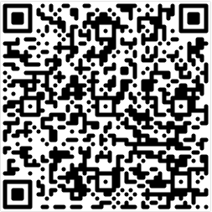
https://play.google.com/store/apps/details?id=com.whiterosemaths.oneminutemathsks1&hl=en_US


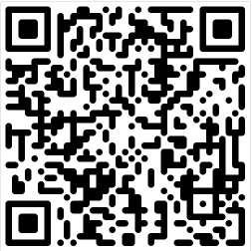
https://apps.apple.com/br/app/1-minute-maths/id1584136366

Times Tables/ Numbots

Your child has a log – in for this website. It is an expectation that all children do this as part of their homework. Please see your child’s teacher if your child can’t log-in.

https://ttrockstars.com/?lang=en

Numbots – KS1 + Year 3 – ensuring quick recall of number bonds.

KS2 + Year 2 – TTRockstars for quick recall of tables

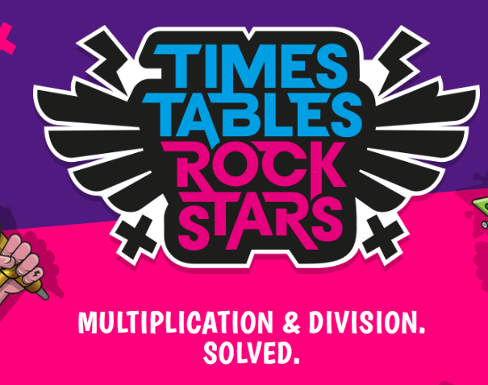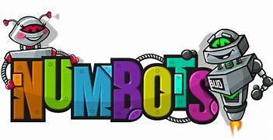

https://www.mathswithamouse.co.uk/home

Videos to help with understanding of Maths concepts such as addition, division etc. Games to play for Times Tables. SATS revision site and arithmetic. All free.





To help with arithmetic. Upper Key Stage Two have a log-in for this.



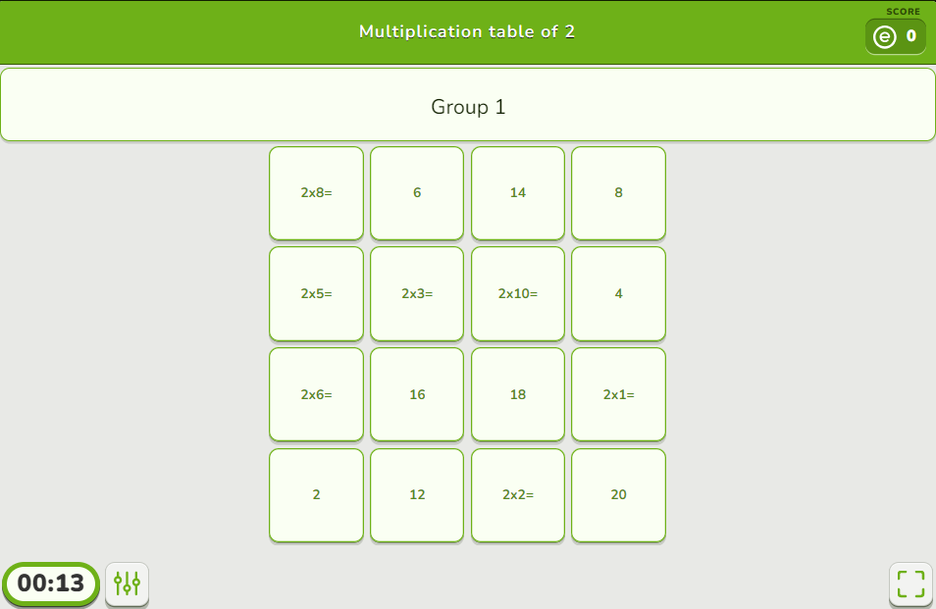
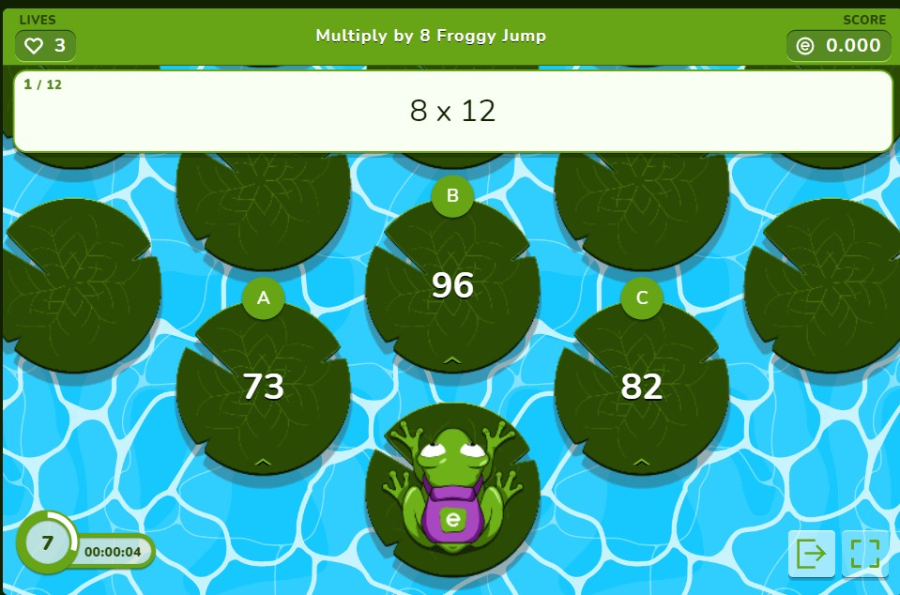

https://www.educaplay.com/learning-resources/?q=math&ageMax=12&areas=9


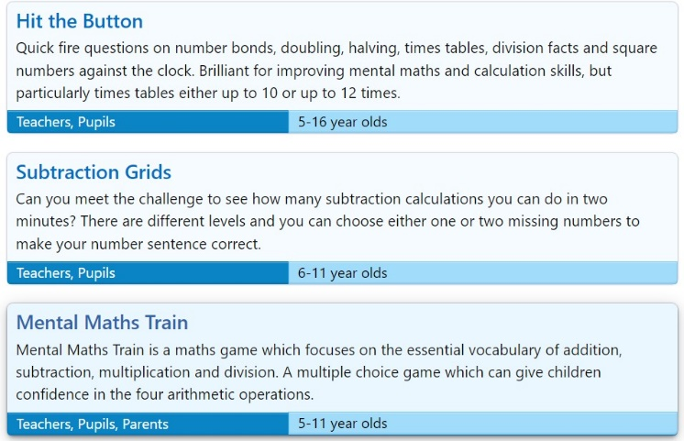
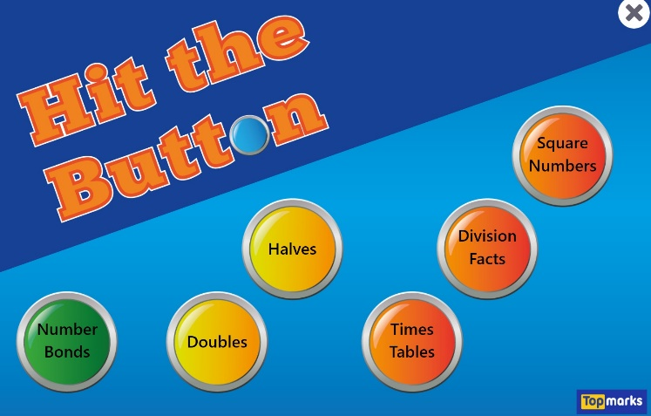

https://www.topmarks.co.uk/Search.aspx?Subject=16&AgeGroup=3


https://mathsframe.co.uk/en/resources/category/22/most-popular

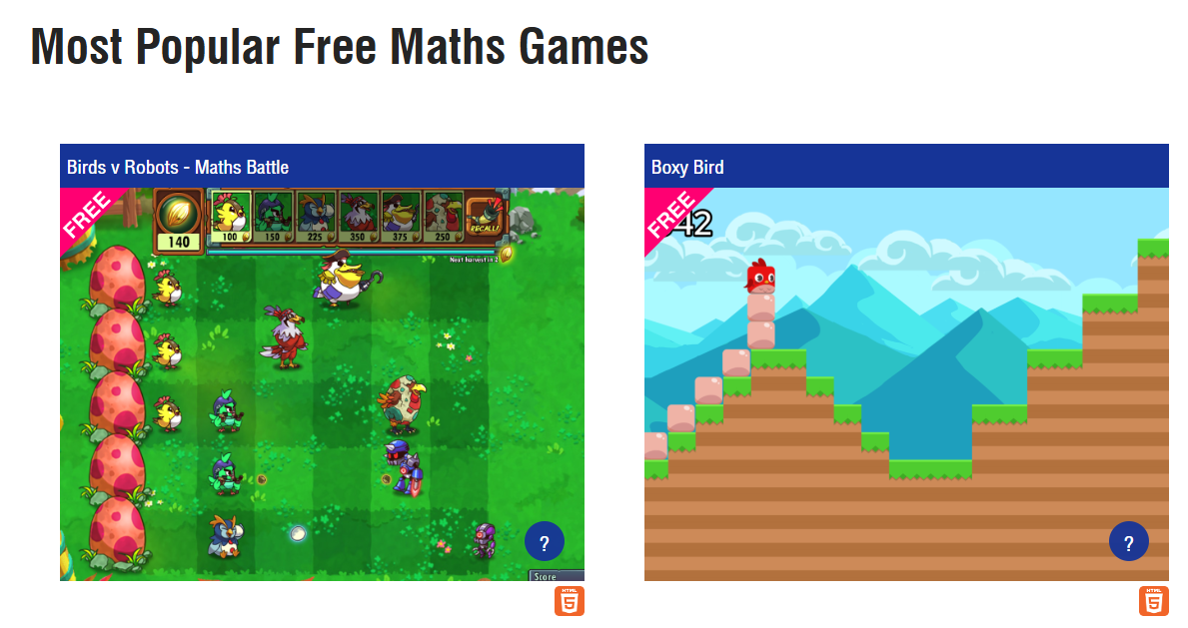

https://www.mathplayground.com/fraction_forest_part1.html



