
We have had a great time celebrating Times Tables Rockstars.
But why did we celebrate it?
Times Tables are a part of our Mathematical building blocks that help us with other areas of Mathematics such as fractions, decimals and percentages. Knowing our times tables helps us to create a solid Maths house. If we are weak at this area then we will find other areas of Mathematics trickier.
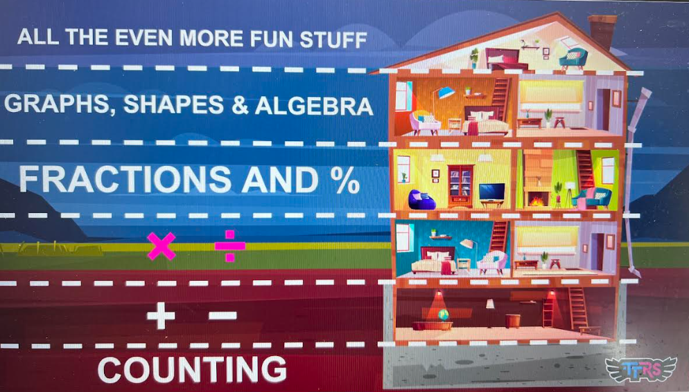
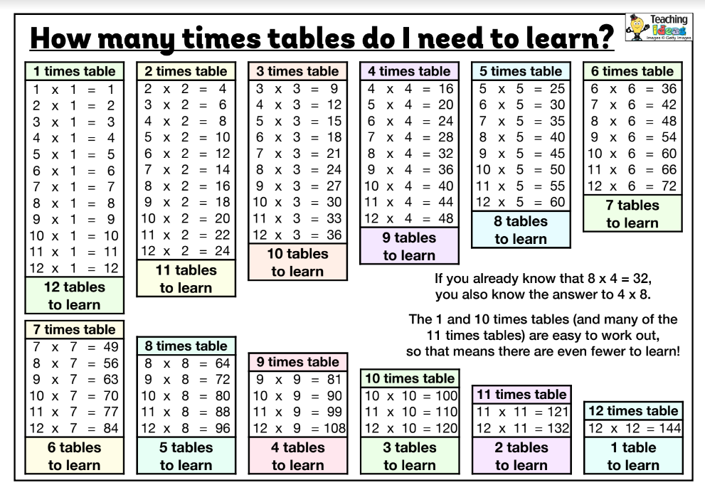

How can we help at home?
- Encourage our children to play with TT Rockstars
- Have a look at other number games online such as:-
https://www.timestables.co.uk/
https://mathsframe.co.uk/en/resources/resource/318/Tommys-Trek-Times-Tables (free)
https://www.topmarks.co.uk/maths-games/hit-the-button
https://www.mathswithamouse.co.uk/terrific-tables
- Sing times tables to pop songs. Type pop song times tables into You Tube… Here are my favourites to get you started……
https://www.youtube.com/watch?v=kWZU6jLdL0M (8 times tables)
https://www.youtube.com/watch?v=tpCSKln_Gzc (9 times tables)
https://www.youtube.com/watch?v=jb2_akO5mdA (6 times tables)
https://www.youtube.com/watch?v=w7N0IsaGVbg (2 times tables)
- Make times tables fortune tellers
https://www.multiplication.com/resources/cootie-catchers
- Play times tables board games
https://matheasily.com/multiplication-board-games.html
- Times Tables colouring
https://www.coloringsquared.com/free-coloring-pages-math-for-kids/math-fact-coloring-pages/free-multiplication-worksheets-math-kids/
- Times Table Snap
Have some cards with the times table equation. Turn over – first person to shout out the correct answer gets the card. The one with the most cards wins.
- Times Table Tennis
Choose a time table and count upwards to 12 x 12. If you get it wrong you must start again.
- Times Tables Tricks and rhymes
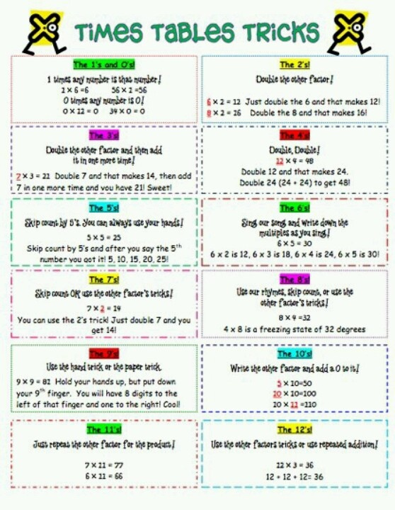
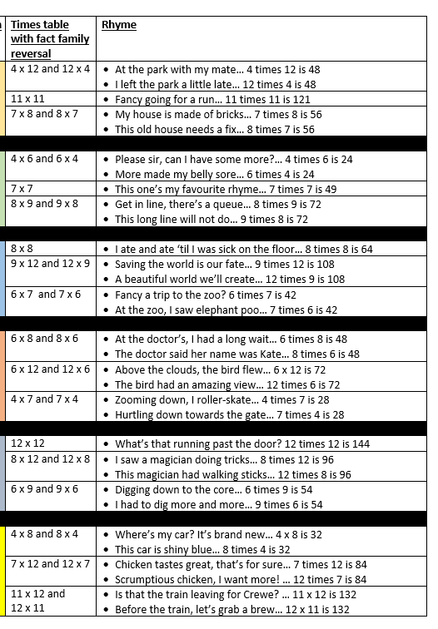

I hope you have found our leaflet helpful. Times Tables can be practiced anywhere. In the car, the bath or even eating breakfast. Have fun!
Mrs Yendall – Maths Co-ordinator

Please see your class teacher who can also help with resources

