As writers…
Through the Literacy Tree units ‘Lubna and Pebble’ and ‘Jim and the Beanstalk’, children will explore themes of friendship, kindness, and imagination while developing key literacy skills. In Lubna and Pebble, they will learn to express emotions and build empathy through character description and dialogue, and in Jim and the Beanstalk, they will study story structure, sequencing, and descriptive language. Across both units, children will strengthen their reading comprehension, vocabulary, and writing skills, fostering a deeper love of stories.

As scientists…
In the Seasonal Changes unit from Developing Experts, children learn to observe how weather, daylight, plants, and animals change across the four seasons. They develop skills in observation, recording, and pattern-spotting, gaining a clear understanding of how the seasons affect the natural world.



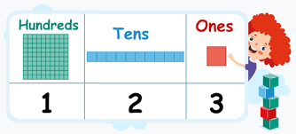
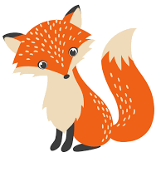
As geographers…
What Is It Like Here?, children will learn to explore and describe the local environment, including its human and physical features. They will develop skills in observation, map reading, and using geographical vocabulary to compare different places.
As unique individuals…
In the Kapow KS1 unit Safety and the Changing Body, children learn about staying safe, how their bodies change, and healthy habits, including how and when to call emergency services.

As people of faith…
Children will learn about Jewish beliefs, practices, and ways of life. They will explore key symbols, celebrations, and customs, gaining an understanding of how Jewish people live and express their faith in everyday life.

This Photo by Unknown Author is licensed under CC BY
As mathematicians…
Children will build key understanding in addition and subtraction by learning to combine and partition numbers, use number bonds, and apply these skills to solve real-life problems. They will develop strategies such as counting on and back, using number lines, and understanding fact families. In the shape unit, children will explore 2D and 3D shapes, identifying their properties, recognising patterns, and using correct mathematical vocabulary.

As performers…
We will perform a Nativity by learning lines, songs, and actions, practicing together, and working as a team to retell the Christmas story for an audience.



As designers…
In the Key Stage 1 Design and Technology unit Structures, children will learn to build strong and stable structures using different materials, exploring shapes, joining methods, and basic design skills.

Fantastic Foxes

Autumn 2
2025

