Intent:
Our intent is to develop the whole child by having a holistic approach to development. We develop the physical, cognitive and affective development of children, so they know, show and grow.
Physical- what we are doing (the driver/physical driver) (HANDS) SHOW- How
Cognitive- metacognition thinking – teaching the pupil to think about thinking - Key NC links (POWER OF THREE) three points (HEAD) KNOW- What
Affective- how we feel/ attitudes (using value- link to school value) (HEART) feeling- social/emotional) GROW- Why
Physical development key:
Gross motor skills (GMS): coordination of the arms, legs and other large body parts
Fine motor skills (FIMS): smaller movements that occur in the wrist, Hands, fingers, feet and toes.
Fundamentals of movement: (FOM)  AGILTY – start and stop, change direction, change of speed, high and low, reaction, sequenced movement  BALANCE - static, dynamic, rotational, counter  COORDINATION  Object control Skills- (OCS) | Fundamental Movement Skills: (FMS) |  |  | Fundamental Sport Skills: (FSS)
 | Locomotor | Stability | Manipulation | Invasion | Striking and fielding- | Net-Wall
 | Walking  Running  Hopping  Skipping  Bounding  Leaping  Jumping  Rolling  Galloping  Sliding  Dodging | Balancing  Landing  Turning  Twisting  Bending  Stretching  Extending  Flexing  Hanging  Bracing  Rotation | Throwing  Catching  Striking  Kicking  Dribbling  Bouncing  Pulling  Pushing  Carrying  Trapping  Collecting | Teamwork  Decision making  Spatial Awareness  Tactics  Athletics:  Starting  Jumping  Running  Power  Strength  Flexibility | Communication  Travelling  Striking- body part, direction, accuracy, power, preparation, contact, follow through, recovery  Sending- static target, moving target, overarm, underarm  Receiving- eyes, hands, feet, base, head, preparation, different objects | Volley  Bounce  Over a barrier  Spins  Tactics  Recovery  Creative Movement:  Rhythm  Body Coordination  Spatial Awareness  Free expression  Strength

FOCUS |  | Term 1 |  | Term 2 |  |  | Term 3 |  |  | Term 4 |  | Term 5 |  | Term 6
OUR PHYSICAL DEVELOPMENT FOCUS  (HANDS) |  | Body Management (FOM)  Development | FOM development  (OCS) | Balance, Flexibility, Control and Strength  (FMS) |  | Outdoor Adventurous Activity  (FMS) | Creative movement Development  (FOM, FMS) | Multi Skill  Development  (FOM,FMS) |  | Net/Wall Development  (FSS) | Hand Invasion (FMS) Development  (FSS) | Quad kids Athletics  (FSS) | Hand Invasion (FMS) Development  (FSS) | Sports Day practice and free PE  (FSS) | Striking and Fielding Development  (FMS)
VEHICLE/SPORTS WE CAN USE  (HANDS) |  | Tag Rugby, Kabbadi | Football, Hockey | Gymnastics | Orienteering/  Team games |  | Dance |  | Team games- e.g capture the flag | Tennis, Badminton, TT, Volleyball | Hockey ,Handball, dodgeball | Athletics | Basketball, Netball, Shuffle ball | Sports Day events |  | Cricket, Rounders, Baseball, Kickball, Longball
National Curriculum focus  (POWER OF THREE)  (HEAD/HANDS  HEART) | THEME:  EYFS/KS1 | SUPERHEROES  LOOK  MOVE  AVOID | SUPERHEROES  DUEL  WIN  LOSE | CIRCUS  MOVE  BALANCE  LAND | ADVENTURERS  SOLVE  EXPLORE  CHALLENGE |  | DANCERS  CREATE  PRACTICE  PERFORM |  | MINECRAFT  COMMUNICATE  COLLABORATE  COMPETE | SPACE INVADERS  STRIKE  REACT  ASSESS | KNIGHTS AND DRAGONS  ATTACK  DEFEND  STRATEGY | OLYMPIANS  RUN  JUMP  THROW | PIRATES  CATCH  MOVE  ASSESS | SPORTS STARS  PRACTICE  IMPROVE  ASSESS |  | CIRCUS  AIM  STRIKE  RETRIEVE
 | KS2 | LOOK  MOVE  AVOID | ATTACK  DEFEND  STRATEGY | CREATE-PRACTICE  PERFORM  PRAISE | SOLVE  EXPLORE  CHALLENGE |  | CREATE-PRACTICE  PERFORM  PRAISE |  | COMMUNICATE  COLLABORATE  COMPETE | STRIKE  REACT  ASSESS | ATTACK  DEFEND  TACTICS | RUN  JUMP THROW | CATCH  MOVE  ASSESS | PRACTICE  IMPROVE  ASSESS |  | AIM  STRIKE  RETRIVE
OUR AFFECTIVE DEVELOPMENT  (HEART)  SCHOOL GAMES VALUE:  In line with our own School games partnership |  |  |  | 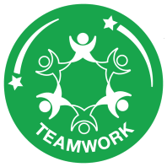 |  |  |  |  |  | 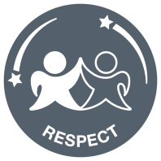 |  | 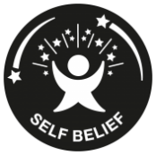 |  | 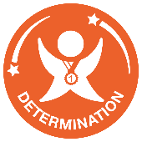
OUR COGNITIVE DEVELOPMENT  (HEAD/HEART) |  | Growth mindset |  | Dealing with perceived success and failure |  |  | Dealing with internal conflict and others |  |  | Showing respect to self, others and equipment |  | Building Resilience |  | Setting a new target/goal

We use Get set for PE as a base for our lesson structure and then implement how it meets our students needs.
Assessment Criteria:
What we will achieve with this curriculum: Using the Holistic synonyms HEAD Thinking, HANDS Doing, HEART Feeling we will develop the whole child in KS1 and KS2.

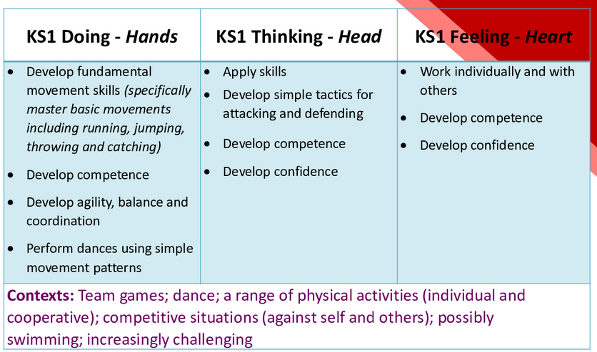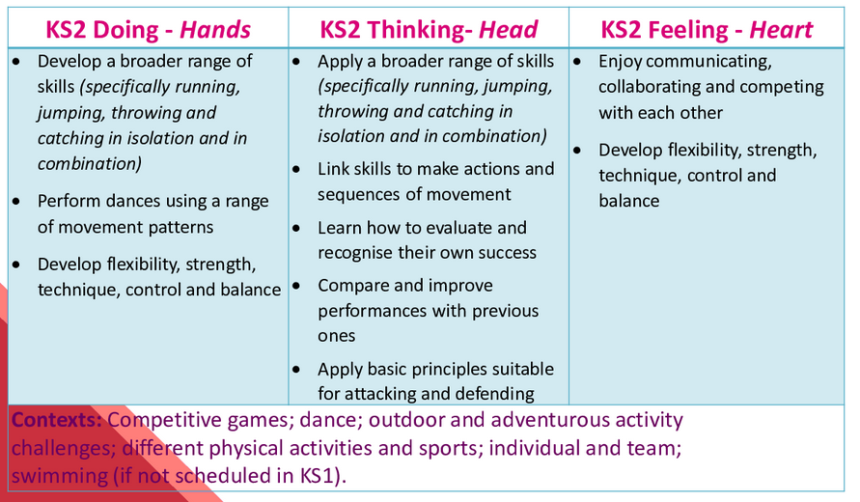

The topics clearly outlined above give continued opportunity for the above criteria to me met. With each Unit giving the chance for revisiting of learning continually throughout the year.

#
Implementation: KNOW/SHOW/GROW
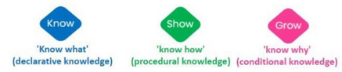
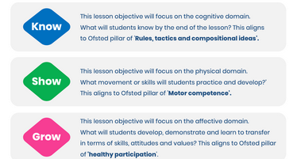

IMPACT:
