Belton CE Primary School
EYFS

Writing Policy

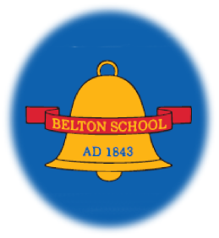

Writing in EYFS
Each week a model text is used within the EYFS class. The model texts are chosen for their quality and include a well-being / growth mindset book, a diversity-based book, a rhyming / repeating refrain book, a traditional tale and a non-fiction book each term. See Whole School Rolling Programme of Text.
In the EYFS, at the beginning of the Autumn term, writing is initiated through our phonics lessons. A new sound is taught each day through the structured Twinkl Phonics programme. The phonics programme focuses on multi-sensory learning with a picture, story, action and song for each new phoneme / grapheme learnt. These are practised daily through writing activities during the phonics lesson and are also further reinforced through carefully designed structured adult-led activities set up within the provision. The aim of the activities are to aid phonological awareness, phonological memory, rapid retrieval of letter/sound correspondence, letter sound mapping, fine motor skills and letter formation in preparation for sentence writing.
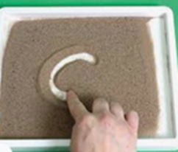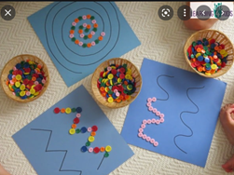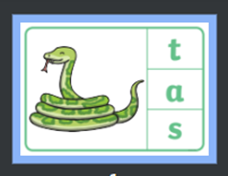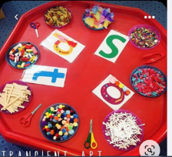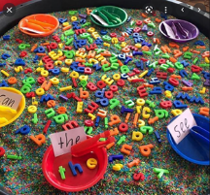

Initially, the children are taught to be able to hear each sound at the beginning and within words. Following teacher modelling, the children use their knowledge of the new graphemes to begin to label pictures with initial sounds.
“I can swim”.
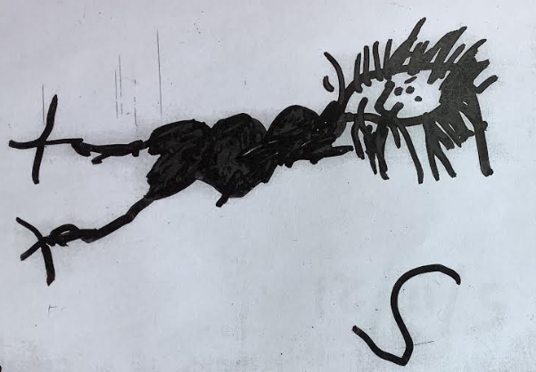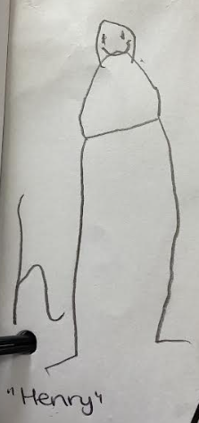

The children are encouraged to write their names from the first week of starting school. They begin by tracing over and copy writing on whiteboards as well as having access to multi-sensory activities within the provision to support this e.g. writing with feathers in sand and creating their names from playdough. With gentle encouragement and praise, the children quickly take responsibility for writing their name on each piece of work, painting and drawing they complete.
As the children build up the number of phoneme / graphemes they learn, they are taught to use a phonics card when writing.
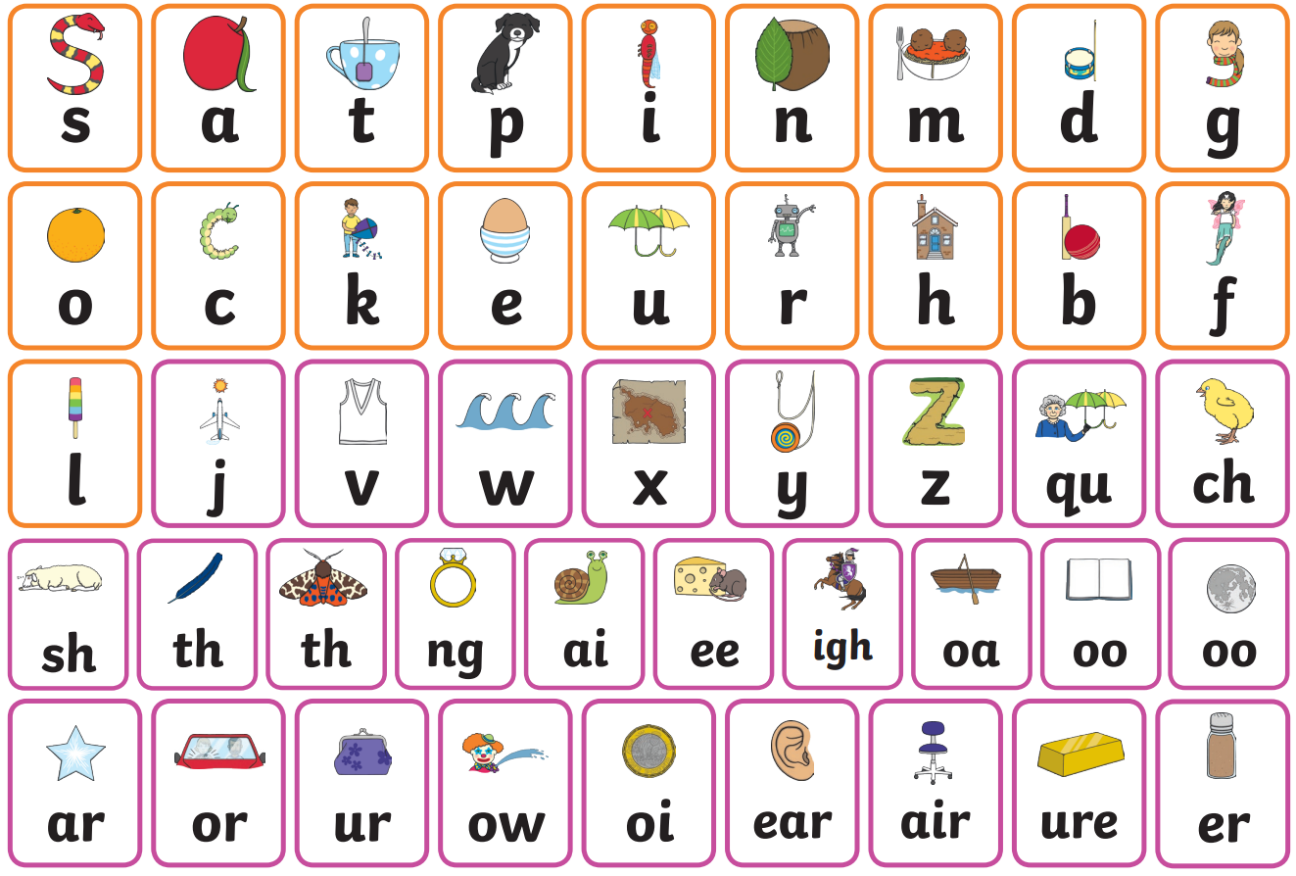
They are available for easy access when writing within the provision through play. They notice how their knowledge of phonemes and graphemes build throughout the year and are aware that by the end of the year, they will know and be able to use all the graphemes on the card independently.
In their phonics lessons, alongside the phonemes and graphemes, the children learn ‘tricky words’. The children learn the whole word in a ‘look and say’ style method and are taught that they can’t use their phonic knowledge to sound and blend or segment these words. The children learn to write stage 2 words first, followed by stage 3 and then this builds to stage 4 by the end of the summer term.
Tricky Words
Stage 2 | Stage 3 | Stage 4
I | he | said | when
no | we | have | then
go | be | like | out
to | me | so | what
the | she | do
into | you | some
 | all | come
 | are | little
 | her | one
 | was | were
The learning of the tricky words is done in a structured manner on a daily basis through the Twinkl phonics programme and is also supported by the structured adult-led activities set up within the provision.
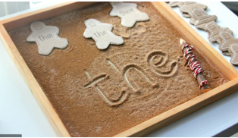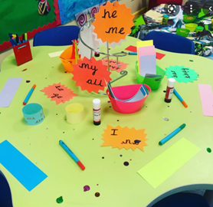
As the children build their knowledge of graphemes and phonemes, their writing lessons build in length and content. Each day a picture or pictures are carefully chosen with respect for the children’s current knowledge and interests are chosen to aid recall and reinforce the grapheme the children learnt the previous day. The pictures are used to inspire the children’s word writing, beginning with cvc words.
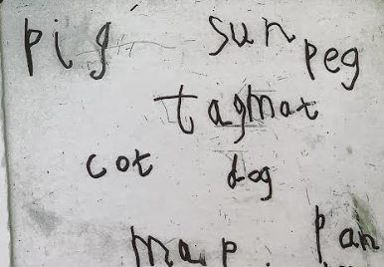
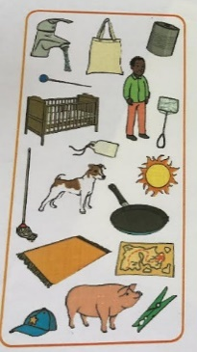
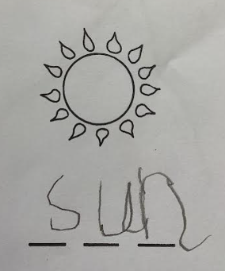

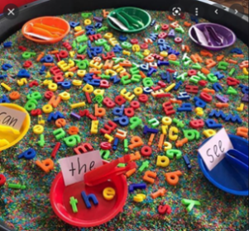
The children are taught to segment words by saying the words slowly and in a disjointed manner ‘like a robot’ and moving their arms backwards and forwards in front of them (like a robot) to add an additional element to their sensory learning. They are encouraged to listen to the sounds in the word they segment and represent each sound with a grapheme.
Through daily structured lessons, single word writing continues to develop and are encouraged throughout the provision.
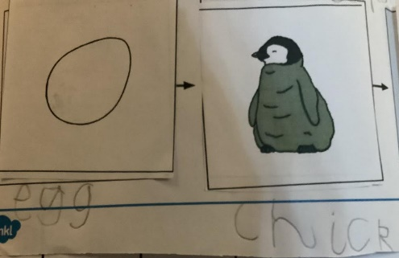

Towards the end of the Autumn term, phrases and captions and then sentences are introduced and modelled on the white board on a daily basis. The children are inspired to write daily through activities connected with the weekly book used in class. The written activities provide a variety of writing genres including labels for pictures, captions for posters, fact sheets, lists, answers to scientific questions, cards, invitations and books.
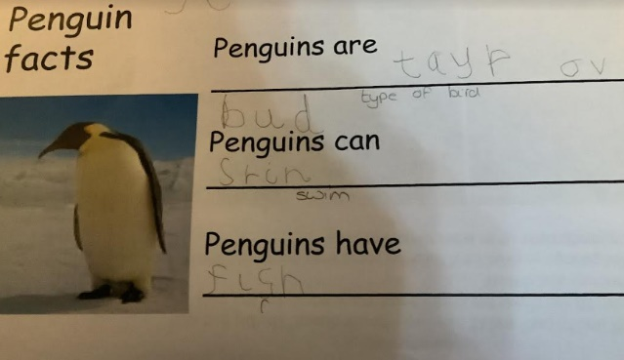
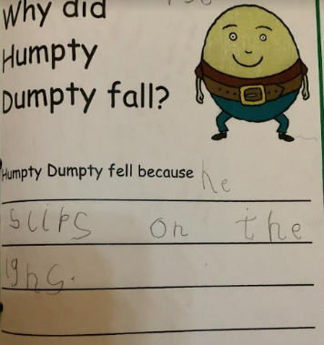

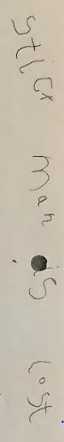

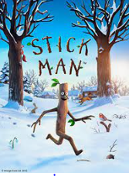

Alongside written activities inspired by the text, quality pictures continue to be used to inspire and give purpose to the writing. E.g. This picture was chosen to encourage the children to write the ‘ai’ sound.
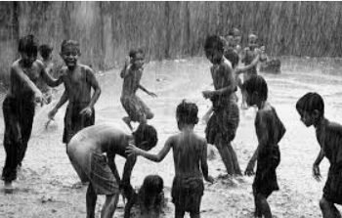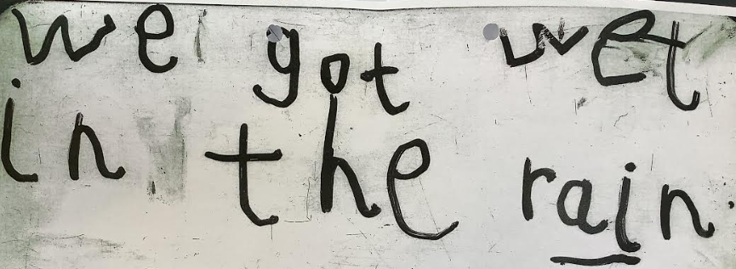
Dictation sentences are given to the children to write to ensure they are able to write using their newly learnt tricky words. Dictation takes the pressure off the children to think of their own sentences and allows them to concentrate on segmenting the phonically plausible words correctly and writing the tricky words with the correct spelling as well as focusing on structuring the sentence with finger spaces and a full stop.
Capital letters are initially introduced when name writing but are taught in more detail in the spring term when the children have a more consistent grasp of the formation of lower-case letters. This is to prevent confusion. Capital letters and letter names (as opposed to letter sounds) are introduced through the alphabet song and alphabet arc. The children have easy access to the alphabet arc and are encouraged to use it consistently during their writing lessons.
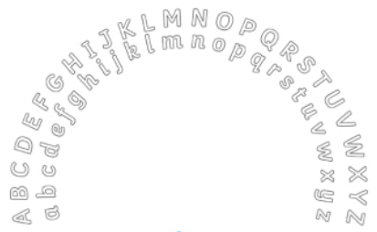
In the summer term, the children continue to write sentences daily, inspired by meaningful pictures (e.g photos from a class trip) and the weekly book used in class. The children are encouraged to self-assess their writing for capital letters, finger spaces and full stops. They are encouraged to read their work to two friends and mark the picture prompt below to show they have done this. In the summer term in the EYFS, we aspire to write at greater length and add further detail to written work in preparation for year 1.
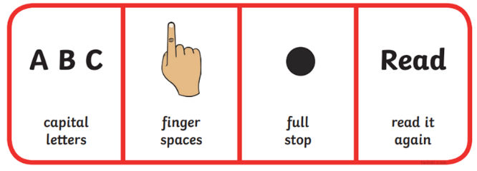

In partnership with our daily teacher led writing, we aim to provide a curriculum that is rich in opportunities for child-initiated writing during play-based learning. High level engagement is what gives the potential for high level attainment. Therefore, it is important to discover the children’s interests and observe where and how they choose to play. With this in mind, we seek to provide writing opportunities that the children are excited by and find highly engaging. The skilled adults within the provision model writing through play and we provide freely available writing resources including coloured paper, squared paper, post-it notes, scrap books, clipboards, blank stickers, little note pads and a variety of prompts for writing.
