Belton CE Primary School

Relationships Education Policy

Including Sex Education Policy

Context
This Relationships Education Policy must be read in conjunction with our PSHCE Policy.
1.1 Relationships Education in our school
We believe Relationships Education is learning about emotional, social and physical aspects of our lives, about ourselves and our relationships. It enables pupils to develop essential life skills for building and maintaining positive, enjoyable, respectful and non-exploitative relationships. It equips pupils with information and skills they need to understand about themselves, their peers and people they meet in the wider community. It explores risks, choices, rights, responsibilities and attitudes. It will help pupils to develop skills to keep themselves and others safer, physically and emotionally, both on and off line. Relationships Education enables pupils to explore their own attitudes and those of others respectfully.
1.2 Context of Wider PSHCE
We deliver Relationships Education as part of our wider provision of Personal, Social, Health and Citizenship Education (PSHCE), which also includes statutory Health Education.
The aims of Relationships Education are further supported by interventions, extracurricular and enrichment activities we provide. For example, wellbeing award developing as a Healthy School, social skills interventions (ELSA).
1.3 Aims of Relationships Education
Through the delivery of Relationships Education we intend to further our school’s aims of providing a curriculum which is relevant to the needs of pupils, both now and in the future. It will enable pupils to develop knowledge, skills and attitudes which enhance their personal development and wellbeing. This will have a direct, positive effect on their progress and achievement in school.
All adults in school will work towards achieving these aims for Relationships Education. We seek to enable our children to:
- develop interpersonal and communication skills
- develop positive, personal values and a moral framework that will guide their decisions and behaviour
- respect themselves and others, their views, backgrounds, cultures and experiences
- develop respectful, caring relationships based on mutuality, reciprocation and trust
- develop their ability to keep themselves and others safe, physically and emotionally, both on and off line
- develop their understanding of a variety of families and how families are central to the wellbeing of children
- recognise and avoid coercive and exploitative relationships
- explore relationships in ways appropriate to their age and stage of development
- value, care for and respect their bodies
- build confidence in accessing additional advice and support for themselves and others.

2. Implementing Our Policy
2.1 Inclusion
In relation to those with special educational needs or disability, we ensure our Relationships Education programme provides for those with additional needs. We recognise that those with SEND are often more vulnerable to sexual harassment and abuse and that we need to ensure that children are supported to develop appropriate strategies and attitudes to keep themselves safer. We consider:
- their level of vulnerability to coercion and pressure
- their previous experience of negative behaviours in peer or child-adult relationships
- their need to learn and demonstrate appropriate behaviour
- their need to develop self-esteem and positive body image
- the need to involve all staff, including ancillary staff and parents/carers, in policy development, planning and training
- the management of personal care
- clarity about sources of support for pupils.
2.2 Equality
The Equality Act 2010 has special resonance in Relationships Education. Through this area of learning we seek to develop key interpersonal skills such as respect and empathy which enable pupils to understand the rights and responsibilities we all have towards one another.
The protected characteristics are: age, disability, gender reassignment, marriage and civil partnership, pregnancy and maternity, race, religion or belief, sex and sexual orientation.
We will ensure that our provision of Relationships Education is not only equally accessible and inclusive for all pupils with protected characteristics, or who have family members with protected characteristics, but also that it reduces discrimination, advances equality of opportunity and encourages good relations between different groups.
In order to ensure that Relationships Education meets the needs of all:
- We will reflect a range of lifestyles and family structures so that all children see themselves and their families reflected back in the lessons.
- We will ensure that the law in relation to, for example, marriage, online behaviours, sexuality, gender and violence are explained in age appropriate ways.
- Where there are different cultural or religious views about families, relationships or behaviours, we will share these to ensure children see their family views represented.
- We will not seek to gain consensus, but will accept and celebrate difference.
- We will, as appropriate, ensure that a variety of views and beliefs are reflected back to pupils.
- In order to ensure that children of all genders can access information they need, we will teach in mixed gender groups wherever possible.
- We will encourage respect and discourage abusive and exploitative relationships.
- We will not ask children to represent the views of a particular religious or cultural group to their peers, unless they choose to do so.
We support children in developing their knowledge about and attitudes towards diversity throughout units of work including:
Families and relationships
Safety and the changing body
2.3 Safeguarding
We understand the importance of high quality Relationships Education as we fulfil our statutory safeguarding duties. Relationship Education enables pupils to understand about mutual, consensual and reciprocated relationships in all their forms. Whether the children are learning about friendships, families, relationships in school or the wider community, they will be developing essential skills which underpin their ability to recognise abusive relationships.
Teaching about Families and relationships and ‘Anti-bullying’ enables us to fulfil our statutory duty to prevent ‘peer-on-peer’ abuse.
In the case of RSE and Personal Safety, we recognise that effective teaching may alert children to what is appropriate and inappropriate behaviour (including inappropriate sexual behaviour) and that there is an increased possibility that a disclosure relating to abuse may be made. RSE and Personal Safety enable us to fulfil our duty to prevent Female Genital Mutilation (FGM). All staff are aware of the Safeguarding and Child Protection procedures and will report disclosures or concerns to the Designated Safeguarding Lead (DSL) immediately.
2.4 Development of the Policy
This policy has been developed in consultation with pupils, staff, governors and parents/carers. The consultation period followed the provision of information about the duties and statutory elements which have to be included in Relationships Education. It has also included gathering views on needs and priorities for the school community.
All views expressed by pupils, staff, governors and parents/carers about the policy have been considered. Consultation did not give a veto to individual members of the school community. The final decision on policy and delivery has been made by the school, having listened to the needs and views of the school community.
2.5 Consulting on our Policy
Before consultation activities, parents/carers, pupils and other stakeholders have been given information about Relationships Education and associated duties in ways which are accessible to them. They have been asked for their views about appropriate ages for particular topics, to share relevant views and beliefs and to consider the suitability of the school’s aims for Relationships Education.
Parents/carers and pupils have been consulted directly through sharing of draft policies, powerpoint presentation (meeting unable to happen due to Covid 19 but presentation shared on WEDUC), resources and document highlighting changes. Comments welcomed through email consultation.
Further consultation with parents/carers and pupils will be carried out when the policy is reviewed, which happens at least every 3 years.

3. Involving the Whole School Community
3.1 Working with Staff
Teaching Relationships Education can be very rewarding, but we understand that, in order to feel confident, staff need opportunities to develop their own knowledge, skills and attitudes. We recognise that every adult has different personal beliefs and attitudes, but that all teachers must understand and comply with their duties connected with safeguarding, equality and inclusion.
Teachers have a duty to deliver statutory areas of the curriculum and all teachers will be supported to develop their skills in delivering non statutory areas such as sex education. We will discuss relevant issues and staff concerns and, where appropriate, arrange training to enable staff members to feel confident in delivering the various aspects of Relationships Education. We will also encourage the sharing of good practice. We may also use team teaching to develop confidence.
Those with special responsibility for the development of Relationships Education will be offered opportunities to consult with advisors and attend external training courses.
3.2 Engaging with Pupils
We will involve pupils in the evaluation and development of their Relationships Education in ways appropriate to their age. We will seek opportunities to discuss children’s views about the content of their PSHCE lessons.
  - We will refer to local/countywide/national data e.g. Health Related Behaviour Survey for our school/district.
  - We will engage the pupils in assessment activities to establish their development needs, for example ‘Draw and Write’ activities.
  - We will encourage pupils to ask questions as they arise by providing anonymous question boxes.
  - We will ask pupils to reflect on their learning and set goals for future learning.
  - We will consult pupils (e.g. through School Council) about their perception of the strengths of our Relationships Education provision and the areas to be further developed.
3.3 Working with Governors
This policy has been developed with governor involvement, so that the governors are able to fulfil their statutory duties.
It is the responsibility of the governors to ensure, through consultation, that the Relationships Education Policy reflects the needs and views of our community.
In order to facilitate this process, the Relationships Education Policy will appear annually on the agenda of one governors’ meeting. The policy will be available on the school’s website. A link governor for PSHCE (including Relationships Education) is nominated.
It is the role of governors to ensure that:
- pupils make progress in Relationships Education in line with the expected educational outcomes
- the subject is well led, effectively managed and well planned
- the quality of provision is subject to regular and effective self-evaluation
- teaching is delivered in a way which is accessible to all
- clear information is given to parents/carers
- the subject is resourced and taught in a way which enables the school to fulfil statutory requirements.
3.4 Communicating with Parents/carers
Parents/carers are the first educators of their children about relationships, emotions, empathy, respect and growing up. We recognise that many children like to receive information about relationships from their parents/carers in addition to their learning in school. Therefore we seek to work in partnership with parents/carers when planning and delivering Relationships Education. We will encourage this partnership by:
Sharing details of our curriculum on our website
Informing parents/carers by newsletter or leaflet of forthcoming Relationships Education topics Personal Safety, Anti-bullying and RSE
Inviting parents to learn more about the approach used in Relationships Education and RSE
  - Providing supportive information about parents’ role in Relationships Education
  - Inviting parents to discuss their views and concerns about Relationships Education on an informal basis through drop ins
  - Signposting parents/carers to sources of support to help them address the needs of their child or build their own confidence in talking about relationships with their children.
3.5 Working with External Agencies and the Wider Community
We believe that all aspects of Relationships Education are most effectively taught by those who know our pupils well and are aware of their needs. We encourage visitors to our school, who may enhance, but never replace, our planned provision. We will work closely with visitors to ensure that the needs of our pupils are met.
We will follow this Code of Practice when working with visitors:
  - The care and management of pupils is the responsibility of the school at all times.
  - In class teaching situations, visitors will not be asked to work alone with pupils, but will be supported by a member of staff.
  - The school will know whether visitors are DBS checked and arrangements will be made to accompany them as appropriate.
  - All visitors will be made aware of the content and principles of this Policy, prior to their visit.
  - All lessons will be planned in direct liaison with the PSHCE Co-ordinator/Class teacher, taking account of the age and needs of the group and the context of the work within the Relationships Education programme.
  - Visitors will be reminded that, whilst contributing to Relationships Education in a classroom setting, they must adhere to the same confidentiality code as staff members. Class teaching must be seen as separate from health or other targeted interventions to support wellbeing.
  - Any resources which a visitor wishes to use or distribute will be discussed and agreed with the PSHCE Co-ordinator and Class Teacher beforehand.
  - The contributions of visitors will be regularly monitored and evaluated.

4. Curriculum Organisation
Our Relationships Education Curriculum (see appendix) is wholly consistent with the DfE statutory requirements for Relationships Education and Health Education (2020), National Curriculum (2014), other DfE and OfSTED guidance. It also reflects best practice described by the Sex Education Forum and PSHE Association. We consider Relationships Education to be a continuous process of learning, which begins before the children enter our school and continues into adulthood. We have planned a curriculum appropriate to each age group with a spiral of progression. All adults working with children have a part to play in supporting the delivery of Relationships Education.
Relationships Education is learning about:
Families and relationships
Safety and the changing body
Health and Wellbeing
Our PSHCE topic structure does not separate delivery of Relationships Education from Health Education and wider PSHCE. We deliver topics which, taking the lead from children’s lived experiences, consider related themes including development of knowledge, skills and attitudes in an integrated way. We do teach some aspects discreetly in year groups
Relationships Education will be taught in:
  - PSHCE through designated lessons, circle time, focused events, health weeks
  - Other curriculum areas, especially Science, English, RE, PE and computing
  - Enrichment activities, especially our assembly programme, growth mindset approaches, visits from the Life Education Centre, social skills groups, involvement in school trips and adventurous activities, activities carried out as part of our development as a healthy school.
4.1 Teaching Methodologies
Our aim is that teachers use a range of teaching methodologies where skills such as communication, compromise and negotiation are practised in classroom situations and where attitudes such as respect and empathy are modelled and discussed. We encourage teachers to ensure that group work, debate, taking other people’s view points and working together are practised in all PSHCE lessons and across the wider curriculum. Our Relationships Education lessons are not simple opportunities to give information, but to explore views and perspectives and develop possible solutions through discussion and interaction.
In keeping with this approach we base our curriculum on a series of questions children will have the opportunity to engage with, rather than banks of knowledge they will acquire.
Ground Rules: Relationships Education is taught in a safe, non-judgemental environment where all adults and children are confident that they will be respected. Specific ground rules will be established at the beginning of any Relationships Education work, in addition to those already used in the classroom. They will cover the following areas:
  - appropriate use of language
  - the asking and answering of personal questions
  - strategies for checking or accessing information.
Distancing Techniques: In order to protect children’s privacy, we will employ teaching and learning strategies which enable them to discuss issues without disclosing personal experience. For example, we will use fiction, puppets, case studies, role-play, videos, theatre in education to enable children to share ideas and opinions and to practise their decision-making skills in a safe learning environment.
4.2 Anti-bullying and Friends and Family
See anti bullying policy
4.3 Relationships and Sex Education (RSE)
Our topic, RSE, combines elements of Relationships Education (e.g. learning about families, personal safety and emotional wellbeing) with aspects of Health Education (e.g. learning about the spread of illnesses and the changing adolescent body). This combination offers the best location for our provision of non-statutory sex education. Although ‘RSE’ as a subject is not statutory at primary level, many aspects of our RSE topic are statutory parts of Relationships Education and Health Education. Some elements of our RSE topic are part of the statutory National Curriculum for Science (e.g. the biological aspects of puberty, reproduction and the spread of viruses).
We will ensure that children receive teaching about puberty at Y5 and Y6 in order to prepare them for the physical, emotional and social changes they are approaching or undergoing. We will review the age at which puberty is introduced depending on the needs of each cohort.
We understand that at times children will benefit from varying methods of delivering the RSE curriculum. For example, we may use single-sex groups or small group teaching where this will help us to meet the needs of particular children more effectively, we will use team teaching where this enables us to best use teacher expertise. We will ensure there are positive educational reasons for each method of delivery.

4.4 Curriculum Materials and Resources
We will primarily use the Kapow Primary and Cambridgeshire Primary Personal Development Programme and the resources recommended within it when planning and delivering Relationships Education. We will avoid a ‘resource-led’ approach, instead focussing on the needs of the children and our planned learning objectives. We will carefully select resources which meet these objectives. We will evaluate teaching resources thoroughly before using them. We will select resources which:
- are consistent with our curriculum for Relationships Education
- relate to the aims and objectives of this policy
- are suitable to the age, maturity, needs, linguistic proficiency and ability of the children
- appeal to adults and children
- are up-to-date in factual content
- are produced by a reputable organisation
- do not show unfair bias e.g. towards a commercial product, religious view point
- avoid racial, gender, sexual, cultural and religious stereotyping and heteronormativity
- encourage active and participative learning
- conform to the statutory requirements for Relationships Education.
4.5 Safe and Effective Practice
- Staff are unable to offer absolute confidentiality.
- We will reassure children that staff will act in their best interests and that this may involve sharing information if the child is at risk of harm.
- Children will be told if information is to be shared (taking special care with very young children or those with significant special needs) and will be offered appropriate support.
Professionals, such as school nurses and youth workers, are bound by their professional codes of conduct when offering advice and guidance to individual pupils. This often involves offering a greater level of confidentiality than school staff are able to give. However, in a classroom and other teaching situations, when they are contributing to our planned Relationships Education programme, they will follow the school’s Confidentiality Policy. Health professionals will ensure that children are aware of the boundaries of confidentiality when beginning work with classes.
Answering Questions: We acknowledge that sensitive and complex issues will arise in Relationships Education, as pupils will naturally ask questions. When spontaneous discussion arises, it will be guided in a way which reflects the stated school aims and curriculum content. As a first principle, we will answer questions relating to the planned curriculum for that age group or below to the whole class. We will answer questions relating to areas beyond the planned curriculum for that age group, in a sensitive and age appropriate way, only to the pupil/s who have asked the question. Teacher may decide to inform families about questions which go beyond the planned curriculum, in order to further home/school partnerships. If a member of staff is uncertain about the answer to a question which goes beyond the curriculum, or indeed whether they wish to answer it, they will seek guidance from the PSHCE leader/Designated Safeguarding Lead. In some cases the question will reach beyond the planned curriculum for Y6 and the question will not be answered in school. The child will be asked if they would like support to ask their questions at home or to another trusted adult.
When answering questions, we shall ensure that sharing personal information by adults, pupils or their families is discouraged. Where the question indicates the need for pastoral support, the conversation will be deferred to a time outside the teaching session and other colleagues may be involved. Where a question or comment from a pupil in the classroom indicates the possibility of abuse, coercion or exploitation, teachers will pass this information to the DSL in line with the school Safeguarding policy.
Sexually Active Pupils: There are extremely rare occasions where a primary-aged child, who is sexually active or contemplating sexual activity, approaches an adult. If this occurs in our school, it will be viewed as a child protection issue. The designated member of staff will follow Safeguarding Procedures and seek advice from the DSL.
4.6 Assessment, Recording, Reporting
From time to time the PSHCE leader will ask staff to reflect on the effectiveness of learning in particular units of work, using the RAG rating sheets in each unit.
We will also use a class record book to record whole class discussions and group work in PSHCE. In some cases, we will ask the children to record key learning activities in a PSHCE Book, which follows them through school, to show their development and progress.

5. Sex Education Policy
5.1 Definition of Sex Education
Following guidance from the DfE, we define Sex Education as learning about ‘how a (human) baby is conceived and born’.
This extends the learning about sexual reproduction in ‘some plants and animals’ required through the Science national curriculum. It also complements the statutory requirement to teach about puberty as part of Science and Health Education, as understanding sexual reproduction in humans enables children to understand the processes of puberty.
5.2 Consultation about Sex Education
We have a taken into account the DfE’s recommendation that all primary schools have a Sex Education programme and we understand that this is not statutory. We understand that our teaching in sex education must be tailored to the needs and physical and emotional maturity of the pupils.
Parents/carers, governors and pupils have been consulted about this and our school has decided that we will offer content in Sex Education in the context of Relationships Education and RSE.
5.3 Content of Sex Education
The content of our Sex Education programme will be gradually developed in an age appropriate way. The children will not learn about human sexual reproduction until Y5/6.
Y1/2 will learn that human babies grow inside their mothers alongside learning in Science that adult animals produce offspring like themselves. (Cats have kittens. Cows have calves etc.)
Y3/4 will learn that every human began when a seed from a male and an egg from a female join together. They will not yet learn about the means by which egg and sperm join.
Y5/6 will learn about human sexual reproduction and other ways that eggs and sperm are joined (eg IVF) in age appropriate detail. They will learn about vaginal birth and caesarean section in age appropriate ways, reflecting the experiences of children and families they know.
5.4 Teaching Methodologies
In Sex Education there is a certain amount of knowledge which has to be imparted. Teachers will give the facts in an accessible way using a range of approaches, such as picture books and scientific descriptions. We will avoid resource-led approaches which rely on worksheets or lengthy audio visual resources. Pupils will be asked to consolidate their learning in ways which enable them to develop skills to discuss sexual body parts and functions confidently.
5.5 Delivery of the Sex Education Curriculum
Sex Education will be delivered as part of our topic called Relationships and Sex Education (RSE) by a teacher, who knows the needs and natures of the children. The teacher is best placed to tailor the learning to the needs of the pupils.
Parents/carers will be informed by letter/email/via the school website about the content of the curriculum in advance of teaching and will be invited to talk to staff if they have questions.
Teachers will be offered support to develop their skills and to learn from others where needed.
5.6 Right to be excused from Sex Education
Parents/carers have the right to request that their child be excused from some or all of Sex Education delivered as part of statutory Relationships Education. Before granting any such request the Head Teacher will discuss the request with parents/carers (and if appropriate with the child) to ensure that their wishes are understood and to clarify the nature and purpose of the curriculum. The educational, social and emotional benefits for the child of being part of the lessons will also be discussed. We will record the discussion and the outcomes.
We will consider compromise arrangements which will enable the child to receive Sex Education at school (e.g. same sex teacher, same sex teaching group).
We will offer support to parents/carers who wish to deliver Sex Education at home.
If a pupil is excused from Sex Education, we will ensure that the pupil receives appropriate, purposeful education during the period of withdrawal.
The parents/carers will be asked to reconfirm their decision to withdraw their children from Sex Education each time a Sex Education element is planned for their child.

6. Monitoring, Review and Evaluation
Monitoring, review and evaluation of the Policy is the responsibility of the PSHCE leader/head teacher. The governing body will ask for information relating to the effectiveness of the policy when it is monitored every year. Information will be gathered from the Head Teacher, the PSHCE Leader parents/carers and pupils to inform judgements about effectiveness.
The policy will be comprehensively reviewed with engagement from members of the school community every three years, or sooner if an issue or incident occurs which warrants it.

7. Appendices
7.1 Our Relationships Education Curriculum
 | Autumn 1 | Autumn 2 | Spring 1 | Spring 2 | Summer 1 | Summer 2
EYFS | Self-regulation: My Feelings  Identifying my feelings  feeling jars  coping strategies  Describing feelings  facial expressions  creating a calm corner | Building Relationships: Special Relationships  My family  Special People  Sharing  I am Unique  My interests  Similarities and differences | Managing self: Taking on challenges  Why do we have rules  Building towers  Team den building  Grounding  Team races  Circus skills | Self regulation: Listening and following instructions | Building relationships: My family and friends | Managing self: Happy head, happy heart

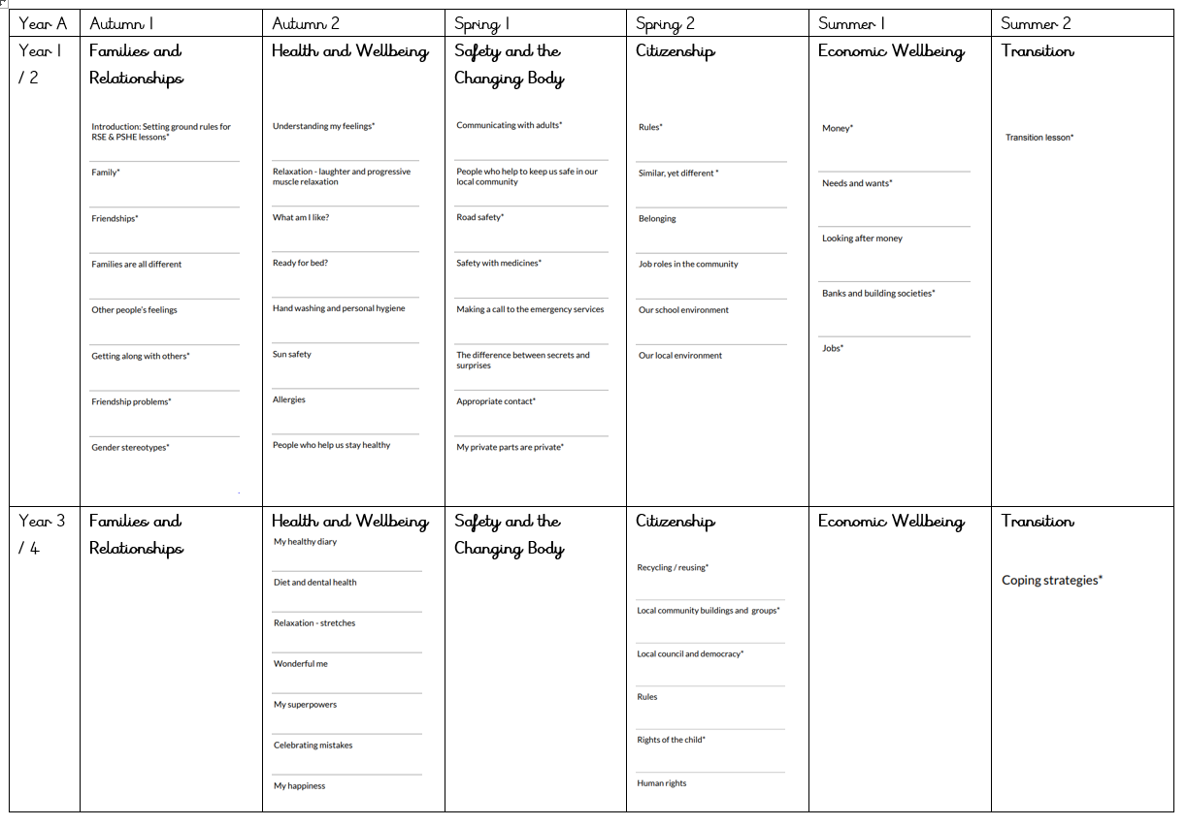
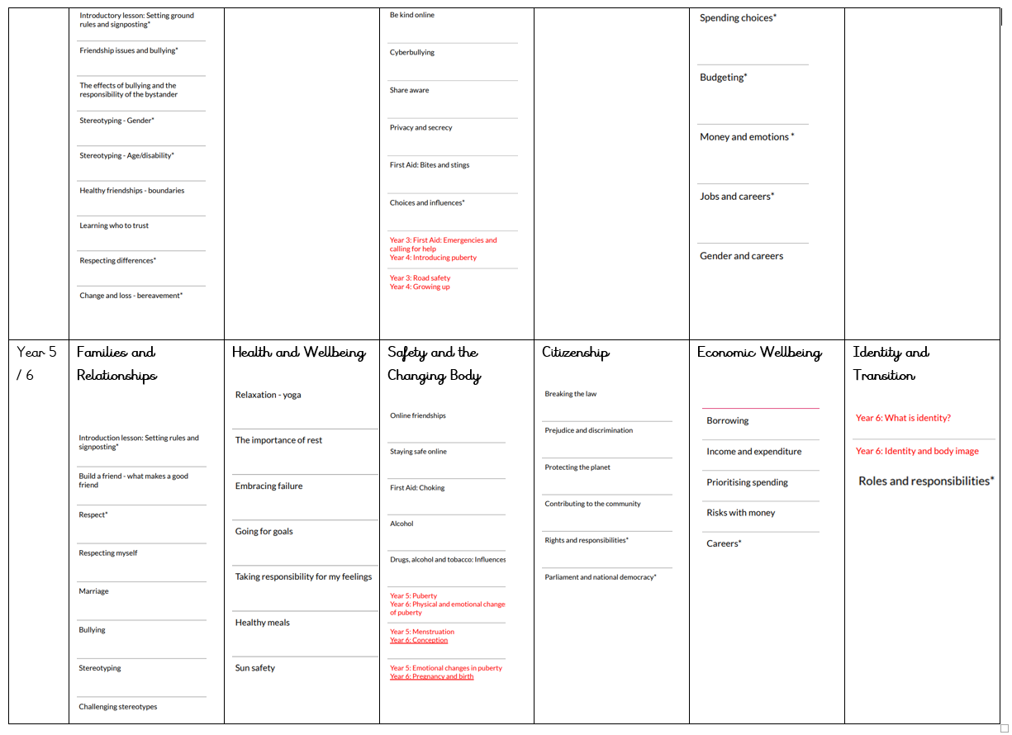
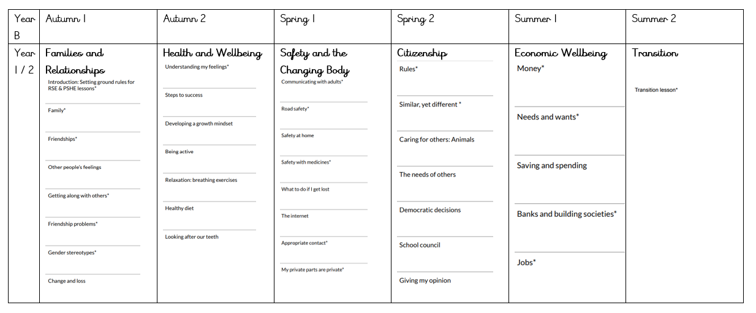
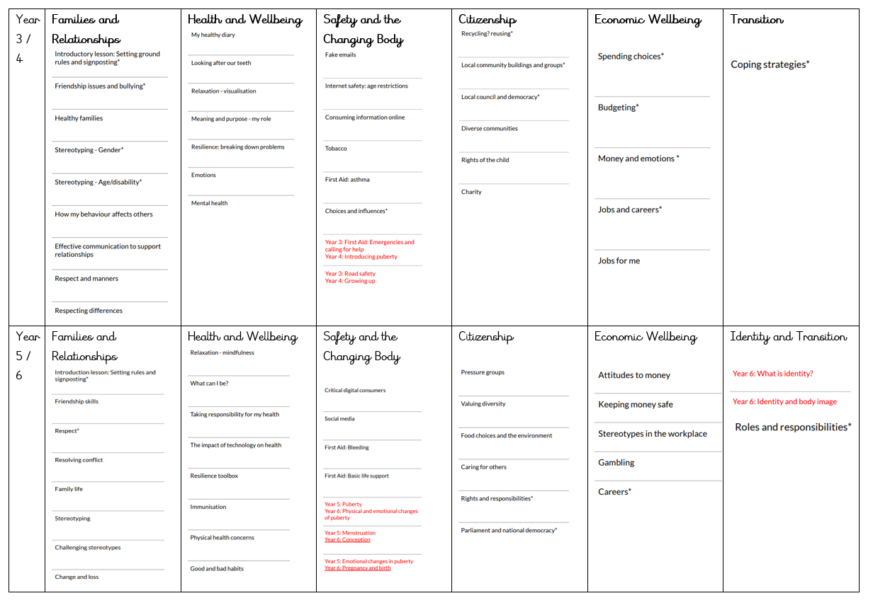
7.2 Linked National Documents
RSE and Health Education
Children and Social Work Bill 2017.
Sex and Relationships Education for the 21st Century’.
Equality Act 2010
Keeping Children Safe in Education
7.3 Our Charter: Working Together in RSE
We are all committed to working towards the implementation and development of the following entitlements.

Children and Young People are entitled to:
- Be valued and respected for who they are, taking into account their background, culture, faith, identity and needs
- Accurate, up-to-date, useful and age-appropriate information delivered in a way that meets their individual needs
- A well-planned, well-delivered RSE programme, which is flexible to cater for their changing needs over time
- Know where and how to access information, support and local services
- Be informed about confidentiality and how it affects them
- Have their views and ideas received in a respectful and non-judgemental manner
- Be involved in developing and evaluating the content, delivery and timing of their RSE programme as appropriate.

Adults working with children are entitled to:
- Access to high quality, up-to-date, accurate information, resources and training
- Mutual understanding of roles and responsibilities in relation to the planning and delivery of RSE
- Contribute their views and ideas in support of the development of RSE for their pupils
- Professional guidance and support
- A clear understanding of school policy relating to RSE.

Parents, carers and other adults in the community are entitled to:
- Accurate, up-to-date, information about RSE policy delivered in an accessible way
- A safe learning environment for their children
- Information on how and when their children are taught RSE
- Understand their right to withdraw their child from the aspects of the curriculum defined as ‘sex education’ and the process for expressing this right
- Have their views and needs listened to in a respectful, non-judgemental manner.

