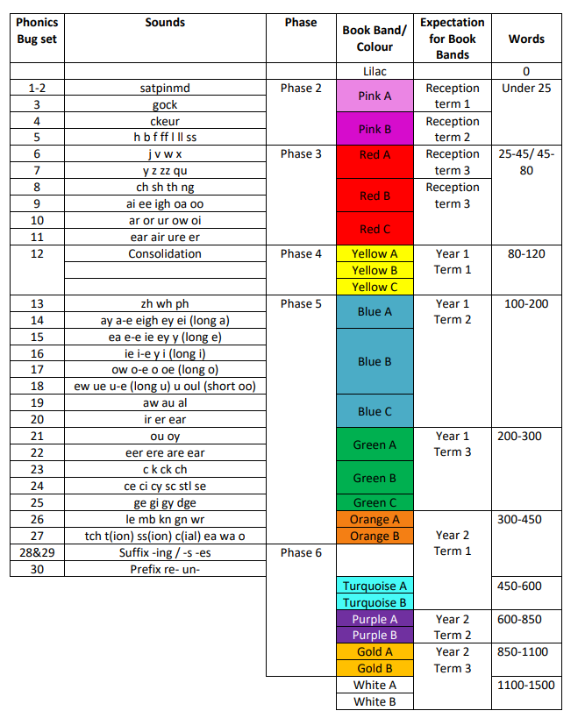
Bug Club Independent Reading Progression Guide
EYFS and Key Stage 1

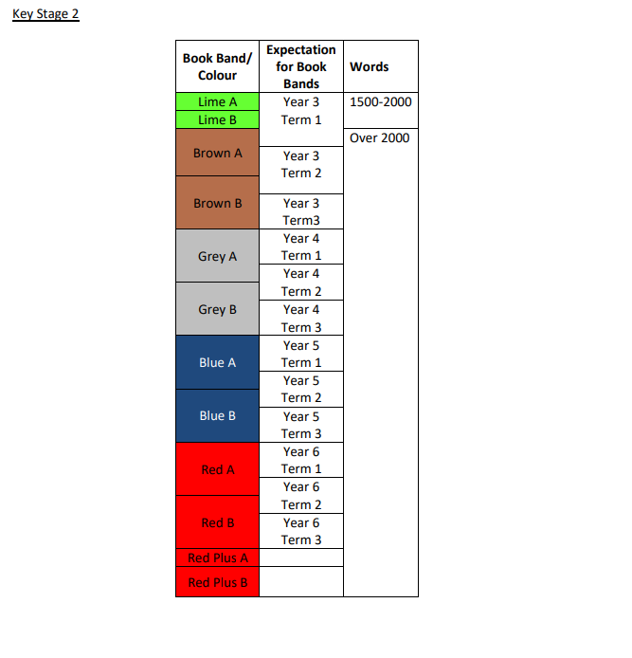
Key Stage 2

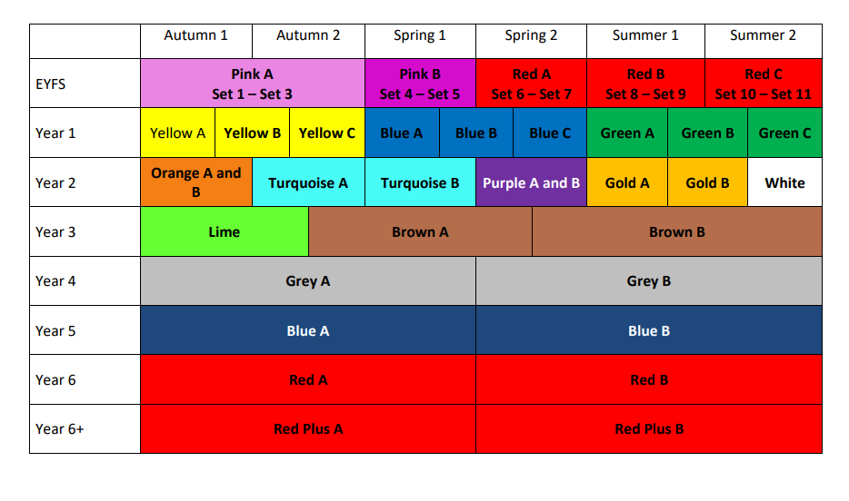
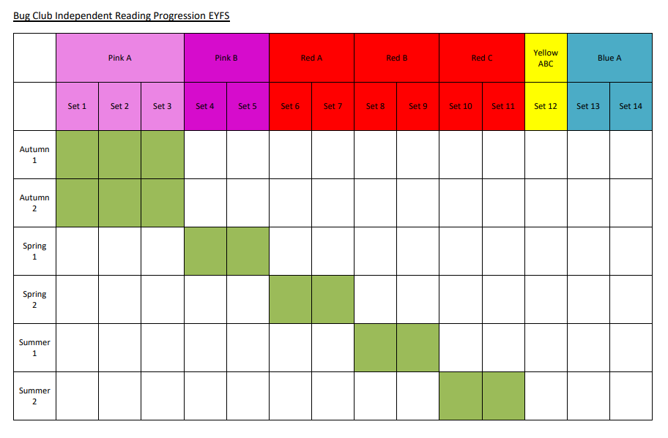
Bug Club Reading Progression EYFS
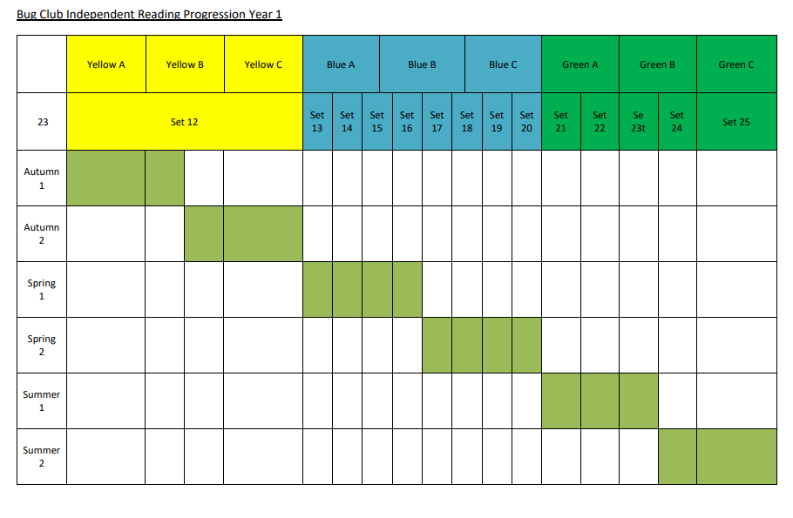
Bug Club Independent Reading Progression Year 1
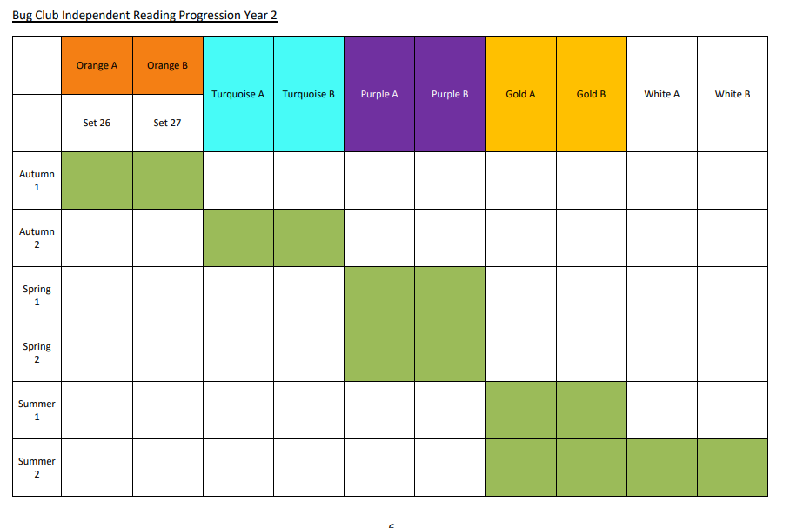
Bug Club Independent Reading Progression Year 2
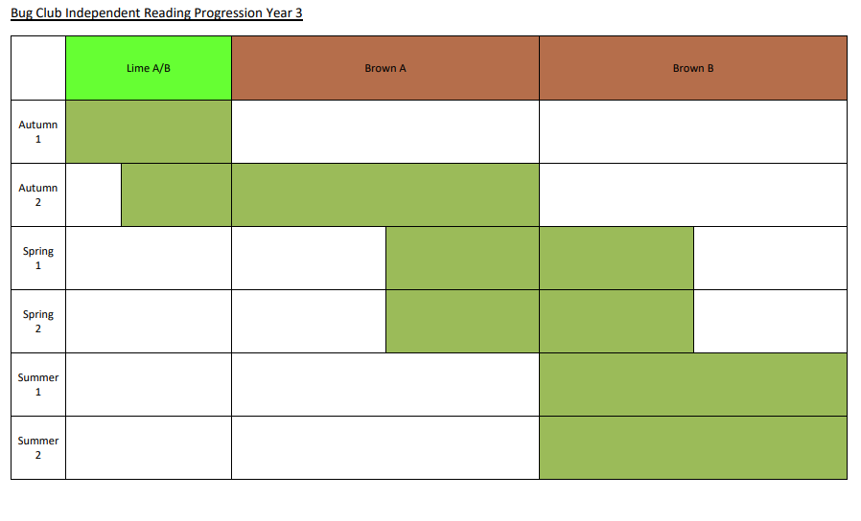
Bug Club Independent Reading Progression Year 3
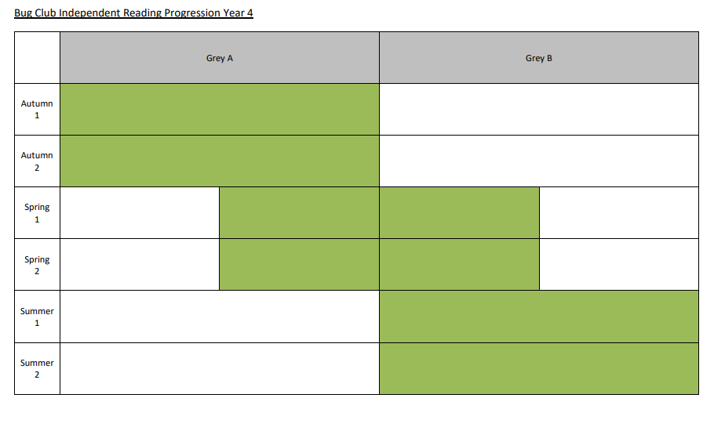
Bug Club Independent Reading Progression Year 4

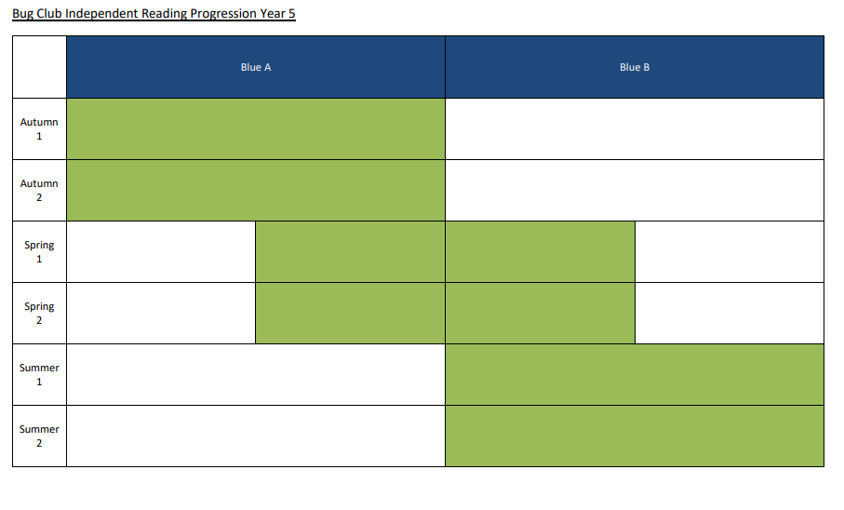
Bug Club Independent Reading Progression Year 5

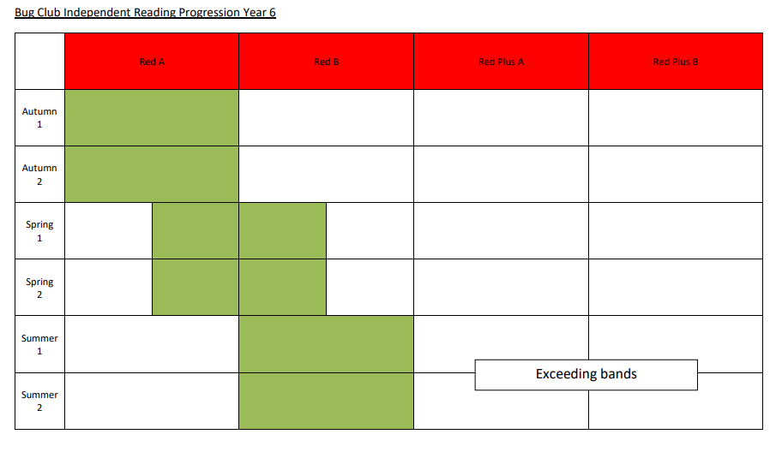
Bug Club Independent Reading Progression Year 6

Book Band Progression against PM Benchmarking

Book Band | PM Benchmark | Book Name | Age Related Expectations |  |  |  |  |  |  | Phonics
 |  |  | R | 1 | 2 | 3 | 4 | 5 | 6
LILAC | 0 |  |  |  |  |  |  |  |  | Phase/level 1
PINK Band 1 A | 1 | The Dog |  |  |  |  |  |  |  | Phase/level 2
PINK Band 1 B | 2 | Look at Us
RED Band 2 A | 3 | Monkeys Car |  |  |  |  |  |  |  | Phase/level 3
RED Band 2 B | 4 | Zac’s Plane
RED Band 2 C | 5 | Matthew is Brave
YELLOW Band 3 A | 6 | Dad’s Present |  |  |  |  |  |  |  | Phase/level 3-4
YELLOW Band 3 B | 7 | The Big Bike
YELLOW Band 3 C | 8 | Joe’s Bean Plant
BLUE Band 4 A | 9 | The Helicopter in the Box |  |  |  |  |  |  |  | Phase/level 4-5
BLUE Band 4 B | 10 | The Best Tunnel
BLUE Band 4 C | 11 | My Beach Holiday
GREEN Band 5 A | 12 | The Donkey and the Wolf |  |  |  |  |  |  |  | Phase/level 5
GREEN Band 5 B | 13 | Wet Day Popcorn
GREEN Band 5 C | 14 | Molly’s Tooth
ORANGE Band 6 A | 15 | The Ice-Cream Dog/Our Teacher Mr Davis |  |  |  |  |  |  |  | Phase/level 5
ORANGE Band 6 B | 16 | The Lucky Kick/ Emperor Penguins
TURQUOISE Band 7 A | 17 | The Swimming Race/The Lantern Parade |  |  |  |  |  |  |  | Phase/level 5-6
TURQUOISE Band 7 B | 18 | The Bags by the gate/BMX Bikes
PURPLE Band 8 A | 19 | A visit to the Aquarium/ Frogs |  |  |  |  |  |  |  | Phase/level 5-6
PURPLE Band 8 B | 20 | Amy’s Song/ Winter
GOLD Band 9 A | 21 | Scaredy Cat/ Plastic in our World
GOLD Band 9 B | 22 | A cure for Hiccups/Bushfires
WHITE Band 10 A | 23 | Flood in the Valley/Water World
WHITE Band 10 B | 24 | The Snowboard Lesson/ Why a River Floods
LIME Band 11 A | 25 | Real Teamwork/ The Greatest Climb
LIME Band 11 B | 26 | The Bigger Half/Snowboarding
KS2 BROWN Band A | 27 | The Stormy Night
KS2 BROWN Band B | 27 | Dogs Should be Kept on Leads
KS2 GREY Band A | 28 | Charlie
KS2 GREY Band B | 28 | How a Parachute Works
KS2 BLUE Band A | 29 | The Wallet
KS2 BLUE Band B | 29 | Wind Power
KS2 RED Band A | 30 | Dr Max
KS2 RED Band B | 30 | Tracking Giant Petrels
RED +

Light grey = below ARE
Dark grey = within AR
Black - = exceeding AR

