Reading Intent
At Belton CE Primary School reading is one of our main priorities and our curriculum reflects a sharp focus upon early reading from the very start of school, as it is the ability to read and understand that opens up learning to children. We aim to provide all children with a high-quality education in English that will teach pupils to speak, read and write fluently so that they can communicate their ideas and emotions to others effectively.
All children will read widely across both fiction and non-fiction to develop their knowledge of themselves and the world in which they live, to establish an appreciation and love of reading, to gain knowledge across the curriculum and develop their comprehension skills. It is our intention to ensure that, by the end of their primary education, all pupils are able to read fluently, and with confidence, in any subject in their forthcoming secondary education.
At Belton CE Primary we use appropriate quality texts for children to read covering all genres. Books are book banded in order to ensure progression and challenge right through to the end of key stage 2. The children’s ability to recognise graphemes and common exception words and their ability to blend and segment are all assessed and tracked. Children are also assessed using PM Benchmarking to ensure they read appropriately challenging books. The children are also assessed termly using NFER papers.

Reading Implementation:
At Belton CE Primary School children begin their reading journey by adopting our schools love of books and shared stories. In EYFS it is here learners are introduced to phonemes/sounds and graphemes/letters systematically. Through daily phonics sessions they also learn to develop and apply blending and segmenting skills for reading using Twinkl Phonics. This is also mirrored in Key Stage 1 with daily phonics sessions. All classes have Reading Records which are used to record how often children read to an adult in school and home. Focus children are heard read at least daily by an adult. Adults within the class support the children to choose appropriate text types for the children supported by the Bug Club scheme (see appendix 1). Children throughout school are given the opportunity to take home a book every day from our Bug Club reading scheme. Teachers allocate children with phonetically decodable books at the appropriate level for each child. Whole class guided reading sessions take place three times a week in EYFS and Key Stage 1 with a focus on vocabulary, sequencing and inference. In Key Stage 2 whole class guided reading sessions are taught daily using high quality texts from a range of genres (see rolling programme – Appendix 2). The skills taught in Key Stage 1 are built upon with a focus on vocabulary, retrieval and explanation, summarising and inference. A different reading skill is taught each day, while developing their pace, fluency, expression and general book talk.

Reading Impact:
Children’s progress in phonics is continually reviewed through periodic phonic assessments and evidence from their reading and writing. Through these, teachers identify the graphemes that need to be addressed which then informs groupings. In June, the National Phonics Screening Check is undertaken to confirm that the children have learned to decode to an age appropriate standard and determines what level of provision they will require the following year. In Key Stage One and Key Stage Two, regular assessment of the children’s decoding and comprehension is undertaken through PM Benchmarking. Reading judgements are secured through the triangulation of test data, evidence from the pupil and the curriculum. Our test data comes from NFER, SATs and PM Benchmarking.

EYFS Whole Class Reading
At Belton CE Primary we have created a book rich environment where books and quality texts are at the heart of the curriculum. In EYFS topics are inspired by a text and is further implemented through the provision. The direct teacher-led lessons of phonics enable all learners to develop and apply new skills while also providing opportunities to further apply these skills within fun and engaging activities and through continuous provision. The children are immersed in a new high quality every week and following a rolling programme of text with the theme of wellbeing and growth mindset, rhyming/ repeated refrain, diversity, traditional tales and non-fiction. (appendix 2) The specific skills taught through whole class reading sessions in EYFS are below.

Monday | Tuesday | Wednesday
Phonics activities are provided throughout the provision all week to consolidate the phonemes taught in teacher led lessons that week.
Vocabulary – challenging vocabulary is selected from the book and opportunities are given to clarify and extend pupils’ understanding of new words orally and through play. | Sequencing – the children are encouraged re-tell the text, some as exact repetition and some in their own words applying the newly taught vocabulary | Inference -offer explanations as to why things might happen, making use of recently introduced vocabulary.

Key Stage 1 Whole Class Reading

In Key Stage 1 we use a balanced and engaging approach to developing reading, which integrates both decoding and comprehension skills.
Transition from EYFS to Key Stage 1 ensures that we pass on high quality, up-to-date information about pupil’s current capabilities in reading and phonics. Teaching is then adapted accordingly to focus on exactly what each pupil needs to progress. This approach is more efficient because effort is spent on the best next step and not wasted by rehearsing skills or content that a child already knows well.

Reading in the first term has a higher emphasis on phonics and consolidating phonemes taught to help aid the fluency. The activities in the autumn term are more hands-on activities to reflect the best practise of EYFS. The year 2 children are also working on taught phonemes based on an autumn term assessment.
In the Spring term we use a wide range of explicit and implicit approaches including planning the teaching of vocabulary, modelling and extending children’s language and thinking during interactions and activities such as shared reading. The text chosen cover a range of genres and specific to Key stage 1 taken from ‘Reading Reconsidered Reading Spine’. The skills taught during this term echo the format from EYFS with vocabulary, sequencing and inference. Teachers introduce these strategies using modelling and structured support, which are strategically reduced as a child progresses until they are capable of completing the activity independently.
The summer term then has a higher emphasis on answering more formal questioning using a rage of Key Stage 1 texts from ‘Deepening Understanding’.

Autumn Term  Monday, Wednesday, Thursday | Spring Term  Monday, Wednesday, Thursday | Summer Term  Monday, Wednesday, Thursday
Phonics assessments and PM Benchmarking  A range of phonics activities linked to the phonemes taught that week.  See phonics progression document to see which phases/levels are taught | Phonics assessments and PM Benchmarking  Vocabulary (suggested ideas)  Year 1 – Draw a picture and orally rehearse a sentence  Year 2 – Locate the word and put in to a written sentence  Sequencing  Year 1 – Draw three pictures to represent the beginning, middle and end  Year 2 – Draw and write short captions to show beginning, middle and end  Inference (picture taken from the text being read)  Year 1 – write simple sentence working on prediction skills  Year 2 – write about predictions based on what has been read | Phonics assessments and PM Benchmarking  A range of Key Stage 1 texts taken from Deepening Understanding. Working on vocabulary, inference and retrieval through a more formal question and answer style

Key Stage 2 Whole Class Reading
Whole class guided reading in Key Stage 2 consists of 30 minutes per day on a 3-week cycle. Texts can link to the class topic/ Writing lesson but if not appropriate can stand alone. The important thing is that it is the correct text i.e appropriately pitched with challenge. See appendix 3 for whole school progression maps. The lesson is structured as follows:
3 Week Cycle
Week 1 | Fiction
Week 2 | Non Fiction
Week 3 | Poetry
10 minutes: Read the text, using a mixture of teacher read, pair read (to each other) and choral read (all together)
5 minutes: Model the Reading skill of the day by explaining the activity.
12 minutes: Children complete the activity in mixed ability pairs or individually.
3 minutes: Feedback from activity/extend learning with an extension.
When picking the extracts, text or books we base our selection on the appropriate pitch and challenge to the needs to the year group and children within the class. The texts have been taken from the ‘Reading Reconsidered Reading Spine’. The texts are chosen and mapped out in a year A and B cycle to suit our mixed age classes. See appendix 2. These texts cover the genres are follows:
The Archaic Language.
The vocabulary, usage, syntax and context for cultural reference of texts over 50 or 100 years old are vastly different and typically more complex than texts written today. Students need to be exposed to and develop proficiency with antiquated forms of expression.

Non-Linear Time Sequences

In passages written exclusively for students—or more specifically for student assessments— time tends to unfold with consistency. A story is narrated in a given style with a given cadence and that cadence endures and remains consistent, but in the best books, books where every aspect of the narration is nuanced to create an exact image, time moves in fits and start. It doubles back. The only way to master such books is to have read them time and again.

Narratively Complex Books

Are sometimes narrated by an unreliable narrator- Scout, for example, who doesn’t understand and misperceives some of what happened to her. Or the narrator in Edgar Allan Poe’s “The Tell-Tale Heart” who is a madman out of touch with reality. Other books have multiple narrators such as Faulkner’s As I Lay Dying. Others have non-human narrators such as the horse that tells the story in Black Beauty. Some books have multiple intertwined and apparently (for a time) unrelated plot lines. These are far harder to read than books with a single plot line and students need to experience these as well.

Figurative/Symbolic Text

Texts which happen on an allegorical or symbolic level.

Resistant Texts

Texts written to deliberately resist easy meaning-making by readers. Perhaps half of the poems ever written fall into this category. You have to assemble meaning around nuances, hints, uncertainties and clues

We focus solely on teaching a different reading skill each day, while developing their pace, fluency, expression and general book talk.
Monday  Vocabulary | Monday is the first day that they are coming in contact with a new text, meaning that they will struggle to tap into any higher order reading skill (such as inference) if they don’t understand the text on a basic level. Pick 4-5 new words that you want them to understand by the end of the session.  We teach children the skill of reading back for context/meaning. They will never know how to do this unless they are shown.
Tuesday  Retrieval | Retrieval is considered one of the easier reading skills, as it is primarily “retrieving” facts/information from the text. For this reason, its paired with explanation. Read the text again, developing increased expression and pace as it’s the second day engaging with this text. We model the activity to the children, by allowing them to try this style of question on their whiteboards.  The absolute key to the skill of explanation is sentence stems. Sentence stems show children explicitly how to answer these questions. The more they practice answering like this, the more it will come naturally to them in structuring their answers to ensure they’re including enough information in their answers.
Wednesday  Summarise or Sequence | Depending on the age of the class we engage with summary or sequencing. By today you should be noticing a difference in children’s fluency and pace while reading the text. Like always, model the task to children prior to “setting them off”.
Thursday  Inference  (text, pictures, music or film) | It’s important for children to be able to apply their reading skills to other media. Inference is arguably the hardest skill to teach, as it involves looking for meaning beyond the text or picture. Helping students understand when information is implied, or not directly stated, will improve their skill in drawing conclusions and making inferences. These skills will be needed when accessing other areas of the curriculum.  Suggested question prompts can be found in ‘Primary English Question Prompts for Key Stage 1 and Key Stage 2’. Parents have also been given copies of these questions prompts to help them guide their children through areas of weakness that has been identified through PM Benchmarking or through the teacher assessments.
Friday  Reading with an adult one to one/ Comprehension | It is important that we hear the children read the books we are sending them home with. While the teacher and support hear individuals read, the remaining children are without adult support and will be completing a comprehension or visiting the library to further enrich the children’s reading environment and reading for pleasure

Individual Reading
At Belton CE Primary School we have a very exciting reading scheme called Bug Club. It is available for all children in Reception - Year 6. Bug Club is a finely levelled reading scheme, which ensures that all children can find books at exactly the right level for them. Appendix 1.
A phonics-based approach is used in Reception class to introduce children to reading. Children learn to decode books that are closely matched to the letters and sounds they are currently learning through our daily phonics sessions using ‘Twinkl Phonics’.
Children are encouraged to read at home on a daily basis. Children keep the same book to allow them to apply their skills to decode the text. They then keep the same book to allow them the opportunity to practise reading for fluency. A reading record book is used as a communication tool between parents and teachers. Children are rewarded for their commitment to regular reading with a reading bookmark which once full can be entered in to a prize draw at the end of the week. Children can choose from a selection of book prizes to keep.
When children move beyond Phase/level 5 phonics and a predominantly phonics approach to reading, then children are taught a broader range of reading skills to develop their understanding of the texts they read. Books are grouped by the coloured book band system and pupils are directed towards the appropriate band for their reading level. Alongside teacher assessment, children are also assessed using PM Benchmarking. See PM Benchmarking alignment to Bug Club reading levels – Appendix 1 Children continue to log their home and school reading in their Reading Record book. Regular reading continues to be encouraged.

Storytime and Reading for Pleasure
Storytime is one of the most pleasurable parts of the school day. A time where everyone comes together, where the pace slows down, and the focus is on sharing a book together.
Making time, each day, to read to children is vital. It’s a time where we can share books that children would otherwise be unable to read themselves. Consequently, they experience plot lines and narrative structures more complex than the ones they’d find in their own books. And as written language tends to use vocabulary in more complex and creative ways than most oral language, reading aloud to children immerses them in rich vocabulary and complex grammatical structures. Storytime is also a space where they hear fluent and expressive reading that they can aspire to recreate. Furthermore, when we read aloud to children, the books we choose are more likely to explore themes, emotional literacy and ideas that young children are unlikely to meet in their graded and decodable texts alone. See appendix 4 for our whole school story time book lists. Each class also look forward to their weekly time slot in our well stocked school library where they are encouraged to sit and share a book with a friend.

Appendices

Appendix 1
Bug Club Independent Reading Progression

Appendix 2
EYFS- Year 6 Rolling Programme of Text

Appendix 3
Whole School Reading Progression Maps

Appendix 4
Whole School Storytime Text

Reading Progression in EYFS:
The EYFS framework is structured very differently to the national curriculum as it is organised across seven areas of learning rather than subject areas.
This document demonstrates which early years outcomes are prerequisite skills for reading within the national curriculum. The table below outlines the most relevant early years outcomes from 3-4 year olds, Reception to ELG brought together from different areas of the Early Years Foundation Stage to match the programme of study for reading.
The most relevant early years outcomes for reading are taken from the following areas of learning:
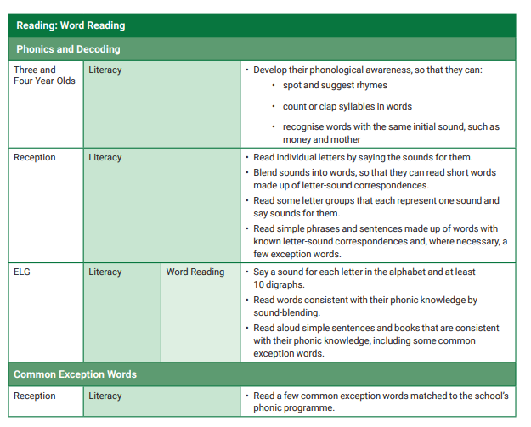
- Communication and Language
- Literacy
- Expressive Arts and Design

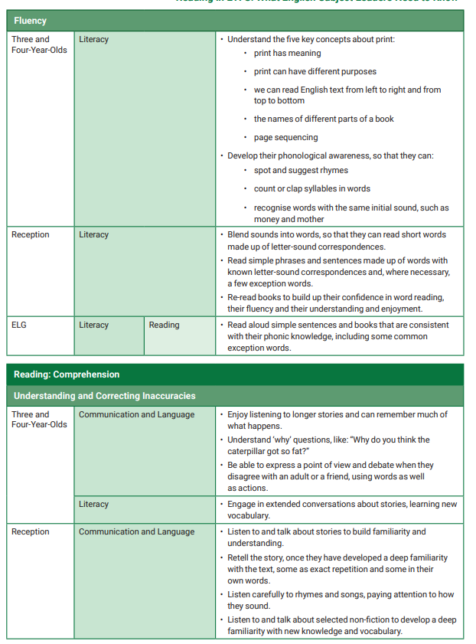
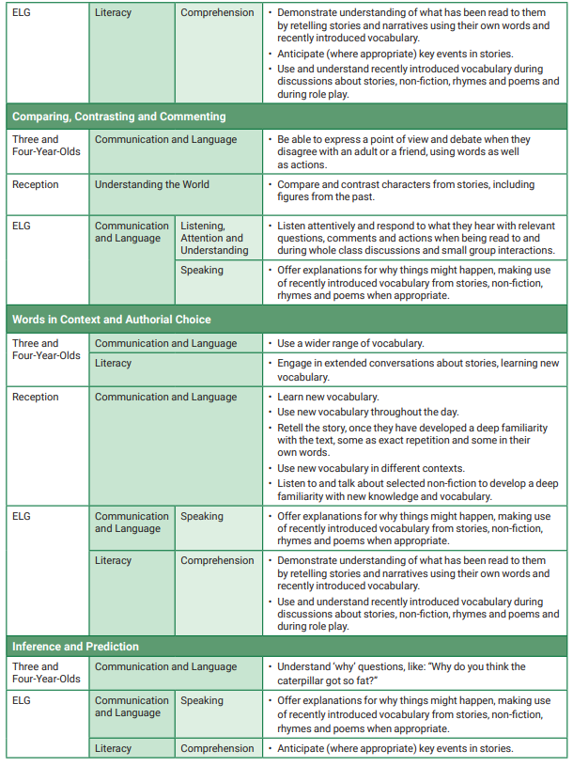

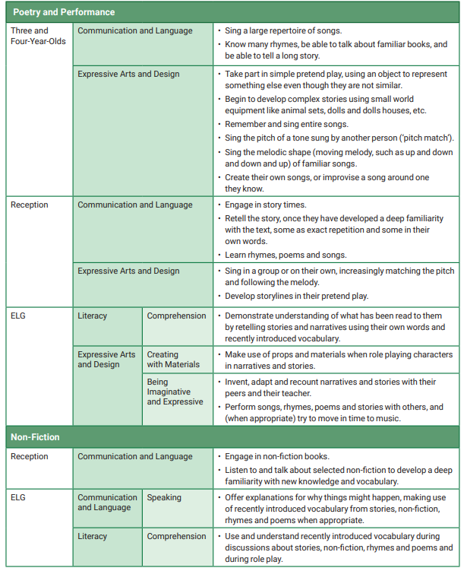

Reading Progression in Key Stage 1 and Key Stage 2

Reading Progression - Retrieval
(Bold objectives/grey boxes = key indicators for National Curriculum for year group)

Skills for  Retrieval | Year 1 | Year 2 | Year 3 | Year 4 | Year 5 | Year 6
National curriculum statements | Becoming very familiar with key stories and retelling them explain clearly their understanding of what is read to them | Becoming increasingly familiar with and retelling a wider range stories answering and asking questions  Discussing the sequence of events in books and how items of information are related | Increasing their familiarity with a wide range of books and retelling some of these orally  Asking questions to improve their understanding of a text Identifying main ideas drawn from more than one paragraph and summarising these  Retrieve and record information from non-fiction |  | Asking questions to improve their understanding  Summarising the main ideas drawn from more than one paragraph, identifying key details to support the main ideas  Retrieve, record and present information from non- fiction
Range of texts/genres | Age appropriate texts: Reading for themselves key stories, fairy stories and traditional tales  Listening to a wide range of poems, stories and non-fiction at a level beyond that at which they can read independently | Age appropriate texts: Reading for themselves a wider range of stories, fairy stories and traditional tales Listening to a wide range of contemporary and classic poetry stories and non-fiction at a level beyond that at which they can read independently | Age appropriate texts:  Reading for themselves a wide range of books, including fairy stories, myths and legends  listening to a wide range of fiction, poetry, plays, non-fiction and reference books or textbooks  Reading books that are structured in different ways and reading for a range of purposes |  | Age appropriate texts:  Reading for themselves an increasingly wide range of fiction, poetry, plays, non-fiction and reference books or textbooks reading books that are structured in different ways and reading for a range of purposes  a wide range of books, including myths, legends and traditional stories, modern fiction, fiction from our literary heritage, and books from other cultures and traditions
Retelling | - Retell story read or heard, parts of a story using props e.g. puppets/ small world/  series of pictures | - Orally retelling a wider range of stories using actions and visual cues from the story | - Retell a wide range of stories orally using actions and visual cues | - Retell a wide range texts orally which is balanced and clear | See summarising and sequencing boxes
Sequencing | - Sequence pictures for the beginning, middle and end of a story read | - Sequence events from a story, explaining reasons for choices | - Sequence pictures or texts from a story or non-fiction text read justifying reasons for choices | - Show understanding of the text by sequencing a selection of unknown text so that they make sense as a whole, justifying reasons for  choices | - Sequence sections/ outlines of unknown texts based upon knowledge of genre features | - Manipulate sections of stories to create and explore more complex narratives e.g. dual narration, flash back
Answering find it questions | - Answer simple questions about characters, setting and key events in a story | - Answer questions about characters, setting/s and key events  - Answer find it questions about key information in a non-fiction text | - Find and select the word/s in a section of a text to answer find it questions | - Find and select words and phrases to answer find it questions from different sections of unknown texts | - Find and select words and phrases from across a whole text to answer find it questions | - Find, select and combine relevant words and phrases from more than one text/source to support answers to find  it questions
Summarising and note  making | - Identify and discuss the setting and names of the characters in a story | - Explain and discuss the key information from what is seen or read | - Summarise orally and in writing the main points from a paragraph using | - Summarise orally and in writing the main points from several paragraphs | - Identify the main ideas from several paragraphs and provide key | - Identify the main idea from across several paragraphs or sections

Skills for  Retrieval | Year 1 | Year 2 | Year 3 | Year 4 | Year 5 | Year 6
 |  | (link to sequencing). | a wider range of prompts | or sections of a text | additional information from a section of the text to support this | of the text and provide key additional information from the text to support this  - Summarise the themes or viewpoints for different texts
Recasting |  |  | - Produce an annotated story/visual map to represent a text that has been read | - Produce an annotated drawing/diagram to represent/summarise a section of a text (non- fiction)  - Complete diagrams, tables and charts to summarise information | - Summarise in different ways including key information e.g. written summary, key words, pictures/ diagrams, charts and making notes for presentations | - Summarise in different ways for different audiences and purposes
Skimming and scanning |  | - Scan text to find given words and phrases | - Skim and scan to identify and use headings and sections in books (glossaries, indexes, contents) to retrieve information | - Scan different sections of unknown texts (fiction and non-fiction) to find missing information | - Scan different texts to find evidence to support answers to questions  - Speed read or skim the text to gain the gist or main idea | - Appropriately select and apply skimming and scanning skills to a range of other texts across the curriculum  e.g. history and geography
Asking find it questions |  | - Ask relevant questions about a story or on- fiction text | - Generate find it questions for a section of fiction and non- fiction texts (which are relevant) | - Generate relevant find it questions from different sections of fiction and non-fiction texts | - Ask relevant find it questions which explore the detail of a text or which require comparison across fiction and non-fiction | - Generate find it questions relevant to different sections of a non-fiction text  - Ask relevant find it questions about different sections of a  story read
Note making skills |  |  |  |  | - Retrieve and record information, producing a set of notes to support  a presentation | - Make notes for presentations to different audiences
Determining validity and importance |  |  |  |  | - Prior to reading, select from a range of texts/ sources of information with a key question or  heading in mind. | - Appraise a text quickly, deciding on its value, quality or usefulness

Reading Progression - Inference
(Bold objectives/grey boxes = key indicators for National Curriculum for year group)

Skills for  inference | Year 1 | Year 2 | Year 3 | Year 4 | Year 5 | Year 6
National curriculum statements | Explain clearly their understanding of what is read to them  Predicting what might happen on the basis of what has been read so far  Discussing the significance of the title and events, making inferences on the basis of what  is being said and done | Making inferences on the basis of what is being said and done  Answering and asking questions  Predicting what might happen on the basis of what has been read so far | Checking that the text makes sense to them, discussing their understanding and explaining the meaning of words in context Predicting what might happen from details stated and implied Drawing inferences such as inferring characters’ feelings, thoughts and motives from their actions, and justifying inferences with evidence  Asking questions to improve their understanding of a text |  | Checking that the book makes sense to them, discussing their understanding and exploring the meaning of words in context Asking questions to improve their understanding  drawing inferences such as inferring characters’ feelings, thoughts and motives from their actions, and justifying inferences with evidence  Predicting what might happen from details stated and implied Distinguish between statements of fact and opinion  Provide reasoned justifications for their views
Range of texts/genres | Age appropriate texts: Reading for themselves key stories, fairy stories and traditional tales  Listening to a wide range of poems, stories and non-fiction at a level beyond that at which they can read independently | Age appropriate texts: Reading for themselves a wider range of stories, fairy stories and traditional tales Listening to a wide range of contemporary and classic poetry stories and non-fiction at a level beyond that at which they can read independently | Age appropriate texts:  Reading for themselves a wide range of books, including fairy stories, myths and legends  listening to a wide range of fiction, poetry, plays, non-fiction and reference books or textbooks  Reading books that are structured in different ways and reading for a range of purposes |  | Age appropriate texts:  Reading for themselves an increasingly wide range of fiction, poetry, plays, non-fiction and reference books or textbooks reading books that are structured in different ways and reading for a range of purposes  a wide range of books, including myths, legends and traditional stories, modern fiction, fiction from our literary heritage, and books from other cultures and traditions
Predicting | - Predict whether a book will be story or non- fiction based upon the cover and title  - Predict what might happen based on what has been read so far | - Make predictions prior to reading based upon the title, cover and skim reading of illustrations  - Make predictions based upon events in the text so far  - Make predictions using experience of reading books based on other familiar texts | - Make predictions prior to reading based upon the title, cover and skim reading of illustrations, contents page and headings  - Make predictions based upon events and actions of characters so far in a story  - Make predictions drawing upon knowledge from other texts  - Make predictions based upon background knowledge of the topic | - Make predictions prior to reading about the likely type of characters or events in a story based upon the front cover, title, knowledge of the author and different genres of writing  - Make plausible predictions based upon events and actions of characters so far in a story – identifying evidence in the text  - Make predictions drawing upon knowledge from other  texts | - Make predictions about characters based upon reading so far – identifying a range of evidence within and beyond the text to support opinion  - Categorise predictions as likely/unlikely based upon what has been read so far | - Make predictions about characters, plots and themes of stories based upon knowledge of fiction genres and other books by the same author  - Make predictions using evidence stated and implied
Cause and |  | - Begin to describe (in book talk) cause and | - Identify the cause of an event | - Identify the multiple causes of an event | - Infer and comment on the possible causes of | - Infer, comment on and make links between the

Skills for  inference | Year 1 | Year 2 | Year 3 | Year 4 | Year 5 | Year 6
effect |  | effect e.g. the effect a  character’s actions have on other characters. | - Infer an effect of a specific event or action | - Infer and comment on a range of possible effects of a specific event or action | events and actions  - Identify which causes are most/least likely based upon evidence in the text and beyond | cause and effects of events and actions  - Evaluate the impact of different causes and effects on people and  places
Identifying evidence to support and justify opinion | - Make links to personal experiences  - Make inferences about character types based on actions E.g. infer stock character types (good/bad/evil /hero etc.) based upon their actions  - Explain clearly what is read to them | - Draw upon personal experiences when commenting on a text  - Draw upon knowledge of the topic outside of the book including other similar books  - Make simple inferences about character feelings based upon their actions and speech | - Justify inferences with evidence  - Infer characters’ feelings, thoughts and motives | - Justify inferences with evidence from within the text and experiences and/or reading beyond the text  - Infer characters’ feelings, thoughts and motives from their actions at different points in a story | - Justify inferences backed by one type of textual evidence from across the text  - Infer and explain how a character’s thoughts, feelings or motives have changed over the course of the text  - Identify statements of fact and opinion. | - Justify inferences backed by a range of types of evidence from across the text  - Infer and compare  different characters’ thoughts, feelings and motives at the same points in a story  - Distinguish between statements of fact and opinion using evidence  to justify.
Drama/ writing in role | - Explore characters through roleplay and drama | - Take on the role of a character e.g. speech bubbles, notes from one character to another or other drama techniques | - Explore characters’ actions and feelings through role play such as hot seating  - Create short improvisations in role | - Explore characters’ actions, feelings and motives through role play such as hot seating  - Demonstrate appropriate empathy through expression | - Explore contrasting characters’ feelings,  thoughts, actions and motives through role play such as hot seating  - Create improvisations in role e.g. creating a new  or alternative scenes | - Create improvisations in role e.g. for a different point in time to that in the text  - Present ideas in role as an expert authority e.g. debate
Asking and answering inference questions |  | - Ask and answer simple relevant inference/ detective questions about a story or simple non-fiction text (no evidence needed) | - Ask and answer inference/ detective relevant questions about a story or non- fiction text which begins to develop character’s feelings and actions | - Ask and answer inference/ detective relevant questions about a story or non- fiction text which begins to develop character’s feelings, actions and motives | - Ask and answer relevant inference/ detective questions for a range of fiction and non-fiction texts  - In discussion and role ask/answer relevant inferences/ detective questions about  characters’ feelings, actions, thoughts and motives | - Ask find it inference/ detective questions which explore the detail of a text or which require comparison across the text

Reading Progression - Text Structure
(Bold objectives/grey boxes = key indicators for National Curriculum for year group)

Skills for Text  structure | Year 1 | Year 2 | Year 3 | Year 4 | Year 5 | Year 6
National curriculum statements | Becoming very familiar with key stories, fairy stories  and traditional tales and considering their particular characteristics | Being introduced to non- fiction books that are structured in different ways | Recognising some different forms of poetry Retrieve and record information from non-fiction  Identifying how structure, and presentation contribute to meaning  Reading books that are structured in different ways and  reading for a range of purposes |  | Reading books that are structured in different ways and reading for a range of purposes  Identifying and discussing conventions in and across a wide range of writing  Identifying how structure and presentation contribute to  meaning
Range of texts/genres | Age appropriate texts: Reading for themselves key stories, fairy stories and traditional tales  Listening to a wide range of poems, stories and non-fiction at a level beyond that at which they can read independently | Age appropriate texts: Reading for themselves a wider range of stories, fairy stories and traditional tales Listening to a wide range of contemporary and classic poetry stories and non-fiction at a level beyond that at which they can read independently | Age appropriate texts:  Reading for themselves a wide range of books, including fairy stories, myths and legends  listening to a wide range of fiction, poetry, plays, non-fiction and reference books or textbooks  Reading books that are structured in different ways and reading for a range of purposes |  | Age appropriate texts:  Reading for themselves an increasingly wide range of fiction, poetry, plays, non-fiction and reference books or textbooks reading books that are structured in different ways and reading for a range of purposes  a wide range of books, including myths, legends and traditional stories, modern fiction, fiction from our literary heritage, and books from other cultures and traditions
Use and function of structural organisers | - Understand and use correctly, terms referring to conventions of print: book, cover, beginning, end, page, word, letter, line  - Identify the title, blurb and author of a story or non-fiction book  - Discuss the significance of the title | - Read non-fiction texts that are structured in different ways  - Begin to identify and name a range of common organisers in non-fiction texts e.g. contents, headings, index, glossary | - Read fiction and non- fiction texts that are structured in different ways  - Name and describe the function of a range of common organisers in non-fiction texts (Y2: contents, headings, index, glossary + Y3: sub- headings, diagrams)  - Use a range of structural organisers (see previous bullet point) to retrieve information from non- fiction texts | - Read fiction and non- fiction texts that are structured in different ways  - Name, use and describe the function of a wider range of common organisers in non-fiction texts (Y2/3: contents, headings, index, glossary, sub-headings, diagrams + Y4: captions and labels, bibliography)  - Use a range of structural organisers (see previous bullet point) to retrieve information from non- fiction texts  - Identifying how structure and presentation contribute to meaning (e.g. more independently and on  Y4 texts) | - Read fiction and non- fiction texts that are structured in different ways  - Identify structural organisers and make comparisons within and across books  - Explain why the author has chosen to structure/present the text in particular way or use a particular structural organiser | - Read fiction and non- fiction texts that are structured in different ways  - Identify structural organisers and make comparisons within and across books  - Discuss the effectiveness of different structures/ presentations of fiction and non-fiction

Skills for Text  structure | Year 1 | Year 2 | Year 3 | Year 4 | Year 5 | Year 6
Features of different text types | - Recognise some typical characters and settings of fairy stories and traditional tales (book work)  - Understand the difference between fiction and non-fiction  - Begin to describe the overall structure of a story e.g. being about to answer: “What is the problem in the story?” | - Recognise and describe some typical features, similarities and differences between fiction and non-fiction texts  - Describe the overall structure of a story, e.g. including how the beginning introduces story and the ending concludes the action | - Recognise and name some different forms of poetry  - Compare and contrast features of stories read  e.g. characters, settings, themes | - Recognise and describe the typical features of a wider range of forms of poetry  - Recognise and describe some features of fiction genres  - Refer to parts of stories, dramas, and poems when writing or speaking about a text, using terms such as chapter, scene, and stanza | - Identify, compare and contrast the features of a range of poetry, non- fiction and fiction genres | - Identify, compare and contrast the features of a range of fiction genres  - Explain major differences between text types
Audience and purpose |  |  | - Begin to read for a range of purposes e.g. research, pleasure, locate specific information  - Recognise the intended audience and purpose of some non-fiction genres | - Read for a range of purposes e.g. research, pleasure, locate specific information | - Read for a range of purposes e.g. research, pleasure, locate specific information, gain an overview | - Read for a range of purposes e.g. research, pleasure, locate specific information, gain an overview, compare and contrast
Supporting meaning |  |  | - Recognise that pictures/photographs can give as much information as the text  - Describe how each successive parts of a text builds on the meaning of earlier sections | - Recognise and explain how presentational devices impact on reading and support meaning e.g. italics, bold, diagrams, bullet points  - Explain how topic sentences (first sentence of section) help cue the reader into the content of  paragraphs | - Explain how a series of chapters, scenes, or stanzas fits together to provide the overall structure of a particular story, drama, or poem | - Use text structure to help summarise the text (linked to AF2)  - Analyse how a particular sentence, chapter, scene, or stanza fits into the overall structure of a text and contributes to the development of the theme, setting, or plot

Reading Progression - Vocabulary
(Bold objectives/grey boxes = key indicators for National Curriculum for year group)

Skills for  Vocabulary | Year 1 | Year 2 | Year 3 | Year 4 | Year 5 | Year 6
National curriculum statements | Recognising and joining in with predictable phrases Discussing word meanings, linking new meanings to those already known | Discussing and clarifying the meanings of words, linking new meanings to known vocabulary  Discussing their favourite words and phrases Recognising simple recurring literary language in stories and poetry | Apply their growing knowledge of root words, prefixes and suffixes to understand the meaning of new words they meet Using dictionaries to check the meaning of words that they have read  Explaining the meaning of words in context  Discussing words and phrases that capture the reader’s interest and imagination  Identifying how language contributes to meaning  Checking that the book makes sense to them, discussing their understanding and exploring the meaning of words in context |  | Apply their growing knowledge of root words, prefixes and suffixes (morphology and etymology), to understand the meaning of new words that they meet  Identifying how language contributes to meaning Asking questions to improve their understanding  Discuss and evaluate how authors use language, including figurative language, considering the impact on the reader Checking that the book makes sense to them, discussing their understanding and exploring the meaning of words in context
Range of texts/genres | Age appropriate texts: Reading for themselves key stories, fairy stories and traditional tales  Listening to a wide range of poems, stories and non-fiction at a level beyond that at which they can read independently | Age appropriate texts: Reading for themselves a wider range of stories, fairy stories and traditional tales Listening to a wide range of contemporary and classic poetry stories and non-fiction at a level beyond that at which they can read independently | Age appropriate texts:  Reading for themselves a wide range of books, including fairy stories, myths and legends  listening to a wide range of fiction, poetry, plays, non-fiction and reference books or textbooks  Reading books that are structured in different ways and reading for a range of purposes |  | Age appropriate texts:  Reading for themselves an increasingly wide range of fiction, poetry, plays, non-fiction and reference books or textbooks reading books that are structured in different ways and reading for a range of purposes  a wide range of books, including myths, legends and traditional stories, modern fiction, fiction from our literary heritage, and books from other cultures and traditions
Identify vocabulary | - Recognise vocabulary associated with different genres provided by the teacher | - Recognise simple recurring literary language in stories and poems e.g. repetition | - Identify patterns in language e.g. repetition, rhyme, alliteration  - Identify and generate words with similar meanings or linked to a  specific focus | - Identify and generate words with similar and opposite meanings | - Identify figurative language devices | - Identify words and phrases that create a particular mood, feeling or attitude including figurative language
Explain the meanings of words | - Discuss word meanings, linking new meanings to those already known | - Discuss and clarify the meanings of new words, linking new meanings to known vocabulary  - Begin to use a range of skills (such as morphology and word classes) to identify the meaning of unknown  words to help place | - Apply their growing knowledge of root words, prefixes and suffixes to understand the meaning of new words they meet  - Explain the meaning of words in given contexts  - Begin to discuss language to extend their interest in the meaning | - Apply their growing knowledge of root words, prefixes and suffixes to understand the meaning of new words they meet  - Explain the meaning of words in given contexts  - Discuss language to extend their interest in the meaning and origin | - Apply their growing knowledge of grammar, morphology and etymology to understand the meaning of new words that they meet in context  - Ask questions about vocabulary to improve  their understanding | - Apply their growing knowledge of grammar, morphology and etymology to understand the meaning of new words that they meet in context  - Ask questions to help clarify their  understanding of

 |  | them into context | and origin of words  - Begin to use dictionaries to check the meaning of words that they have read | of words  - Use dictionaries to check the meaning of words that they have read |  | vocabulary
Explain the intended impact of words and phrases on the reader | - Recognise and join in with predictable phrases | - Discuss their favourite words and phrases from the text | - Discuss words and phrases that capture the reader’s interest and imagination | - Discuss words and phrases that capture the reader’s interest and imagination giving reasons for their choices  - Explain why the author has used a particular word or phrase | - Discuss how language contributes to the overall meaning  - Discuss how authors use figurative language and the impact of these on the reader  - Compare the impact of different language devices within a text | - Explain how words and phrases create a particular mood, feeling or attitude  - Consider the impact on the reader of a range of vocabulary and language devices  - Compare the impact of language devices across texts
Recognise and explain how language is linked to audience and purpose | - Capture and apply new vocabulary in writing | - Collect and apply new vocabulary in writing | - Begin to recognise key vocabulary and language features from different genres and apply to writing. | - Recognise key vocabulary and language features from different genres and apply to writing. | - Recognise language and vocabulary used by an author for a specific genre and compare to another author, considering impact on reader. | - Recognise and compare language and vocabulary features across different text types and between authors and consider impact on reader.  - Suggest how language would need to change  for different audiences

Reading Progression - Compare and Contrast
(Bold objectives/grey boxes = key indicators for National Curriculum for year group)

Skills for Compare and  Contrast | Year 1 | Year 2 | Year 3 | Year 4 | Year 5 | Year 6
National curriculum statements | Being encouraged to link what they read or hear read to their own experiences | Discussing the sequence of events in books and how items of information are related Being introduced to non- fiction books that are structured in different ways | Identifying themes and conventions in a wide range of books Reading books that are structured in different ways and reading for a range of purposes |  | Making comparisons within and across books  Reading books that are structured in different ways and reading for a range of purposes  Identifying and discussing themes and conventions in and across a wide range of writing (text types)  Non statutory - Pupils should be shown how to compare  characters, settings, themes and other aspects of what they read
Range of texts/genres | Age appropriate texts: Reading for themselves key stories, fairy stories and traditional tales  Listening to a wide range of poems, stories and non-fiction at a level beyond that at which they can read independently | Age appropriate texts: Reading for themselves a wider range of stories, fairy stories and traditional tales Listening to a wide range of contemporary and classic poetry stories and non-fiction at a level beyond that at which they can read independently | Age appropriate texts:  Reading for themselves a wide range of books, including fairy stories, myths and legends  listening to a wide range of fiction, poetry, plays, non-fiction and reference books or textbooks  Reading books that are structured in different ways and reading for a range of purposes |  | Age appropriate texts:  Reading for themselves an increasingly wide range of fiction, poetry, plays, non-fiction and reference books or textbooks reading books that are structured in different ways and reading for a range of purposes  a wide range of books, including myths, legends and traditional stories, modern fiction, fiction from our literary heritage, and books from other cultures and tradition.
Identify, discuss and record similarities and differences | - Understand the difference between fiction and non-fiction | - Read non-fiction books which are structured in different ways  - Identify and describe some differences between fiction and non- fiction books  - Compare and contrast two or more versions of the same story e.g. two versions of the same story | - Compare and contrast features of stories read  e.g. characters, settings, openings, endings  - Compare and contrast two or more versions of the same story e.g. comparing a play script of a story to the narrative | - Compare and contrast character development in a play to characterisation in stories or narrative poetry  - Compare and contrast information from different sources about the same topic, identifying similarities in content and structure  - Compare and contrast the themes, settings, and plots of stories | - Identify, compare and contrast the features of a range of different forms of  - Poetry  - Non-fiction  - Fiction  - Compare and contrast purpose and viewpoint and evaluate the usefulness of each source  - Begin to compare and contrast authors’ styles | - Identify, compare and contrast the features of a range of fiction genres (e.g. contemporary v traditional) including poetry  - Compare information, ideas, values and attitudes represented within and across texts  - Analyse how an author develops and contrasts the points of view of different characters or narrators in a text  - Compare and contrast authors’ style, purpose  and viewpoint.
Identify, compare and contrast | - Begin to identify similar and repeated language which occurs in more  than one story e.g once | - Compare and contrast language within a type of story read e.g.  traditional tales – one | - Compare and contrast language within a type of story read e.g. fairy tales  and plays | - Compare and contrast language across different types of stories read e.g.  fairy tales, myths and | - Compare the language of poetry, prose and non- fiction for the same theme  or information | - Compare and contrast different language within and across books

Skills for Compare and  Contrast | Year 1 | Year 2 | Year 3 | Year 4 | Year 5 | Year 6
vocabulary | upon a time | early morning/ once upon a time |  | legends and science fiction
Making links | - Link reading to personal experiences | - Discuss the sequence of events in stories  - Discuss how items of information are related in a book  - Make links between current and prior reading | - Identify and compare themes of fictional stories | - Identify and compare themes in a wider range of fiction and non- fiction | - Compare how a common theme is presented in a range of texts | - Compare and contrast themes and topics in stories of the same genre e.g. mysteries and adventure stories  - Explain the relationship between characters, plot, setting, point of  view and theme

Reading Progression - Reviewing and Performing
(Bold objectives/grey boxes = key indicators for National Curriculum for year group)

Skills for  Reviewing and Performing | Year 1 | Year 2 | Year 3 | Year 4 | Year 5 | Year 6
National curriculum statements | Participate in discussion about what is read to them, taking turns and listening to what others say  Learning to appreciate rhymes and poems, and to recite some by heart  Listening to and discussing a wide range of poems, stories and non-fiction at a level beyond that at which they can read independently | Listening to, discussing and expressing views about a wide range of contemporary and classic poetry, stories and non- fiction at a level beyond that at which they can read independently  Answering and asking questions  Continuing to build up a repertoire of poems learnt by heart, appreciating these and reciting some, with appropriate intonation to make the meaning clear  Participate in discussion about books, poems & other works that are read to them & those that they can read for themselves, taking turns  and listening to what others | Listening to and discussing a wide range of fiction, poetry, plays, non-fiction and reference books or textbooks  Preparing poems and play scripts to read aloud and to perform, showing understanding through intonation, tone, volume and action  Participate in discussion about both books that are read to them and those they can read for themselves, taking turns and listening to what others say  Asking questions to improve their understanding of a text |  | Learning a wider range of poetry by heart  Preparing poems and plays to read aloud and to perform, showing understanding through intonation, tone and volume so that the meaning is clear to an audience  Asking questions to improve their understanding  Recommending books that they have read to their peers, giving reasons for their choices  Participate in discussions about books, building on their own and others’ ideas and challenging views courteously  Explain and discuss their understanding of what they have read, including through formal presentations and debates,

Skills for Reviewing and  Performing | Year 1 | Year 2 | Year 3 | Year 4 | Year 5 | Year 6
say
Explain and discuss their understanding of books, poems and other material, both those that they listen to and those that they read for
themselves
National Curriculum Statements - spoken language  (linked to reading) | Ask relevant questions to extend their understanding and knowledge Articulate and justify answers, arguments and opinions  Use spoken language to develop understanding through speculating, hypothesising, imagining and exploring ideas Participate in discussions, presentations, performances, role play/improvisations and debates  Consider and evaluate different viewpoints, attending to and building on the contributions of others
Range of texts/genres | Age appropriate texts: Reading for themselves key stories, fairy stories and traditional tales  Listening to a wide range of poems, stories and non-fiction at a level beyond that at which they can read independently | Age appropriate texts: Reading for themselves a wider range of stories, fairy stories and traditional tales Listening to a wide range of contemporary and classic poetry stories and non-fiction  at a level beyond that at which they can read independently | Age appropriate texts:  Reading for themselves a wide range of books, including fairy stories, myths and legends  listening to a wide range of fiction, poetry, plays, non-fiction and reference books or textbooks  Reading books that are structured in different ways and reading for a range of purposes |  | Age appropriate texts:  Reading for themselves an increasingly wide range of fiction, poetry, plays, non-fiction and reference books or textbooks reading books that are structured in different ways and reading for a range of purposes  a wide range of books, including myths, legends and traditional stories, modern fiction, fiction from our literary heritage, and books from other cultures and tradition.
Discussing and debating | - Participate in discussion about what is read to them (stories, poems and non-fiction at a level beyond which they can read independently),  - Take turns and listen to what others say | - Listen to, discuss and express views about a wide range of contemporary and classic poetry, stories and non-fiction at a level beyond that at which they can read independently  - Participate in discussion about books, poems & other works that they can read for themselves,  - Take turns and listen to what others say  - Explain their understanding of books poems and other materials that they have read and which have  been read to them | - Discuss a range of fiction, poetry, plays, non-fiction and reference books or textbooks that they have read themselves and which have been read to them  - Take turns, listen to what others say  - Discuss specific events, characters or sections of a text  - Discuss words and phrases which captures the readers interest and imagination | - Discuss a wide range of fiction, poetry, plays, non-fiction and reference books or textbooks that they have read themselves and which have been read to them  - Take turns, listen to what others say and ask follow up questions to contributions made by others  - Identify and discuss the purpose of a text and the intended impact on the reader  - Identify and discuss the difference between fact and opinion  - Discuss the impact | - Participate in discussions about books, building on their own  and others’ ideas  - Ask questions to clarify others’ opinions  - Explain and discuss their understanding of what they have read  - Provide reasoned justifications for their views  - Identify and discuss themes and points of view within and across texts | - Participate in discussions about books, building on their own and others’ ideas  - Challenge views courteously  - Explain and discuss their understanding of what they have read through formal debates  - Provide reasoned justifications and a wider range of evidence to support their views  - Comment on the overall impact of a text on the reader

Skills for Reviewing and  Performing | Year 1 | Year 2 | Year 3 | Year 4 | Year 5 | Year 6
words and phrases which capture the readers interest and
imagination
Evaluating and Reviewing | - State whether they like a story or poem | - State whether they like a story and characters within the story  - State which text they prefer and give a reason to support their opinion | - Write structured reviews of a text, stating which were their favourite parts and why | - Write structured reviews of a text, evaluating the overall text as well as reviewing specific elements | - Recommend to their peers orally and in writing books that they have read  - Give reasons for recommendations  - Write independent reviews of a text | - Recommend books that they have read to wider audiences e.g. on-line, local library  - Write independent reviews and give reasons for specific  recommendations
Presenting and performing | - Recognise and join in with predictable phrases  - Recite some poems and rhymes by heart  - Retell key fairy stories and traditional tales verbally. | - Continue to build up a repertoire of poems learnt by heart, reciting some, with appropriate intonation to make the meaning clear  - Retell a wider range of fairy stories and traditional tales verbally | - Prepare poems and play scripts to read aloud and to perform, showing understanding through volume and action | - Prepare poems and play scripts to read aloud and to perform, showing understanding through intonation, tone, volume and action | - Learn a range of poetry by heart  - Prepare poems and plays to read aloud and to perform, showing understanding through intonation, tone and volume so that the meaning is clear to an audience  - Explain their understanding by presenting some of their  ideas to others | - Learn a wider range of poetry by heart  - Prepare poems and plays to read aloud and to perform, showing understanding through intonation, tone and volume so that the meaning is clear to an audience  - Explain and discuss their understanding of what they have read through  formal presentations

