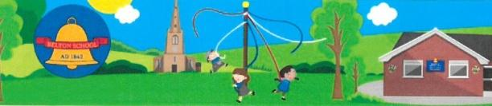
Belton C of E Primary School
Achieving the Best Together
Headteacher: Miss J Scott BSc (Hons) NPQH
Sadlers Wells, Belton, Leicestershire. LE12 9TS Email: office@beltonprimary.org
Telephone: 01530 222304 Website: www.belton.leics.sch.uk

Chromebook Loan agreement

Please read the following and sign below if you agree to abide by these conditions of use:

I / We will:
- Ensure that the Chromebook is returned to the school in full working order on the first day back of school.
- Not allow the device to be used to browse, download or send material that could be considered offensive. I am aware that the school filtering system will not work on my home WIFI and therefore I am responsible for monitoring use.
- Take precautions when using data transfer devices such as memory sticks e.g. only using them to transfer data from computers with up to date defence systems.
- Ensure any confidential data is protected by password.
- Not knowingly download software that could contain malware, virus, phishing etc.

I agree to pay for a full replacement, a sum of £260 within one month of the return on the property to school, if there is any physical, theft or water, fire damage to the property and/or its components.

Signed________________________________________ (parent / carer) Date _______________

Name of child / children using the chromebook: ____________________________________

Chromebook serial number ____________________________________

Signed______________________________________________ Date_______________________

Please copy this agreement and give it to the parent / carer. One copy to be kept in school.

